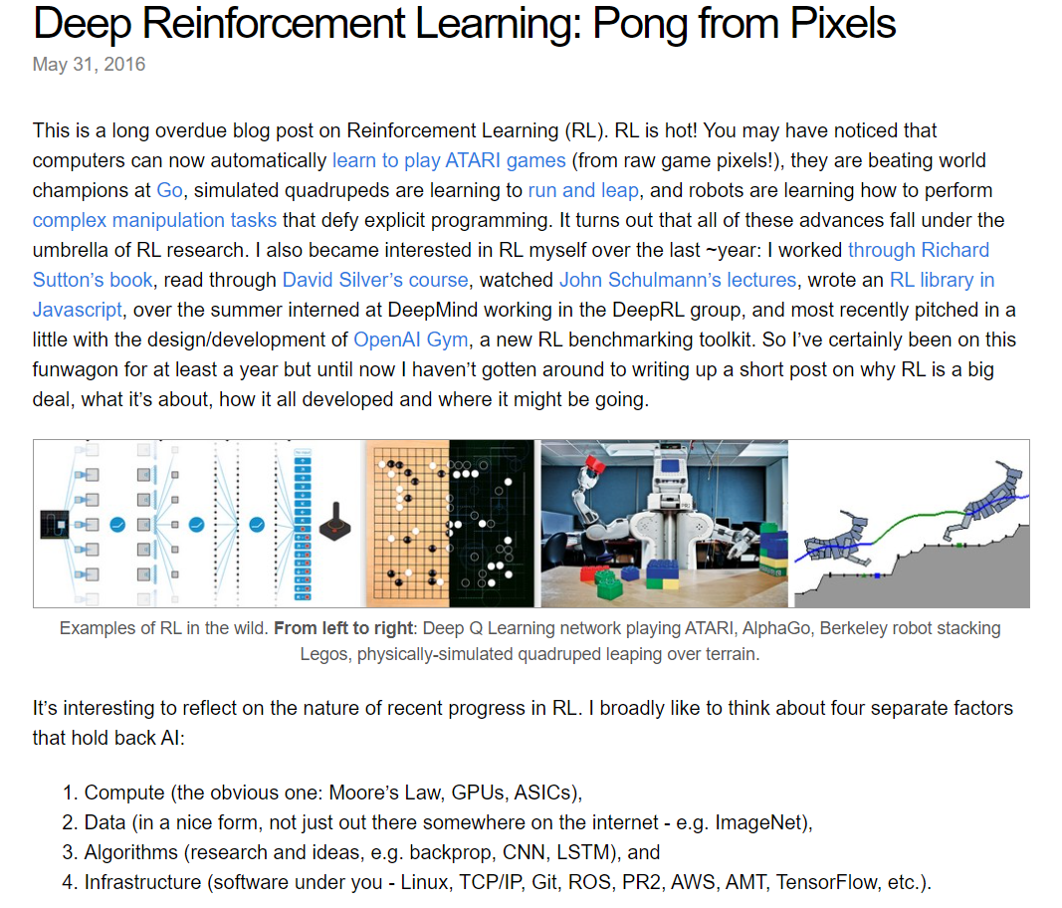

The first part of the blog post is an introduction to Deep Reinforcement Learning (RL). Here are the key points in a simplified manner:

* **Reinforcement Learning (RL) is a type of machine learning** where an agent learns through trial and error by interacting with its environment. The agent receives rewards for good actions and penalties for bad actions. This allows the agent to learn what actions are best to achieve a goal. Unlike supervised learning, where a human provides the training data and the correct answers, RL allows the agent to learn on its own by exploring the environment and figuring out what works best.
* **RL has been used to achieve impressive results** such as training computers to play Atari games from scratch, beating champions at the game Go, and even controlling robots to perform complex tasks. AlphaGo, for example, is a computer program that uses RL to achieve superhuman performance at the game of Go.
* The blog post author recently became interested in RL and has been learning about it through various resources, including Richard Sutton's book, David Silver's course, and John Schulmann's lectures. He also worked on an RL library in Javascript and interned at DeepMind, a company that is at the forefront of RL research.



Kaparthy also mentions some of the challenges that hold back advancements in Artificial Intelligence (AI) in general. These challenges include:

* **Compute** - This refers to the processing power needed to train complex AI models. Fortunately, Moore's Law (which states that the number of transistors on a microchip doubles about every two years) is helping to address this challenge. As computing power increases, it becomes possible to train more complex and powerful RL agents.
* **Data** - Large amounts of data are needed to train AI models. This data needs to be in a usable format, not just raw data that is freely available on the internet. For RL, the data typically consists of the agent's observations of the environment, the actions it took, and the rewards it received. This data can be used to train the agent's decision-making policy, which is the mapping from observations to actions.
* **Algorithms** - New algorithms are needed to develop more powerful AI models. In the field of RL, there are many different algorithms that can be used to train an agent's decision-making policy. Some of the most popular algorithms include Q-learning and Deep Q-learning.
* **Infrastructure** - This refers to the software and hardware infrastructure that is needed to support the development of AI. This includes things like operating systems, networking protocols, and cloud computing platforms. For RL, having a robust infrastructure is important for training complex agents that can interact with complex environments.

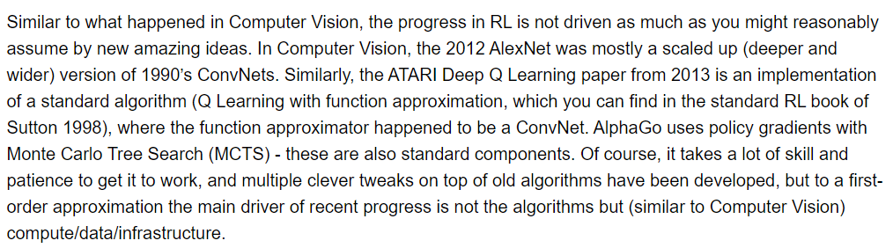

The text is talking about how progress in artificial intelligence (AI) is not mainly driven by entirely new ideas, but by improvements in computing power, data, and infrastructure.

Here is a breakdown of the relevant terms:

**Artificial Intelligence (AI):** This is a branch of computer science that deals with the creation of intelligent agents, which are systems that can reason, learn, and act autonomously.

Reinforcement Learning (RL): This is a type of machine learning where an agent learns by trial and error through interacting with its environment. The agent receives rewards for good actions and penalties for bad actions, and it learns to take actions that maximize its rewards over time.

**Convolutional Neural Networks (ConvNets):** This is a type of artificial neural network that is particularly well-suited for image recognition tasks. ConvNets are inspired by the structure of the human visual cortex and are able to extract features from images that are useful for classification.

**Deep Learning**: This is a type of machine learning that uses artificial neural networks with many layers. Deep learning models have been able to achieve state-of-the-art results on a wide range of tasks, including image recognition, natural language processing, and speech recognition.

**Monte Carlo Tree Search (MCTS**): This is a tree search algorithm that is often used in game playing programs. MCTS works by exploring different possible moves in a game and evaluating the potential outcomes of those moves.

The text says that the progress in computer vision made in 2012 with AlexNet was mostly due to using a deeper and wider version of an algorithm called a convolutional neural network (ConvNet) that had been around since the 1990s. Similarly, the progress in reinforcement learning made in 2013 with Deep Q Learning was mostly due to using a convolutional neural network as a function approximator in a standard algorithm called Q-learning.



In other words, the big breakthroughs in computer vision and reinforcement learning weren't entirely new ideas. Instead, they were due to applying existing algorithms with more powerful computers, more data, and better infrastructure.

The text also says that this doesn't mean that there isn't a lot of skill and effort involved in making these algorithms work. It takes a lot of work to get these algorithms to work well, and there have been many important tweaks made to these algorithms. But the main reason why they work so well now is because we have better computers, more data, and better infrastructure than we did in the past.

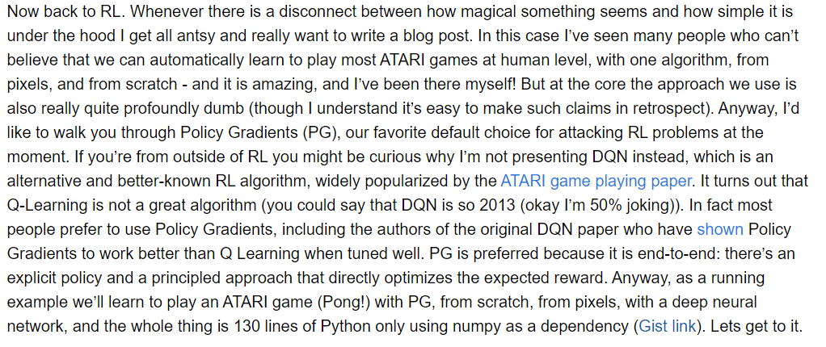

**Reinforcement Learning (RL) Approaches**

The paragraph delves into two common approaches in Reinforcement Learning (RL): Policy Gradients and Deep Q-Networks (DQN). RL is a type of machine learning where an agent learns through trial and error by interacting with its environment. The agent receives rewards for actions that lead to desirable outcomes and penalties for those that don't. Over time, the agent learns to take actions that maximize its long-term rewards.

**Policy Gradients vs Deep Q-Networks (DQN)**

The author expresses a preference for Policy Gradients over Deep Q-Networks (DQN) for tackling RL problems. Here's a breakdown of why:

Policy Gradients: Policy Gradients is an RL algorithm where the agent's policy, essentially a set of rules dictating the best course of action for a given situation, is directly optimized. This approach offers an advantage because it directly optimizes for the desired outcome (the reward).

Deep Q-Networks (DQN): DQN is an RL algorithm categorized as an off-policy method. This means it can learn from past experiences stored in memory, even if those experiences were generated by a different strategy than the one currently being evaluated. While DQN has gained significant recognition due to its success in Atari games, the author argues that it has limitations.

**DQN Limitations and Preference for Policy Gradients**

The author contends that Q-learning, the foundation of DQN, is not an ideal RL algorithm. They argue that Policy Gradients are favored for several reasons, including:



End-to-End Learning: Policy Gradients involve a clear-cut policy and a structured approach that directly optimizes the anticipated reward. This end-to-end approach simplifies the learning process, in contrast to DQN which requires learning a separate value function (Q-value) to estimate the future reward for each action in a given state.

Better Performance: The author highlights studies indicating that Policy Gradients, when well-tuned, outperform Q-learning algorithms like DQN. This is because Policy Gradients directly optimize the policy for the reward signal, whereas DQN requires learning an intermediate value function.

Additional Insights on Policy Gradients

Policy Gradient methods are further categorized into different approaches based on how they estimate the impact of an action on the expected reward. Some common methods include REINFORCE and Actor-Critic. These distinctions are beyond the scope of the text excerpt, but they highlight the versatility of Policy Gradients within the RL domain.

**Summary**

The paragraph emphasizes Policy Gradients as a compelling RL approach due to its straightforward, end-to-end nature and its potential to outperform other methods like DQN. The author intends to showcase the power of Policy Gradients by implementing it from scratch to teach a program to play Pong, an Atari game. This hands-on approach will further solidify the understanding of Policy Gradients by demonstrating its practical implementation in a game playing scenario.

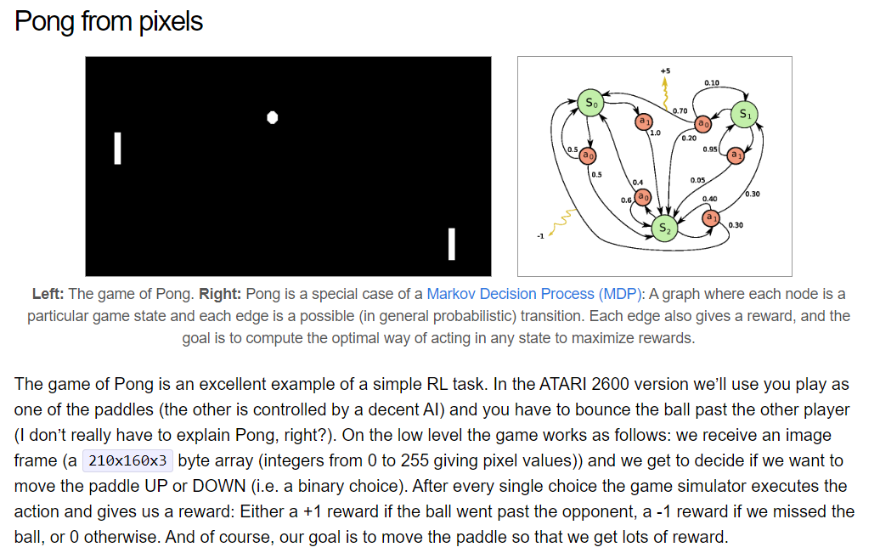

The text describes Pong as a classic example of a Markov Decision Process (MDP), a mathematical framework for modeling decision-making scenarios. MDPs offer a structured approach to analyzing problems involving sequential decision-making with rewards. Here's a breakdown of how Pong exemplifies an MDP:

**States**: MDPs encompass a set of possible states the system can occupy. In Pong, a state could represent the entire game configuration, including:

The ball's position (x and y coordinates)

The paddles' positions (y coordinates for each paddle)

The current score

**Actions:** MDPs define a set of actions the agent can take in each state. In Pong, the agent (the learning algorithm) controls one paddle and can perform two actions:

Move the paddle up

Move the paddle down

**Transitions:** MDPs consider the potential transitions between states resulting from the agent's actions. The probability of transitioning to a new state depends on the current state and the chosen action. For instance, in Pong:

If the agent moves the paddle up in a specific state (current ball position and paddle position), there's a probability the ball will bounce upwards off the paddle, another probability it'll bounce downwards, and a third probability it might miss the paddle entirely.



Rewards: MDPs incorporate rewards assigned to the agent for taking actions in specific states. In Pong, the rewards incentivize the agent to achieve the game's objective:

Positive reward (+1): The agent earns a reward when it scores a point by the ball passing the opponent's paddle.

Negative reward (-1): The agent receives a penalty for missing the ball, allowing it to hit the wall on its side.

The core objective in an MDP is for the agent to learn a policy, a mapping mechanism that dictates the optimal action to take in a given state. This policy should be designed to maximize the agent's cumulative reward over time.

**Why Pong is Suitable for Reinforcement Learning (RL)**

The text emphasizes Pong's suitability as a foundational RL task due to several factors:

Tractable State Space: Compared to more complex environments, Pong's state space, the collection of all possible states, is relatively small. This characteristic makes it computationally feasible to explore all possible states and develop an effective policy.

Discrete Action Set: The agent's actions in Pong are limited to moving the paddle up or down. This finite set of discrete actions simplifies the learning process compared to scenarios with continuous action spaces.



Clear Reward Signal: The rewards in Pong (+1 for a point, -1 for missing the ball) are unambiguous and directly tied to the game's objective. This well-defined reward structure facilitates learning for the RL algorithm.

In essence, Pong's well-defined state space, action set, and reward system make it an approachable environment for an RL agent to grasp the core concepts of reinforcement learning.

Beyond the Basics: Policy Gradients and Learning from Scratch

The latter part of the text delves into Policy Gradients, a specific RL approach, and the author's intention to implement it from scratch to train a program to play Pong. Here's a deeper look at these aspects:

Policy Gradients: This RL method directly optimizes the agent's policy to maximize the anticipated reward. It offers an advantage because it aligns with the ultimate goal: maximizing the reward signal.

Learning from Scratch: By building an RL agent from scratch to control a Pong paddle using Policy Gradients, the author intends to illustrate the practical application of this RL technique in a game-playing scenario. This hands-on approach reinforces the theoretical understanding of Policy Gradients.

In conclusion, the section sheds light on how Pong's properties make it a valuable tool for understanding the fundamentals of RL through MDPs and implementing specific RL algorithms like Policy Gradients.

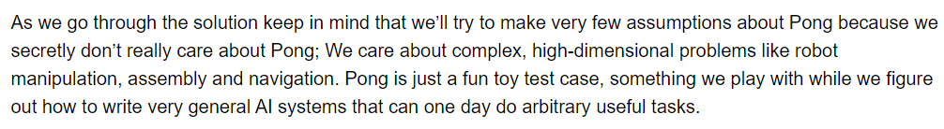

The text discusses the idea that while Pong may seem like a simple game, it can be a useful tool for introducing complex artificial intelligence (AI) concepts.

Here's a breakdown of the key points:

Making AI Less Abstract: The text acknowledges that AI can be a vast and abstract field. By using Pong as a starting point, the authors aim to make core AI concepts more relatable and easier to understand.

Pong as an Exemplar: The text describes Pong as a microcosm of the real world, highlighting that even seemingly simple games like Pong involve perception, decision-making, and motor control – all crucial aspects of AI.

Learning from Scratch: The authors emphasize the value of building an AI system from scratch to tackle Pong. This hands-on approach fosters a deeper understanding of the underlying algorithms and how they work together to achieve a goal.

Building Blocks of Intelligence: Through the process of creating an AI agent to play Pong, learners will encounter fundamental AI concepts like:

Perception: The ability to interpret sensory information, which in Pong could involve tracking the movement of the ball and paddle.

Decision-Making: Selecting the most appropriate action based on the perceived state of the game, such as moving the paddle up or down.

Motor Control: Executing the chosen action, in this case, precisely controlling the movement of the Pong paddle.

Real-World Applications: The text concludes by mentioning that the skills developed through tackling Pong with AI can be applied to more complex real-world scenarios. By grasping the fundamentals of perception, decision-making, and motor control in a simplified environment, learners can build a foundation for understanding and creating AI solutions for more intricate tasks.

In essence, the text promotes using Pong as a stepping stone to introduce core AI concepts and provide a practical learning experience through building an AI agent from scratch.

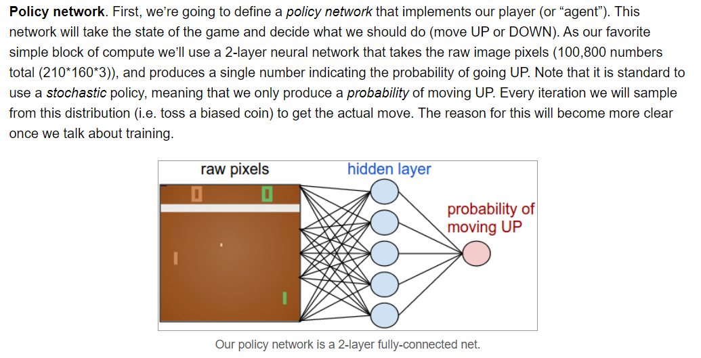

Policy Network: As discussed earlier, a policy network is a neural network that takes the state of the environment (all the relevant information at a specific point in time) as input and outputs the probability of taking a particular action. In this case, the environment is the Pong game, and the actions are moving the paddle up or down.

2-Layer Neural Network: The text describes a policy network with two layers. A neural network is a computer program inspired by the structure and function of the human brain. It consists of interconnected nodes (artificial neurons) that process information. Layers refer to how these nodes are arranged. In a 2-layer network, there's an input layer, an output layer, and potentially a hidden layer in between.

Raw Pixels: The input layer of this policy network receives the raw pixels from the Pong game as input. This means the network sees the game exactly as we do on the screen, with each pixel represented by a number indicating its brightness or color.

Hidden Layer: The text mentions a hidden layer with 100 nodes. This layer processes the information received from the input layer (raw pixels) and transforms it into a format suitable for the output layer. The workings of this hidden layer are complex, but it essentially extracts important features from the image (like the position of the ball and the paddle) to help decide which action to take.

Output Layer: The output layer of this policy network has just one node, which calculates the probability of moving the paddle up. Since moving down is the other possible action, the probability of moving down can be derived by subtracting the probability of moving up from 1 (100%).



Stochastic Policy: As mentioned before, this policy network outputs a probability, not a definitive up or down command. This is because using a stochastic policy allows the agent to explore different actions and learn from the outcomes over time.

In summary, the text describes a simple policy network using a 2-layer neural network to process the raw pixels of the Pong game and determine the probability of moving the paddle up. This is a basic example to illustrate the concept of policy networks in reinforcement learning.

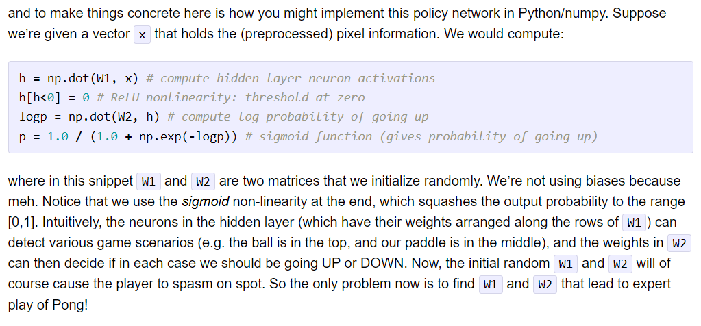

Here's a breakdown of the formula and the surrounding text:

**Sigmoid Activation Function**: An activation function is a mathematical function used in neural networks to introduce non-linearity into the network's output. Non-linearity is important because it allows the network to learn complex patterns in the data. The sigmoid function specifically maps its input values into a range between 0 and 1, which is ideal for representing probabilities (0 means "never" and 1 means "always").

**Non-linearity**: In the context of neural networks, non-linearity refers to the ability of a network to model complex relationships between its inputs and outputs. Here's a breakdown of why it's crucial:

**Linear vs. Non-linear Relationships**: Imagine a straight line. That's a simple example of a linear relationship, where a constant change in one variable leads to a constant change in another. However, many real-world relationships are not linear. For instance, as you study more hours for a test, your score might not increase at a constant rate. It might improve slowly at first, then more rapidly as you grasp the concepts, and then plateau as you reach your peak understanding.

**Limitations of Linear Models**: If a neural network only has linear relationships between its layers (like a straight line through all the nodes), it can only learn very basic patterns. It wouldn't be able to capture the complexities of real-world data, where there are often curves, bends, and intricate dependencies.



**Importance of Non-linearity**: Non-linearity allows neural networks to learn these intricate patterns. By introducing non-linearity through activation functions like sigmoid (used in the formula you saw), the network can model more complex relationships between its inputs and outputs. This enables it to learn sophisticated tasks like image recognition, speech understanding, and game playing (like playing Pong!).

Here's an analogy: Imagine you're trying to fit a curved puzzle piece into a flat surface. A flat tool wouldn't work, but a tool with bends and curves could match the puzzle piece's shape perfectly. Similarly, non-linearity gives neural networks the flexibility to adapt to the intricate shapes of real-world data.

**Understanding the Formula**

The formula calculates the probability (p) of moving the paddle up based on the weighted sum of the inputs (x) to the output layer. Here's a breakdown of the mathematical notation:

h = W1 * x: This part calculates a weighted sum of the inputs (x) to the output layer.

W1 represents the weights of the connections between the hidden layer and the output layer. These weights are like tuning knobs that the network learns to adjust during training.

x represents the input vector to the output layer, which likely contains features extracted from the raw Pong game pixels by the hidden layer (e.g., the relative positions of the ball and paddle).

h[h < 0] = 0: This line applies a threshold function to the weighted sum (h). Any value in h less than zero is set to zero. This essentially introduces a non-linearity (because a straight line wouldn't have this threshold behavior) and helps push the output of h towards positive values.



log(p) = W2 * h: This part calculates the log probability (log(p)) using another weighted sum.

W2 represents the weights between the output node and the hidden layer (there's typically just one node in the output layer for a binary decision like up or down).

p = 1 / (1 + exp(-log(p))) : This final step uses the log probability (log(p)) to calculate the actual probability (p) of moving the paddle up. It does this by applying the sigmoid function (exp(-x) / (1 + exp(-x))). The sigmoid function takes any real number as input and squishes it between 0 and 1, making it suitable for representing probabilities.

Summary

The formula translates the weighted input signals from the hidden layer into a probability between 0 (never move up) and 1 (always move up) using a sigmoid activation function. This probability will be used by the policy network to decide whether to move the paddle up or down (by comparing the probability to a random number).



Understanding the Snippet

The snippet talks about using a stochastic policy network, which means the network outputs a probability for an action (like moving the paddle up in Pong) instead of a guaranteed up or down command. This is why the text mentions sampling from the probability distribution.

Here's a breakdown of the process mentioned in the snippet:

Forward Pass: The agent (policy network) receives the current state of the environment (Pong game) as input and calculates the probability of moving the paddle up (using the formula you saw previously).

Sampling from Probability Distribution: Instead of directly using the calculated probability (let's call it P(up)), the text suggests sampling from a probability distribution with P(up) as the mean. Imagine this probability distribution as a bell curve centered at P(up). Sampling from this distribution means randomly selecting a value from this curve.

Action Based on Sample: Depending on the sampled value (which will be close to P(up) most of the time, but could be slightly higher or lower due to the random nature of sampling), the agent decides whether to move the paddle up or down.

Why Sample from the Probability Distribution?

There are two main reasons why the text recommends sampling from the probability distribution, even though the policy network already calculates a probability:

Exploration vs. Exploitation: In RL, there's a balance between exploration (trying new actions) and exploitation (focusing on actions that have proven rewarding in the past). By introducing randomness through sampling, the agent explores different actions occasionally, even if they seem less likely to be optimal based on the calculated probability. This exploration can help the agent discover new strategies or unexpected rewards in the environment.

Gradient Smoothing: During training, the policy network's weights are adjusted based on the difference between the predicted reward and the actual reward received. When the agent directly uses the calculated probability (P(up)) for moving the paddle up or down, the gradient (the measure of how much to adjust the weights) can be very sharp, making it difficult for the training process to converge smoothly. Sampling from the distribution introduces a slight randomness that helps smooth out the gradients and can lead to more stable training.

In essence, sampling from the probability distribution during training with a stochastic policy network helps encourage exploration and facilitates smoother learning for the policy network.

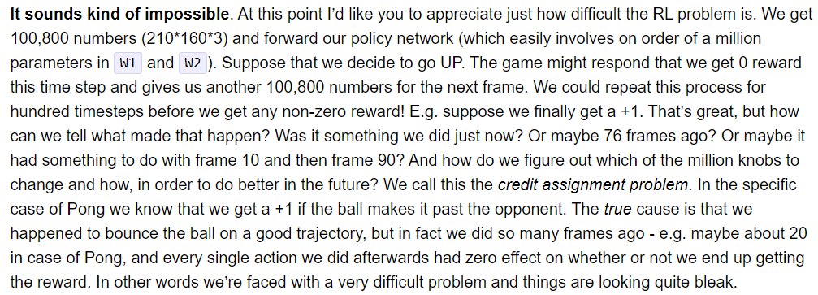

The text describes how the reward signal is used to train the policy network in a step-by-step manner:

**Simulate an Episode**: An episode refers to a single run or game of Pong. The agent (policy network) interacts with the environment (Pong game) by playing the game until it ends (winning a point, losing a point, or reaching a time limit).

**Observe Transitions**: During each step of the episode, the agent observes the state of the environment (the current screen of the Pong game) and takes an action (move the paddle up or down based on the probability calculated by the policy network).

**Record Transitions**: The text mentions keeping track of the transitions experienced by the agent. A transition typically includes the state, the action taken, and the resulting reward received.

**Calculate Total Reward**: Once the episode is complete (game ends), the agent calculates the total reward it received for the entire episode (sum of all the rewards throughout the game). This total reward serves as the overall performance metric for that episode.

**Policy Gradient Update**: Here's where the recorded transitions come into play. The text mentions using a policy gradient update rule to adjust the weights of the policy network. This update rule essentially strengthens the connections in the network that led to actions that resulted in higher rewards during the episode, while weakening connections that resulted in lower rewards.

Policy Gradient Updates in More Detail:

Policy gradient update rules are a core concept in training policy networks for RL. Here's a simplified explanation of how they work:

**Gradients**: Imagine a landscape with hills and valleys. A gradient points you in the direction of the steepest ascent. In the context of neural networks, gradients indicate how much to adjust the weights of the network to move towards a higher reward (like climbing a hill).



**Backpropagation**: This is a common technique used to calculate gradients in neural networks. It essentially works by propagating the error (difference between predicted reward and actual reward) backwards through the network, allowing adjustments to the weights in proportion to their contribution to the error.

**Policy Gradient in this Context**: In the context of the text, the policy gradient update rule considers the recorded transitions from an episode and the total reward received. It uses backpropagation to calculate how much each weight in the policy network contributed to the total reward. Based on these contributions, the weights are adjusted to strengthen the connections that led to higher rewards and weaken those that led to lower rewards.

**The Challenge: Which Actions Deserve Credit?**

Imagine an agent is playing a game like Pong. It wins a point. The agent receives a positive reward signal, but the question arises: Which actions during the entire game actually contributed to winning that point?

* Was it the last paddle movement that hit the ball just right?
* Or was it a series of good paddle movements throughout the rally that kept the ball in play?
* Perhaps some earlier defensive blocks prevented the opponent from scoring and set up the winning opportunity?

The credit assignment problem lies in determining how much credit (positive reinforcement) to assign to each action the agent took during the episode (game) that ultimately led to the reward (winning the point).

Challenges in Assigning Credit

There are several reasons why assigning credit can be difficult:



**Delayed Rewards**: In many RL scenarios, rewards are not received immediately after an action. They might come much later after a sequence of actions. For instance, in Pong, defensive blocks might not directly result in a reward, but they set the stage for a later winning move.

**Long Action Sequences**: Real-world tasks often involve long sequences of actions before a reward is received. Attributing the reward solely to the most recent action is inaccurate.

Policy Gradients and Credit Assignment

The text focuses on training a policy network using policy gradients. While policy gradients are a powerful approach, they can also be susceptible to the credit assignment problem. Here's why:

**Focus on Recent Actions**: Policy gradients typically use the total reward from an episode and backpropagate the error through the network. This can lead to a stronger emphasis on the most recent actions, potentially neglecting the contributions of earlier actions in the sequence.

By understanding and potentially mitigating the credit assignment problem, RL algorithms can become more efficient at learning complex tasks that involve long sequences of actions and delayed rewards.

**Summary**

The text describes how the policy network is trained through a process of playing the Pong game (simulating episodes), recording its experiences (transitions), and using the reward signal (total episode reward) to adjust the network's weights through policy gradient updates. By iterating through this process, the policy network progressively learns to take actions that maximize its reward (winning Pong games).

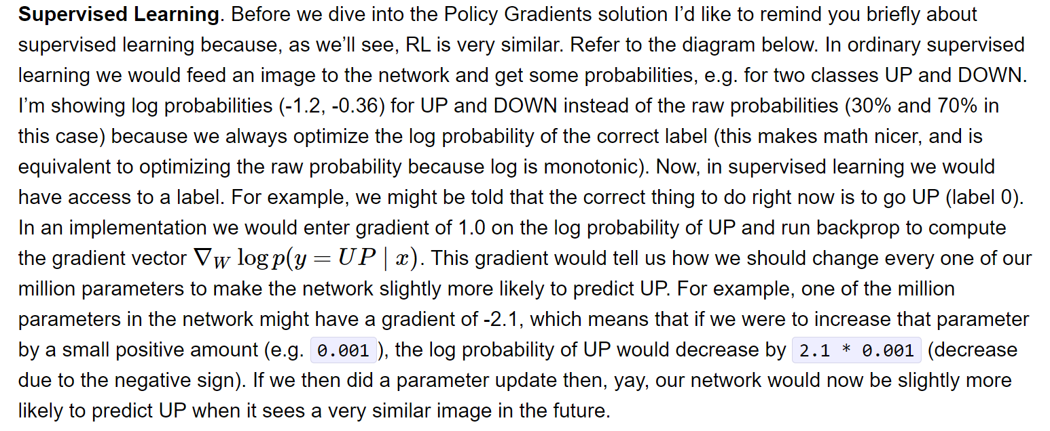

In supervised learning, a machine learning model is trained on a dataset of labeled examples. Each instance consists of an input and a corresponding desired output. The model is essentially learning to map the inputs to the outputs by fine-tuning its internal parameters based on the provided training data. For instance, a supervised learning model can be trained to identify handwritten digits by being presented with numerous images of handwritten digits, each labeled with the correct digit.

On the other hand, reinforcement learning is a type of machine learning where an agent learns through interacting with its environment. The agent receives rewards or penalties for the actions it takes, and it strives to learn actions that maximize its long-term reward. The blog post mentions policy gradients, a common method for training reinforcement learning agents.

The provided excerpt centers on the parallels between supervised learning and RL. In supervised learning, the model is given a label, which acts as the correct output for a specific input. Conversely, in RL, the agent doesn't receive a label but gets a reward signal indicating how positive or negative its most recent action was. The agent can then leverage this reward signal to update its internal parameters in a way that ideally results in greater rewards in the future.

**Log probabilities**: These represent the probabilities of an event occurring, expressed in logarithms. They are employed in supervised learning because, mathematically, they are more convenient to work with than raw probabilities.

**Gradient**: This refers to a mathematical vector that points in the direction of a function's steepest ascent. In the context of machine learning, gradients are instrumental in updating a model's parameters to enhance its performance.

**Backprop**: Short for backpropagation, it's a widely used algorithm for training neural networks. It accomplishes this by calculating the gradient of the error function with respect to each of the network's parameters. This gradient can then be used to update the parameters in a way that reduces the error.

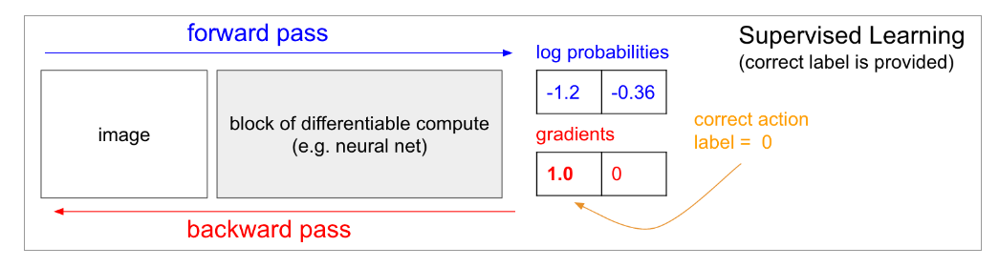

Forward pass: This signifies the initial passage of data through a neural network, where the input data is processed through the network's layers to generate an output.

Log probabilities: These represent the probabilities of an event occurring, expressed in logarithms. They are employed because, mathematically, they are more convenient to work with than raw probabilities.

Supervised Learning (correct label is provided): This indicates that the model is being trained with supervised learning, where it receives labeled data (inputs with corresponding correct outputs). In the image, the correct label is 0.

Block of differentiable compute gradients: This refers to the calculation of gradients within a neural network. Gradients are mathematical vectors that specify the direction of a function's steepest ascent. In neural networks, they are used to update the network's parameters during the backward pass.

Correct action: This signifies the action that the agent should take based on the input and the provided correct label.

Backward pass: This represents the backward propagation of errors through the neural network. It's a technique used to update the network's parameters based on the gradients calculated during the forward pass. The goal is to minimize the difference between the network's output and the desired output (correct label).

Key Points

The image illustrates how supervised learning with a neural network can be used to assign labels or categories to data. The forward pass calculates the probabilities of the input belonging to various categories, while the backward pass refines the network’s parameters to enhance its accuracy in assigning labels.

In essence, the image depicts the inner workings of a neural network during supervised learning where it is trained on labeled data to produce accurate outputs.

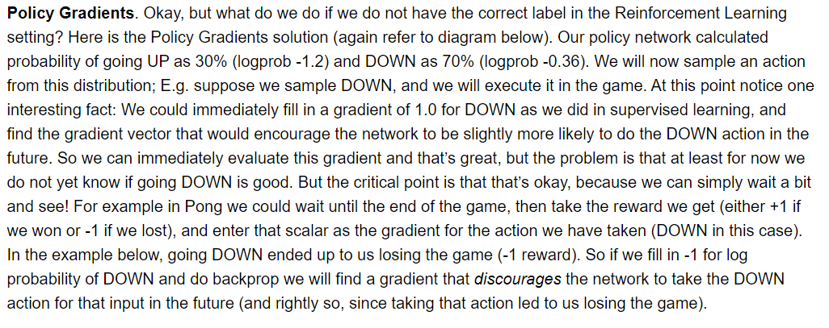

Policy Network: The RL agent has a policy network that takes the current state of the environment as input (e.g., the position of the ball in Pong) and outputs the probability of taking each possible action (e.g., moving the paddle up or down).

**Action Selection**: The agent samples an action from this probability distribution (e.g., up or down).

**Reward Signal**: The agent takes the action in the environment and observes the reward. This reward signal is a key aspect of RL; it tells the agent how well it’s doing without explicitly telling it what action to take. In the example of Pong, the reward might be +1 for winning the game and -1 for losing.

**Policy Update**: Here’s where policy gradients come in. Although the agent doesn't have labels for each state-action pair (like it does in supervised learning), it can use the reward signal to update its policy network. The policy gradient is calculated based on the reward and encourages the network to take actions that led to higher rewards in the past.

Policy Network Output: The policy network calculates the probability of moving the paddle up (30%) and down (70%).

**Action Selection**: The agent samples an action, suppose it picks down (70% probability).

**Action Execution**: The agent executes the action (moves down).

**Reward Signal**: The agent observes the outcome: suppose the agent loses the game after moving down (negative reward -1).

**Policy Update**: This negative reward is used to update the policy network in a way that discourages the network from moving down in similar situations in the future. Essentially, the policy gradient tells the network that this action led to a bad outcome (losing the game), so the network should be less likely to take that action again in similar situations.

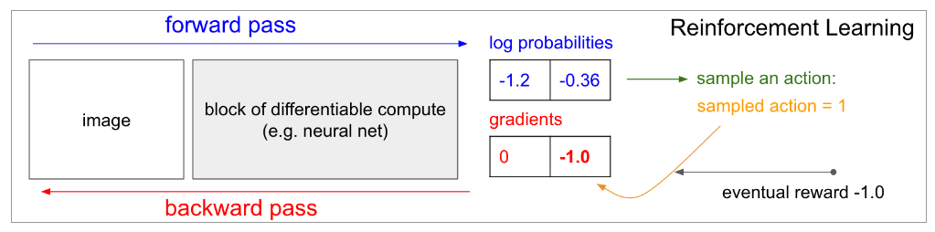The diagram depicts the core components of the policy gradients algorithm and the data flow through them. Here’s a breakdown of the different parts:

**Block of differentiable compute (e.g. neural network)**: This is the agent’s policy network, which takes the current state of the environment as input and outputs a probability distribution over the possible actions the agent can take. The network is differentiable, meaning the gradients can be calculated for its weights with respect to the output.

**Forward pass**: This refers to the initial propagation of data through the neural network. The input to the network is the current state of the environment, which could be a vector of numbers representing various aspects of the environment. For instance, in the Pong example, the state might include the vertical position of the ball and the agent’s paddle. The output of the network is a probability distribution over the possible actions the agent can take. In Pong, this might be the probability of moving the paddle up or down.

**Log probabilities**: These are the logarithms of the probabilities assigned by the policy network to each action. Because they are more mathematically convenient to work with than the raw probabilities, especially when calculating gradients, log probabilities are often used instead of raw probabilities in policy gradient algorithms.

**Sample an action**: Based on the probability distribution outputted by the policy network, an action is chosen. This can be done using a random number generator. For example, if the network outputs a 70% probability of moving the paddle up and a 30% probability of moving the paddle down, a randomly generated number between 0 and 1 would be compared to the cumulative probabilities. If the number is less than 0.7, the agent would move the paddle up. Otherwise, it would move the paddle down.

**Eventual reward**: This refers to the reward signal received by the agent after taking an action in the environment. The reward can be positive or negative. In Pong, the agent receives a positive reward for scoring a point and a negative reward for losing a point.

**Backward pass**: This refers to the propagation of the error signal backwards through the network. The error signal is calculated based on the difference between the eventual reward received by the agent and the expected reward, which is a function of the state and the agent’s policy. The backward pass uses backpropagation, a common technique in neural networks, to compute the gradients of the error signal with respect to each weight in the network.



**Gradients**: These are the calculated values that indicate how much the error changed with respect to each weight in the network. These gradients are used to update the weights of the network in a way that will improve the agent’s policy over time. By following the gradients, the weights are adjusted such that the agent is more likely to take actions that lead to higher rewards in the future.

**Policy Improvement**

The core idea behind policy gradients is to iteratively improve the agent’s policy through the following steps:

1. The agent takes an action in the environment based on the current policy.
2. The agent receives a reward signal from the environment.
3. The reward signal is propagated back through the network to compute the gradients.
4. The weights of the network are updated using the gradients.
5. Steps 1-4 are repeated.

Over time, as the agent continues to explore the environment and receive rewards, the policy network is updated to favor actions that lead to higher rewards.

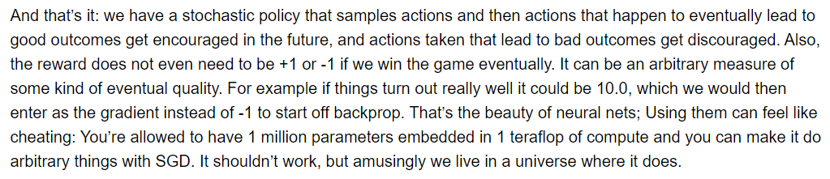

**Policy**: A policy in reinforcement learning refers to a mapping from states to actions. It essentially dictates how the agent should behave given a specific situation (state) in the environment. The agent aims to learn a policy that maximizes its expected reward over time.

**Stochastic Policy**: A stochastic policy incorporates randomness when selecting actions. This means the agent might choose a different action even in the same state, depending on the outcome of a probability distribution.

**Reward Signal**: The reward signal is a feedback mechanism that the agent receives from the environment based on the actions it takes. Positive rewards indicate desirable actions, while negative rewards signify unfavorable actions.

**Gradient**: The gradient is a mathematical concept that indicates the direction of the steepest ascent of a function. In the context of policy gradients, the gradient points towards the update to the policy that is most likely to result in a higher expected reward.

**Backpropagation**: Backpropagation is an algorithm commonly used for training neural networks. It calculates the gradient of a function efficiently, which in policy gradients translates to determining the gradient of the expected reward with respect to the policy parameters (weights of the neural network).

**SGD (Stochastic Gradient Descent)**: SGD is an optimization algorithm that iteratively updates parameters in the direction of the gradient. In policy gradients, SGD is used to update the policy parameters (weights of the neural network) towards a direction that is expected to increase the expected reward.

**Benefits of Policy Gradients**

**Direct Policy Optimization**: Policy gradients directly optimize the policy function, making them applicable to various reinforcement learning problems.

**Flexible Policy Representation**: Policy gradients can work with different policy function representations, including neural networks, which allows for complex and non-linear policies.

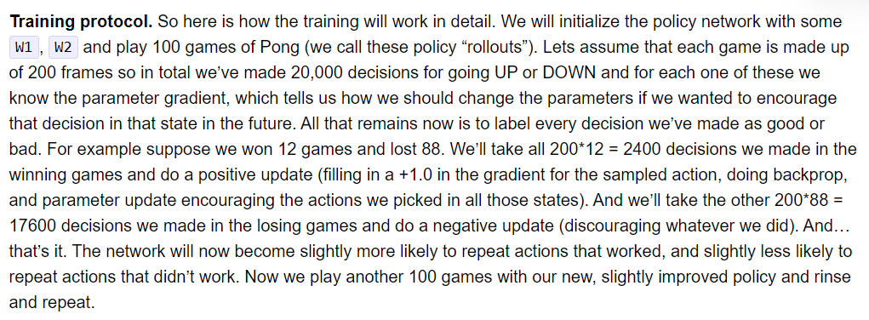The training protocol refers to the process of training the neural network to play Pong. Here are the steps involved:

1. **Initialize the policy network**: This involves setting the initial weights and biases of the neural network. These weights and biases are what the network will use to learn how to play Pong.
2. **Play games of Pong**: The neural network plays a number of games of Pong (100 in the example). Each game is called a policy rollout.
3. **Calculate the parameter gradien**t: For each decision (moving the paddle up or down) made by the network during a game, the parameter gradient is calculated. The parameter gradient tells you how much you should change the weights and biases of the network in order to encourage the network to make that decision again in the future.
4. **Label decisions as good or bad**: After all the games have been played, each decision made by the network is labeled as good or bad. A decision is considered good if it was made during a game that the network won. Conversely, a decision is considered bad if it was made during a game that the network lost.
5. **Update the network**: The weights and biases of the network are updated based on the labels assigned to each decision. Decisions that were labeled good are encouraged by making small changes to the weights and biases in the direction of the parameter gradient. Decisions that were labeled bad are discouraged by making small changes to the weights and biases in the opposite direction of the parameter gradient.
6. **Repeat**: Steps 2-5 are repeated. The network plays another 100 games of Pong, and then the weights and biases are updated again based on the results of those games. This process is continued for many iterations until the network learns to play Pong well.

In simpler terms…

The training protocol is a step-by-step process for teaching a neural network how to play Pong. The network starts out by knowing nothing about how to play the game. Then, it plays a bunch of games and learns from its mistakes. After each game, the network is rewarded for the good decisions it made and penalized for the bad decisions it made. Over time, the network learns to make better and better decisions, until eventually it becomes a skilled Pong player.

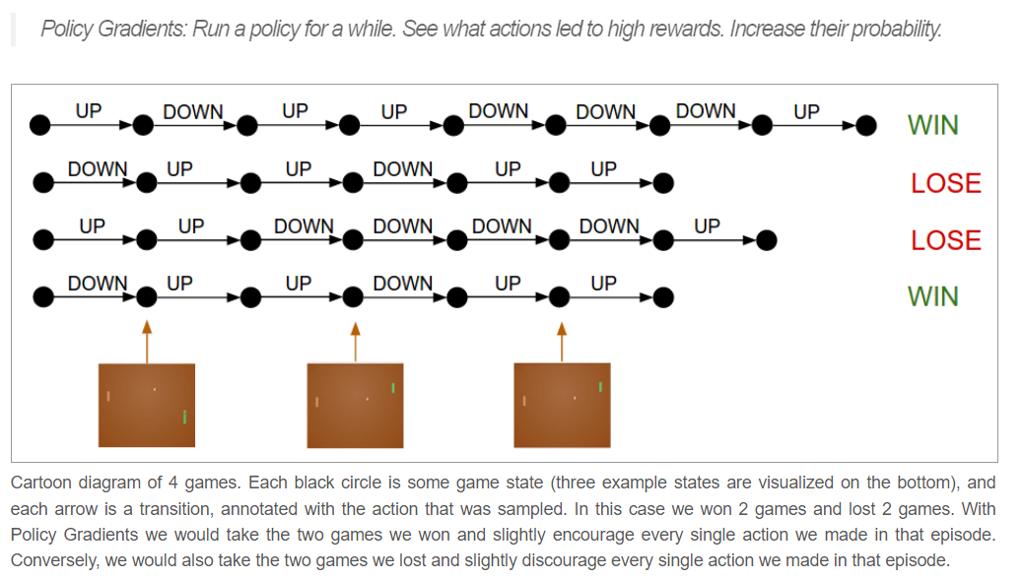  
The diagram shows four games of Pong. Each black circle represents a state in the game, and the arrows show the transitions between states, labeled with the action taken (up or down). The text explains that two games were won and two were lost.

Here are some of the reinforcement learning terms used in the diagram and the blog post:

* Policy: A policy is a strategy that the agent uses to decide what action to take in a given state. In the case of Pong, the policy would decide whether to move the paddle up or down.
* Action: An action is a specific thing that the agent can do in the environment. In Pong, the agent can move the paddle up or down.
* State: A state is a snapshot of the environment at a particular point in time. In Pong, the state would include the position of the ball and the paddle.
* Reward: A reward is a signal that the agent receives from the environment to indicate how well it is doing. In Pong, the agent would receive a reward for winning the game and a penalty for losing the game.

Policy gradients are a reinforcement learning algorithm that can be used to train an agent to improve its policy over time. The algorithm works by evaluating the agent's current policy and then making adjustments to the policy in order to increase the likelihood of the agent taking actions that lead to high rewards.

In the context of the diagram, the agent would use the results of the four games to update its policy. For the two games that were won, the agent would increase the probability of taking the actions that it took in those games. For the two games that were lost, the agent would decrease the probability of taking the actions that it took in those games.

By iteratively updating its policy in this way, the agent can learn to improve its performance over time.

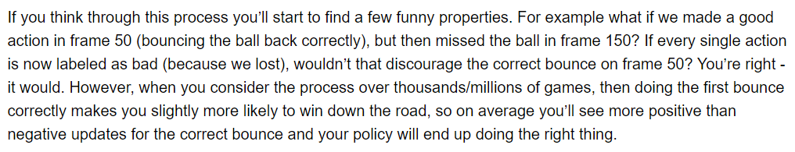

The agent receives rewards for good actions and penalties for bad actions, and it learns to take actions that maximize its rewards.

In the context of the blog post, the agent is the neural network, and the environment is the Pong game. The agent receives a reward of 1 for winning a point and a reward of 0 for losing a point. The agent learns by trial and error, and it eventually learns to play Pong at a superhuman level.

The text is discussing one of the challenges of reinforcement learning. The challenge is that the agent may take a good action early on in a game, but then later take a bad action that leads to the agent losing the game. In this case, the agent will receive a negative reward, even though the good action early on in the game actually helped the agent to win.

The text says that this is a problem because the agent may learn to avoid taking the good action early on in the game, even though it is actually a good action. This is because the agent is only considering the reward it received at the end of the game, and it is not considering the fact that the good action early on in the game helped it to win.

The solution to this problem is to use a technique called credit assignment. Credit assignment is a technique that allows the agent to assign credit for the reward it receives to the actions that it took earlier on in the game. In this way, the agent can learn that the good action early on in the game was actually a good action, even though it did not lead to an immediate reward.

In the blog post, Karpathy discusses a specific technique for credit assignment called temporal difference learning. Temporal difference learning is a technique that allows the agent to estimate the future rewards that it will receive by taking a particular action. In this way, the agent can learn to take actions that will lead to positive rewards in the long run, even if they do not lead to immediate rewards.

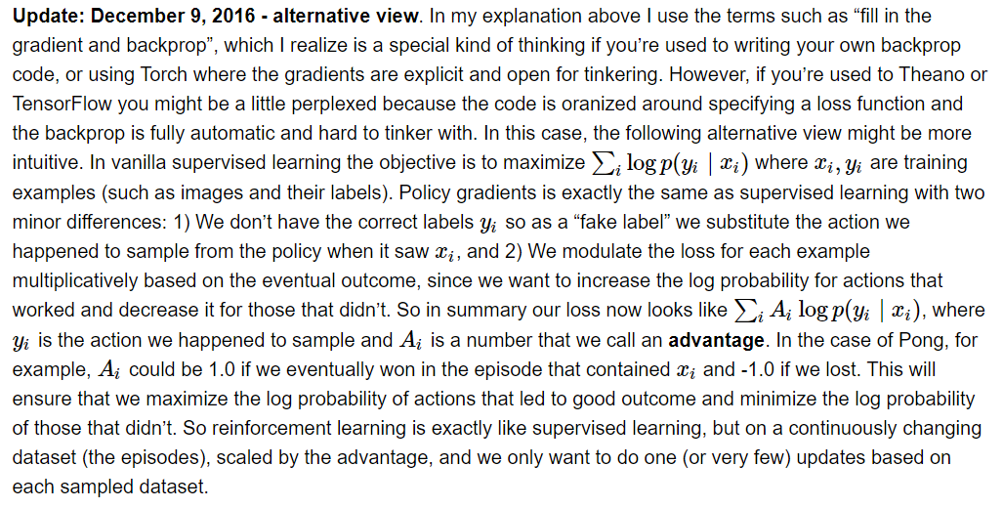

In the update, Karpathy addresses the concept of policy gradients and how it can be understood from the perspective of supervised learning.

Backpropagation and Deep Learning Frameworks:

Backpropagation is a common algorithm used in training neural networks. It refers to the process of propagating the error signal backward through the network in order to adjust the weights of the neurons. This process allows the network to learn from its mistakes and improve its performance on future tasks.

Deep learning frameworks such as Theano and TensorFlow provide automatic differentiation, which simplifies the computation of gradients and alleviates the need for manual backpropagation code. Gradients are essential for various optimization algorithms used in machine learning to update the parameters (weights and biases) of a model. By automatically computing these gradients, deep learning frameworks significantly streamline the training process.

Policy Gradients as Supervised Learning with Advantages:

The text explains that policy gradients, a reinforcement learning technique, can be formulated as a form of supervised learning with two key distinctions.



Supervised Learning vs. Reinforcement Learning:

In supervised learning, a dataset of training examples (xi), (yi) is provided, where (xi) is the input and (yi) is the desired output or label for that input. The goal is to train a model to map unseen inputs to the correct outputs. For instance, an image classification model can be trained on a dataset of labeled images, where each image is an input (xi) and its corresponding label (yi) is the category of the object depicted in the image.

In contrast, reinforcement learning involves an agent interacting with an environment. The agent receives rewards or penalties for the actions it takes, and it must learn to take actions that maximize its long-term reward. Unlike supervised learning, where the correct labels are readily available, the agent in reinforcement learning must learn by trial and error through exploration and interaction with the environment.

Difference 1: Missing Labels and Actor-Critic Distinction:

In policy gradients, unlike supervised learning, the correct labels (yi) are not available beforehand. Instead, a “fake label” is used, which is the action (ai) that the agent took given the state (xi) it observed. This highlights the distinction between actor-critic methods in reinforcement learning.

In this case, the policy gradient method acts as the actor, choosing actions based on the current state. The actor can be implemented as a neural network that takes the state of the environment as input and outputs the probabilities of taking different actions.



The advantage function serves as the critic, evaluating the quality of those actions. The critic estimates the advantage, which is the difference between the long-term reward that the agent expects to receive by taking a particular action and the average reward the agent would receive in that state.

Difference 2: Advantage Function:

The second difference is that the loss for each example (i) is weighted by a value called the advantage (Ai). The advantage function measures how much better or worse the chosen action was compared to the average action. This helps the model focus on learning from the actions that led to positive outcomes and avoid the ones that resulted in negative outcomes.

The advantage function allows the policy gradient method to learn from the rewards it receives throughout an entire episode (a sequence of interactions with the environment) rather than just the immediate reward for a single action. This enables the agent to learn long-term strategies that can lead to higher rewards in the future.

Policy Gradient Loss:

The update provides an equation for the policy gradient loss function which incorporates these two modifications to supervised learning.

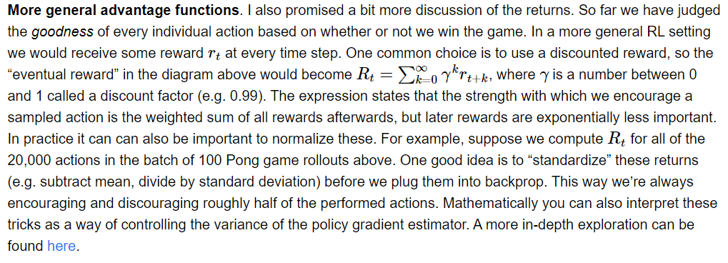

The text discusses discounted rewards and return normalization in the context of policy gradients and advantage functions.

**Discounted Rewards**

In reinforcement learning, unlike supervised learning where the desired output or label for each training example is readily available, rewards are often received sparsely throughout an episode (a sequence of interactions with the environment), and rewards obtained later tend to be less valuable to the agent than immediate rewards. Discounted rewards address this by exponentially decreasing the weight of future rewards. This makes the agent focus more on the rewards it expects to receive in the immediate future, while still considering the potential benefits of long-term rewards.

The formula used for calculating the discounted reward is *krt+k*, where:

* *Rt* represents the total discounted reward.
* *rt*​ denotes the reward received at time step *t*.
* *γ* is the discount factor, a value between 0 and 1 (often set to 0.99). The discount factor determines how much importance is placed on future rewards. A higher discount factor assigns greater weight to long-term rewards, while a lower discount factor prioritizes immediate rewards.

For instance, consider a game of Pong. Imagine the agent receives a reward of +1 for winning a point and a reward of 0 for every other timestep. With a discount factor of 0.99, the discounted reward for winning a point at timestep 100 would be 0.99^(100-1) = 0.36, whereas the discounted reward for winning a point at timestep 1 would be 0.99^(1-1) = 1.



**Why discounted rewards?**

Think about learning a new skill in the real world, like riding a bike. When you first start learning, you might get a small reward, like praise from a parent or coach, for even just sitting on the bike. These small, early rewards help you get started and learn the basic mechanics.

As you get better, the focus shifts to bigger rewards, like being able to ride down the street. But you probably wouldn’t get a huge reward for riding down the street if you hadn’t already learned the basics first, like balancing and pedaling.

Discounted rewards work in a similar way. By giving the agent more credit for earlier rewards, the agent is encouraged to learn the fundamental steps that will eventually lead to a big reward.

**Standardizing the Rewards**

The text also mentions that it can be helpful to standardize the rewards before feeding them into the computer program that’s training the agent. This means subtracting the average reward from each reward and then dividing by the standard deviation. This helps the training process work better because it makes the rewards easier to compare to each other.

Imagine you’re training an agent to play two different games, Game A and Game B. In Game A, the agent gets a reward of either 0 or 10. In Game B, the agent gets a reward of either 0 or 100. Even though the rewards in Game B are much larger, the agent might actually learn more effectively from Game A. This is because the rewards in Game A are easier to distinguish between (a difference of 10) compared to the rewards in Game B (a difference of 100).

Standardizing the rewards helps to fix this problem by putting the rewards from both games on the same scale. This makes it easier for the training program to compare the rewards and learn which actions are more effective.

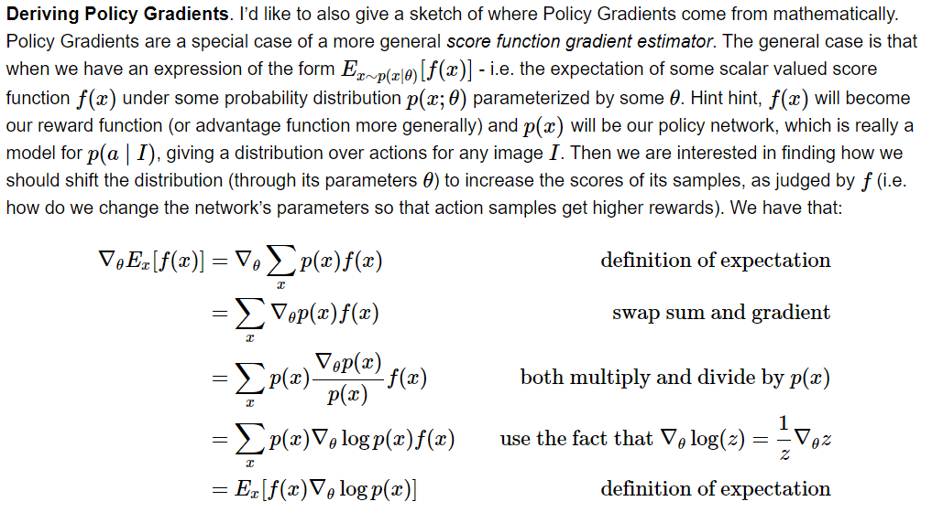

Understanding the Formulas

The formulas show how to calculate the policy gradient, which tells the agent how much to adjust its policy network to maximize its score.

Expectation (E): This represents the average score the agent expects to receive by following a particular policy. Imagine you train your dog to fetch 10 times. You might expect it to fetch successfully 7 times on average. This average score (7 out of 10) is the expectation.

Policy Network: This is a computer program that translates what the agent observes (like the position of the ball in Pong) into actions (moving the paddle up or down). The policy network assigns probabilities to different actions. For example, there might be a higher probability of moving the paddle up if the ball is high on the screen.

Score Function (f(x)): This function assigns a numerical value (score) to the outcome of an action the agent takes. Scoring high motivates the agent to take similar actions again. In Pong, the score could be +1 for hitting the ball and -1 for missing it.



Deriving the Policy Gradients

The formulas show how to find the policy gradient by taking the derivative of the expectation function with respect to the parameters (θ) of the policy network. Finding the derivative helps us understand how much a small change in the policy (represented by θ) will affect the expected score (E).

The first formula shows how to calculate the expectation (E) for a function (f(x)). It basically sums the score (f(x)) for each possible outcome (x), weighted by how probable (p(x)) that outcome is.

The subsequent formulas manipulate this formula to isolate the term that shows how the expected score changes when we tweak the policy network (θ).

In essence, these formulas take the complex idea of a policy gradient and break it down into smaller, more manageable steps that a computer can use to update the agent’s policy network, making it better at achieving its goal.

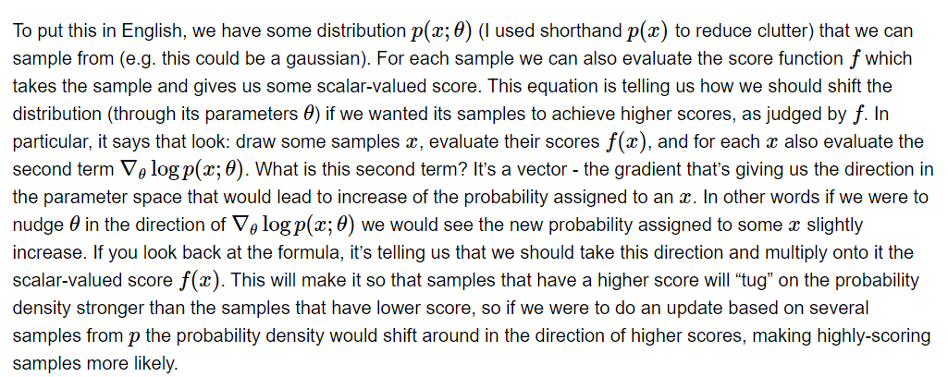

The text is explaining a mathematical formula used in policy gradients. Let's break it down step by step:

Probability Distribution: Imagine you have a bunch of data points, and these data points are scattered around according to a certain rule. This rule, or the way the data is spread out, is called a probability distribution. The equation refers to a specific probability distribution, written as p(x; θ), where x represents a data point and θ represents the parameters that define the rule (e.g., the mean and standard deviation for a normal distribution).

Sampling: The text says we can “sample” from this distribution. Sampling means randomly picking a data point according to the rule of the distribution. In other words, it’s like picking a point at random from the bunch of data points we imagined earlier.

Score Function (f): The text introduces a score function, denoted by f. This function takes a data point (x) as input and assigns a score to it. The score can be anything you want it to be, depending on the specific problem you’re trying to solve. In reinforcement learning, the score is usually a measure of how good or bad an action is for the agent.

Gradient: The part of the equation denoted by "Vlog p(x; θ)" is a bit more complex. It involves the gradient of the log of the probability distribution. A gradient is a mathematical concept that tells you in which direction a function is changing most rapidly. In this case, the gradient tells us how much changing the parameters (θ) of the distribution will change the probability of getting a particular data point (x).

  
**Intuition Behind the Formula**

The equation is saying that we should update the probability distribution to favor data points that have higher scores according to the score function (f). The update is done by considering both the score (f(x)) and the gradient (Vlog p(x; θ)).

Here's an analogy to understand this better: imagine you are training a dog to fetch a ball. Whenever the dog fetches the ball (good action), you give it a treat (high score). Over time, the dog will learn to associate fetching the ball with getting treats and will start doing it more often. This is similar to how the agent updates its policy (probability distribution) to favor actions that lead to higher scores.

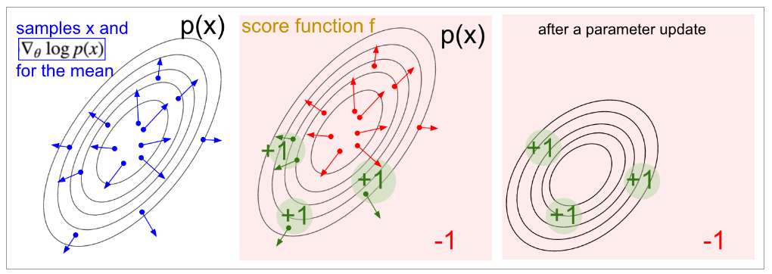

**Visualizing the Policy Update**

The image you sent provides a visual representation of the concept. The left side shows a probability distribution (the blue curve). The right side shows the same distribution after an update based on the policy gradient formula.

* **Green area:** This area represents the good actions (high scores according to the score function).
* **Red area:** This area represents the bad actions (low scores).

The update makes the probability distribution shift slightly to the right. This means the agent is now more likely to take the actions that were in the green area before (because they had higher scores). This is how the agent learns to favor good actions over time.

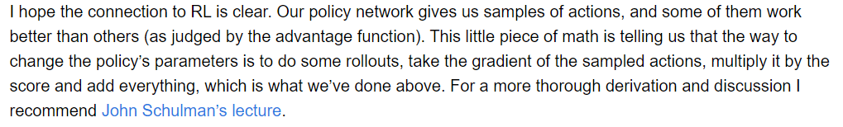

As a little recap…

Here are some explanations of the technical terms:

Policy network: This is a special kind of computer program that is designed to choose actions. In the case of Pong, the actions are things like moving the paddle up or down. The policy network tries to choose the actions that will lead to the agent winning the game.

Rollouts: This refers to playing the game from start to finish. In this context, it means that the agent plays Pong many times and the computer program keeps track of how well it does each time.

Gradient: This is a mathematical concept that is used to find the steepest path up a hill. In this context, the computer program is trying to find the changes to the policy network that will make it better at playing Pong. The gradient helps the computer program find the direction to make these changes.

Advantage function: This is a function that helps the computer program determine which actions were better than others. In Pong, the agent gets points for winning the game and loses points for losing. The advantage function helps the computer program understand which actions led to the agent getting more points.

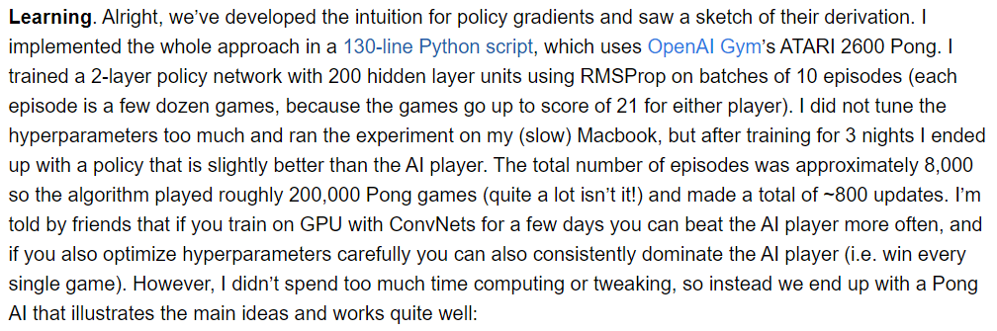 Training the Neural Network

The text describes how the author trained a neural network with two layers and 200 hidden units per layer to play Pong. A neural network is a computer program inspired by the structure of the brain. It is made up of interconnected nodes that process information. Each layer in a neural network performs a different stage of processing on the data it receives. Hidden layers are where most of the computation happens.

The training process involves showing the neural network many examples of Pong gameplay and giving it feedback based on its performance. In this case, the feedback is in the form of rewards (points) for winning the game and penalties for losing. The neural network uses this feedback to adjust its internal parameters, which are essentially the weights of the connections between its nodes. These weights determine how the network processes information and ultimately influence the decisions it makes (its policy) when playing the game.

OpenAI Gym's ATARI 2600 Pong

OpenAI Gym is a toolkit designed specifically for developing and comparing reinforcement learning algorithms. Atari 2600 is a classic video game console, and Pong is a simple game where two paddles hit a ball back and forth.

The Pong environment provides a controlled setting for the agent to learn. The agent can interact with the environment by moving its paddle up or down, and it receives a reward signal based on its success in keeping the ball in play. This reward signal helps the agent learn which actions are more likely to lead to a positive outcome.

Challenges and Improvements

The author mentions that they trained the model on a Macbook for several nights and achieved modest success. They also acknowledge that the performance could be significantly improved with more powerful hardware and more careful tuning of the algorithm.



One challenge in training reinforcement learning agents is finding the right balance between exploration and exploitation. Exploration refers to the agent's ability to try new actions and learn about the environment. Exploitation refers to the agent's ability to leverage its current knowledge to maximize its rewards.

Another challenge is the computational cost of training complex reinforcement learning models. Training a neural network with millions of parameters on a large dataset like Atari games can take days or even weeks on a standard computer. However, advancements in hardware like GPUs (graphics processing units) can significantly speed up the training process.

By carefully tuning the hyperparameters of the model (learning rate, number of hidden layers, etc.) and using more powerful hardware for training, the agent's performance could be significantly improved. In fact, the author points out that with a convolutional neural network (ConvNet) architecture and a GPU, the agent could potentially be trained to win every game of Pong against the built-in AI player. ConvNets are a type of neural network architecture that is particularly well-suited for working with visual data like the pixels that make up the Pong game.

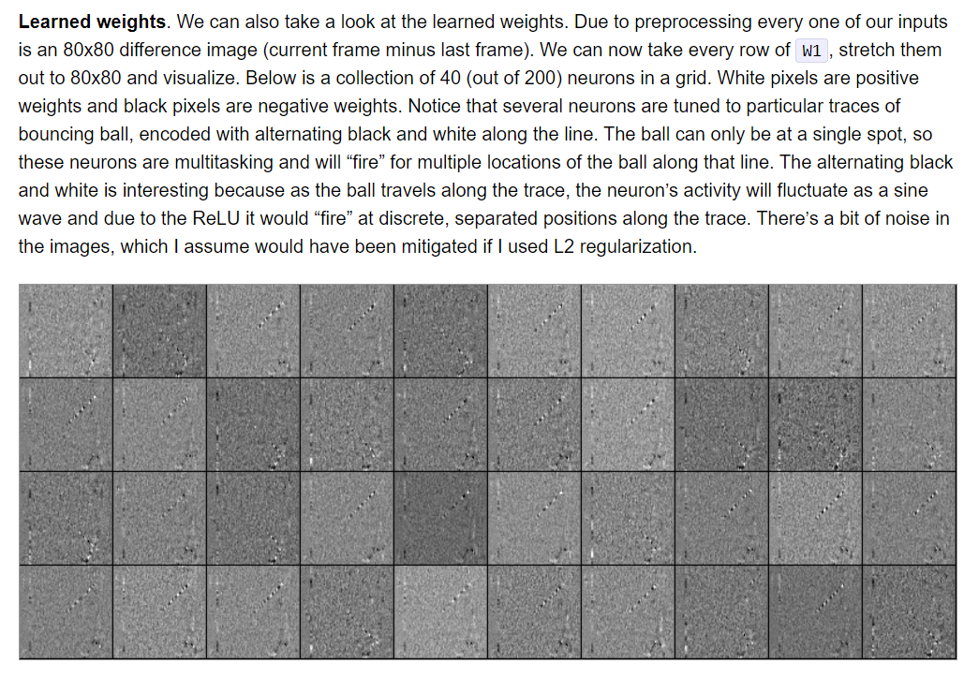  
Here's a breakdown of the key concepts:

Weights: Imagine these as dials that control the volume of different radio stations. In the Pong example, the image the program sees is like a radio with many stations broadcasting different information (like the position of the ball or the background). The weights determine which stations the program pays attention to most. A high weight for a part of the image means the program focuses on that information heavily, while a low weight means it tunes that information out.

Learning: This refers to how the program gets better at playing Pong over time. Initially, the weights are set randomly, like randomly tuning into different radio stations. The program then plays Pong, and based on its success (winning points), it adjusts the weights. Parts of the image that helped it win (like seeing the ball) get their weights turned up, while unimportant parts (like the background) have their weights dialed down. Over time, the program learns which parts of the image are important for playing well.

Positive weights: These are like turning up the volume on a radio station. A positive weight on a specific part of the image means the program pays more attention to it. For example, the program might give a high positive weight to the part of the image that shows the ball.

Negative weights: These are like turning down the volume on a radio station. A negative weight on a specific part of the image means the program pays less attention to it. For example, the program might give negative weights to the parts of the image that show the background.



Neurons: These are the basic building blocks of artificial neural networks, which are like simplified models of the brain. In this case, the neurons are like tiny decision makers within the program that are learning to play Pong. Each neuron is responsible for detecting a specific feature in the image, such as the presence of the ball or the paddle.

ReLU: This stands for Rectified Linear Unit. It's a function that acts like a switch within the artificial neural network. Neurons can only fire (activate) if the signal they receive is strong enough. The ReLU function helps determine if a neuron should fire based on the information it gets from the image (via the weights).

L2 regularization: Imagine this as a technique to prevent the program from overfitting to its training data. Overfitting is like studying only a specific set of practice problems for a test, so you might do well on those problems but poorly on anything different. In machine learning, this can happen when a program memorizes the specific details of the training data (like every pixel in a Pong game) instead of learning the general concepts (like how the ball moves). L2 regularization helps prevent this by penalizing the program for having extreme weight values, encouraging it to focus on the important features rather than random noise in the data.



The text says that by looking at the weights of the neurons, we can see what the computer program has learned to pay attention to in the image. For example, the text says that some of the neurons are tuned to detect the bouncing ball. This means these neurons have learned to activate (fire) when they see a certain pattern of pixels in the image that corresponds to the ball. The black and white alternating pattern in the image refers to how these neurons detect the vertical movement of the ball. As the ball moves up and down, the active part of the neuron shifts accordingly.

The text also says that there is some noise in the weights, which could be improved with a technique called L2 regularization. As mentioned earlier, this is a way to prevent the program from focusing on unimportant details in the image.

Overall, the text is explaining how a computer program can learn to play a game by adjusting weights based on its experience. This is a simplified explanation of a complex topic called reinforcement learning, but it should give you a basic understanding of how the program learns to identify important features in the image to play Pong effectively.

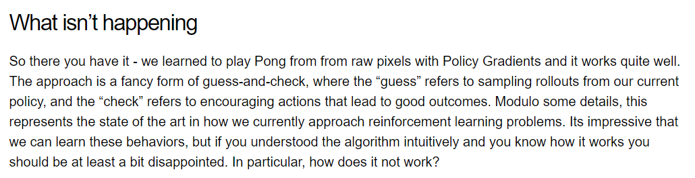

The text acknowledges that this method can be effective for training AI, but it also points out a limitation. While reinforcement learning can enable a computer program to perform a task well, it may not necessarily provide the program with a deep understanding of how the world works.

In other words, the model developed can be good for simpler tasks, with a frequent reward system that will give the model a constant signal that it is indeed making progress. When handed more complex tasks that require a more in-depth understanding of all the nuances of the actual system, the model will undoubtedly fail. We will go into more detail on this!

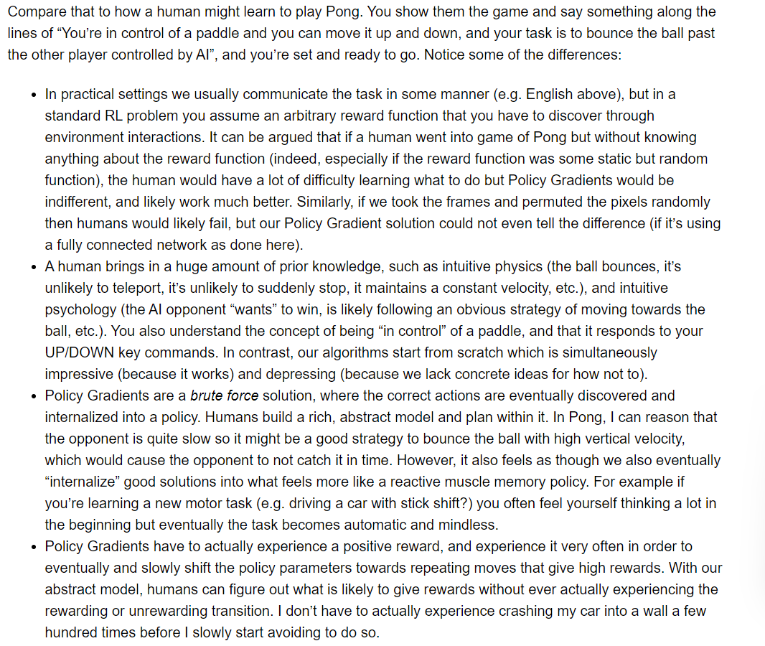 Reinforcement learning is a type of machine learning where a computer program learns by trial and error. The program is given a task and a reward function, which tells the program how good each action is. The program then tries different actions and sees what rewards it gets. Over time, the program learns to choose the actions that get the highest rewards.

Learning by humans is much more complex. Humans come to a task with a lot of prior knowledge, such as knowledge of physics and how the world works. We can also understand the concept of goals and subgoals. This makes it much easier for us to learn new things.

The text says that reinforcement learning, like the policy gradient algorithm mentioned in the passage, is a brute force way of learning. The program just tries different things (different policies) until it finds something that works. Humans, on the other hand, can use their prior knowledge to come up with a plan for how to achieve a goal. This makes learning much more efficient.

For example, in the game of Pong, as mentioned in the text, a human player knows that the goal is to hit the ball past the other player. The player can also use their knowledge of physics to predict how the ball will bounce. This makes it easy for the player to learn how to play the game.

The text contrasts this with how a reinforcement learning program would learn to play Pong. The program would have to learn everything from scratch. The program would have to try hitting the ball in all different directions until it eventually figured out how to win. This would be a much slower and more difficult way to learn.

The text also says that reinforcement learning can eventually learn to perform complex tasks. However, it does this by slowly learning what works and what doesn't through trial and error. Humans, on the other hand, can learn much faster by using their prior knowledge to come up with a plan.

Here are some of the important terms explained in the text:

Reward function: A function that tells a reinforcement learning program how good each action is. In the context of the blog post, it could be winning a point in Pong.

Prior knowledge: The knowledge that a person brings to a task. For instance, a human playing Pong knows what a paddle is and how it works.

Goal: The thing that a person is trying to achieve. In Pong, the goal is to win by scoring more points than the opponent.

Subgoal: A smaller goal that helps a person achieve a larger goal. In Pong, a subgoal might be to hit the ball towards the opponent’s side of the table.

Key Differences Between Reinforcement Learning and Human Learning

The passage highlights the following key differences between how computers learn through reinforcement learning and how humans learn:

Prior knowledge: Humans come to a learning task with a lot of prior knowledge about the world, including physics and how things work. This allows them to learn much faster than reinforcement learning algorithms, which typically start from scratch.

Planning vs Trial and Error: Humans can use their prior knowledge to plan how to achieve a goal. This is in contrast to reinforcement learning, which is a trial and error approach.



Learning from Others: Humans can learn from watching others or by being instructed. Reinforcement learning algorithms typically don't learn from others.

Analogy: Learning to Ride a Bike

Imagine you are learning to ride a bike. As a human, you already have a lot of prior knowledge about the world that can help you learn. For example, you know that the bike will stay upright if you keep moving forward. You also know how to steer and balance.

A reinforcement learning algorithm would have to learn everything from scratch. It would start by randomly flailing its handlebars and pedals. Eventually, through trial and error, it would learn how to keep the bike upright and move forward. However, this would be a much slower and more difficult way to learn than learning from a human instructor or watching someone else ride a bike.

Overall, the passage highlights the difference between how computers learn through reinforcement learning and how humans learn. While reinforcement learning can be effective for some tasks, it can be much slower and less efficient than human learning that leverages our existing knowledge and understanding of the world.

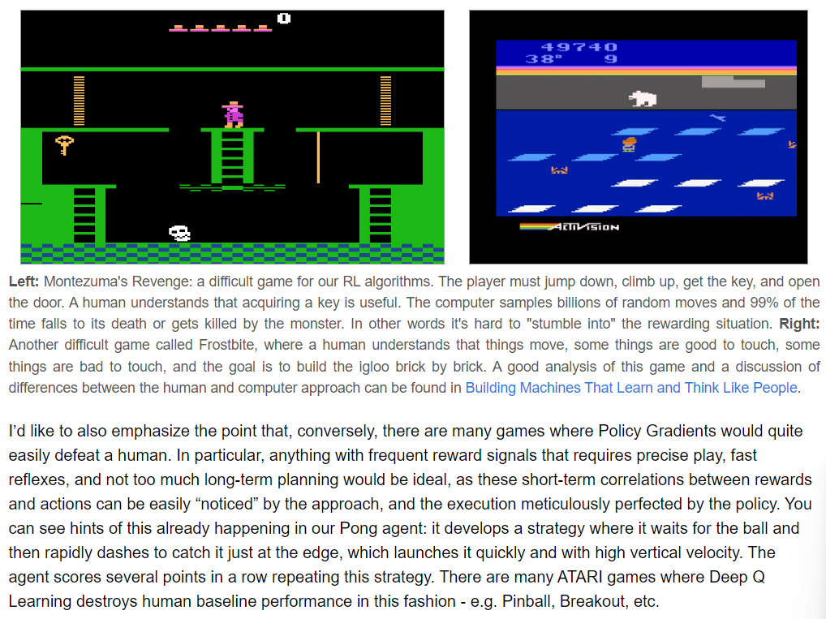

The text compares how humans and computers learn to play video games. The image shows screenshots from two Atari games, Montezuma’s Revenge and Frostbite.

**Montezuma's Revenge**

In Montezuma's Revenge, the player needs to solve a series of puzzles to progress through the game. This requires understanding the relationship between actions and consequences. For instance, the player needs to find a key and use it to open a door.

For a human player, this is fairly straightforward. We can infer that the key is important because it's placed in a special location and the door seems like it needs a key to open.

However, for a computer program using reinforcement learning (RL), this would be much more challenging. Reinforcement learning is a type of machine learning where a program learns by trial and error. The program receives rewards for actions that take it closer to its goal and penalties for actions that don’t. In Montezuma's Revenge, the program would have to explore the game world randomly until it accidentally manages to get the key and open the door. This process could take a very long time because the game doesn't provide the program with any clues about what actions are likely to lead to success.

**Frostbite**

The same challenge applies to Frostbite, another game featured in the image. Here, the player needs to collect bricks to build an igloo. Some objects in the game are helpful, like the bricks, while others are harmful, like the monsters. Again, a human player can easily distinguish between these elements based on their appearance and how they interact with the game world.

 An RL program, however, would need to learn this through trial and error. It would have to bump into objects and learn from the resulting consequences (positive or negative) whether those objects are helpful or harmful.

Reinforcement Learning vs. Human Learning

The key takeaway from the text is the difference between how humans and computers learn using reinforcement learning. Humans are capable of logical reasoning and can infer the relationships between objects and events in the world. This allows us to learn from observation and instruction much faster than trial and error.

Reinforcement learning, on the other hand, is a more basic approach to learning. It works well for relatively simple tasks where the program can easily learn which actions lead to rewards. However, for more complex tasks that require planning and understanding the cause-and-effect of actions, RL is less efficient.

The blog post discusses reinforcement learning in more detail. It also talks about some games where RL is more successful, such as Pong, where the program learns to react quickly based on the movement of the ball. This is because the game provides frequent rewards (points) and the relationship between actions and rewards is clear.

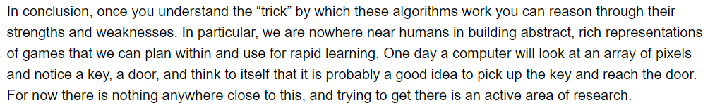

The text is the conclusion of a blog post about reinforcement learning (RL). RL is a type of artificial intelligence (AI) where an agent learns by trial and error, like a student figuring out the best way to study for an exam. The agent is placed in an environment, like a maze, and receives rewards, like a good grade, for good actions and penalties, like a bad grade, for bad actions. Over time, the agent learns to take actions that maximize the reward, just like a student learns how to study effectively.

The text says that once you understand how RL algorithms work, you can start to see their strengths and weaknesses. One weakness is that RL agents are not very good at understanding complex things like humans do. Imagine playing a video game where you need to find a key to open a door.

A human player would quickly realize that they need to pick up the key to get to the door. An RL agent, however, might not understand this connection. It would only learn through trial and error, like bumping into the key repeatedly, that picking up the key leads to a reward, like being able to progress to the next level.

Here's a real-world example: imagine an RL agent controlling a robot vacuum cleaner. The environment is the house, the reward is a clean floor, and the actions are moving in different directions and sucking up dirt. The RL agent would learn how to navigate the house and suck up dirt through trial and error, bumping into walls and furniture at first, but eventually figuring out an efficient way to clean the floor.

However, unlike a human who can easily understand the concept of a key and a door, the RL agent would not necessarily understand that there is a key-door connection. It would only know that picking up the key in certain situations leads to a reward.

The blog post concludes by saying that researchers are working on developing RL agents that can better understand complex environments, like understanding the connection between a key and a door. This is an active area of research, and there is still a lot of work to be done.

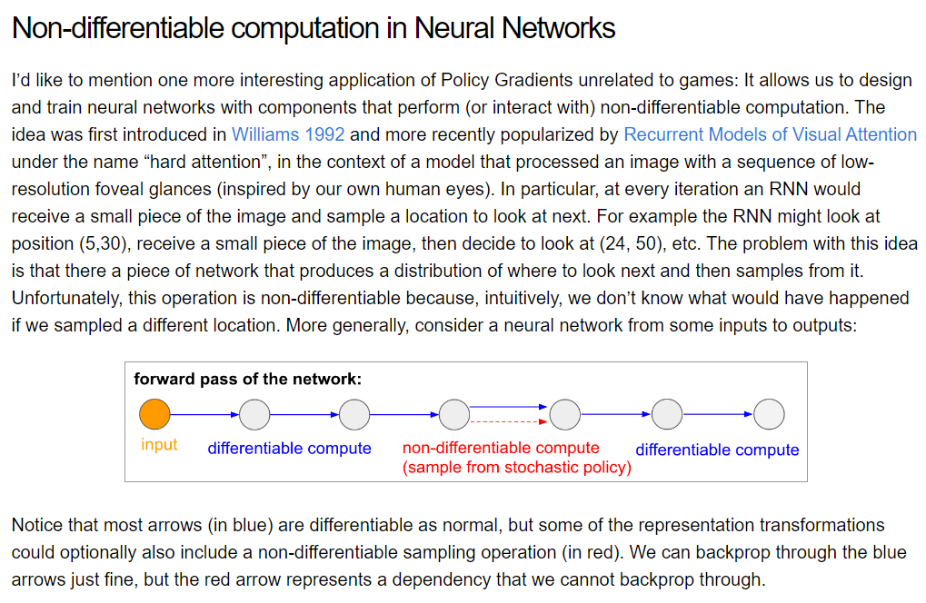

The document discusses non-differentiable computation in the context of Neural Turing Machines (NTMs). NTMs are a type of neural network that can be used for tasks that require reading and writing to memory. However, standard backpropagation cannot be used to train NTMs because the write operation involves soft reads and writes, which are not differentiable.

In simpler terms, non-differentiable computation refers to mathematical operations that are difficult to use for training neural networks with a technique called backpropagation. Backpropagation is a way to train neural networks by propagating the errors backward through the network, which helps the network learn from its mistakes. However, it only works if the math operations used in the network are differentiable, meaning small changes to the input lead to small changes in the output.

Some operations, like choosing one option out of a set of possibilities at random (sampling), are not differentiable. This can cause problems for training neural networks with backpropagation because the network cannot learn from its mistakes as effectively.

The article mentions that policy gradients can be a solution to this problem. Policy gradients work by giving the neural network a reward when it makes good decisions, even if those decisions involve non-differentiable computations like sampling. This way, the network can still learn even if it can't learn in the usual way using backpropagation.



The text you sent talks about a special kind of training for artificial intelligence (AI) called policy gradients. It focuses on a specific challenge that arises when you train certain types of neural networks, especially those that deal with images.

**Neural networks**

* These are computer programs loosely inspired by the human brain that are good at finding patterns in data. They are used in many kinds of AI, including image recognition and speech recognition.
* In the case of images, a neural network can be trained to recognize the position of objects in a scene or even identify the objects themselves.

**Non-differentiable computation**

* This refers to a math operation that is difficult to use for training neural networks with backpropagation. Most of the operations in a neural network are differentiable, which means small changes to the input lead to small changes in the output. Backpropagation relies on this property.
* But some operations are not differentiable, and these can cause problems for training with backpropagation. An example of a non-differentiable computation, which is relevant to the text, is choosing one option out of a set of possibilities at random. This is called sampling.



**Sampling in neural networks for images**

* Imagine you are looking at a photo. You can’t see the whole image at once, so you have to move your gaze around to take in different parts of the image.
* A neural network can be trained to do something similar. The network can be shown a small part of an image, and then it has to decide where to look next in order to best understand the entire image.
* This decision of where to look next is an example of sampling, because the network is choosing one option (out of many possible locations in the image) at random.

**The problem with sampling**

* As mentioned earlier, sampling is a non-differentiable computation. This means that normal training with backpropagation cannot be used on the part of the network that does the sampling.
* This is a problem because the network cannot learn from its mistakes as effectively.

**How policy gradients can help**

* Policy gradients can be used to get around this problem. It’s a bit like training a dog – you can’t tell the dog exactly how to catch a frisbee, but you can reward it when it does a good job.
* In the same way, policy gradients can be used to reward the neural network when it makes good sampling decisions.
* The text mentions that this technique is inspired by how humans look at scenes. This is a reference to the field of computational neuroscience, which studies how the brain works.
* The text says that this is an interesting application of policy gradients “unrelated to games”. This is because the blog post that this text comes from is about using policy gradients to train a neural network to play the game Pong.

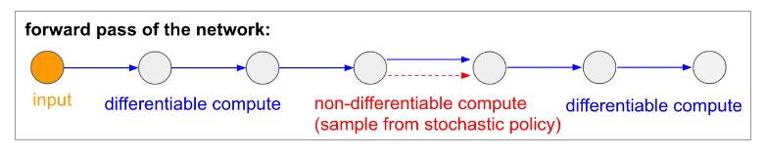

Overall, the image depicts a simplified version of a neural network where the first part represents the input layer, the second part represents a hidden layer with two parts, and the third part represents the output layer.

Let’s break down the image:

**Input Layer:** This layer receives the initial data that the network will process. In the context of the article, this data is likely an image that the neural network needs to interpret.

**Hidden layer:** This layer performs most of the computation in the network. Here, the data from the input layer is transformed. The upper text “differentiable compute” refers to the mathematical operations happening in this layer that can be used for backpropagation, a technique for training neural networks.

The lower text “(sample from stochastic policy)” refers to the non-differentiable computation happening in this layer. This means the network is choosing one option out of a set of possibilities at random, like selecting where to focus its attention on the image.

**Output layer:** This layer produces the final output of the network. In the context of the article, this output might be a decision about where to move next in an image in order to navigate an environment.

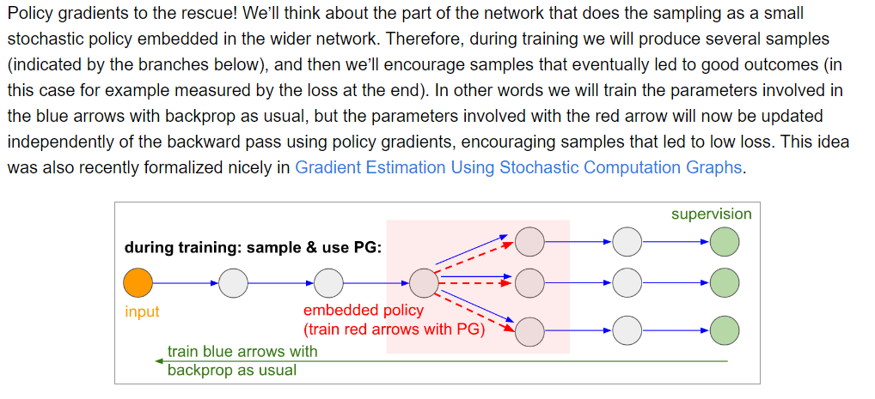

The text discusses a technique called policy gradients, used to train a type of artificial intelligence (AI) called reinforcement learning. Reinforcement learning is similar to how a student learns by trial and error: getting good grades for good answers and bad grades for bad answers.

In the context of the image, the part of the network that explores through trial and error is called the policy. Imagine this policy as a student trying to guess the answer the teacher wants. The text explains that during training, the AI will try out various guesses (shown by the branches below the word "input" in the image). Whichever guess leads to the best outcome (like getting a good grade) is considered a “good guess”. The AI then adjusts itself to make these “good guesses” more likely in the future.

The text mentions two ways the AI adjusts itself. The first way is regular backpropagation, a common technique used to train neural networks. Backpropagation is like a teacher explaining to the student why their answer was wrong and how to improve it.

The second way is a new technique called policy gradients. Policy gradients act like a different kind of teacher, instead of explaining why an answer was wrong, it simply tells the AI “hey, that guess you made that led to a good outcome? Make more guesses like that in the future!” This is reflected in the image by the red arrow updating the policy separately from the blue arrows which update the rest of the network through backpropagation.

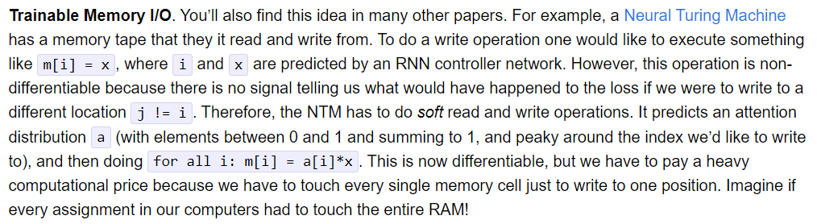

The text dives into a specific concept called Trainable Memory I/O. This concept is relevant to a type of artificial neural network called a Neural Turing Machine (NTM). Let's break those terms down one at a time:

Memory I/O: I/O stands for input/output. In the context of computers, it refers to how data is stored in memory and retrieved from memory. So, memory I/O refers to the way a computer program reads from and writes to memory.

Neural Network: This is a type of artificial intelligence inspired by the structure of the human brain. It consists of interconnected nodes that process information.

Neural Turing Machine (NTM): This is a special kind of neural network that includes a memory component. This memory component allows the NTM to store information and access it later, similar to how a computer uses RAM.

The blog post talks about how difficult it can be to train an NTM to directly write to specific parts of its memory. The problem is that the way computers typically write to memory isn't compatible with the way neural networks are trained.

Here's a more specific breakdown of the challenges mentioned in the text:

Non-differentiable: This is a mathematical term that refers to something that can't be easily represented by a smooth curve. In the world of neural networks, we train them by adjusting the weights of connections between nodes based on how much they contribute to errors. If something is non-differentiable, it makes it difficult to calculate those errors and update the weights correctly.

Training a neural network is like training a dog. You show the dog what you want it to do (give it an example), and then you reward it when it does something right and nudge it in the right direction when it makes a mistake. In this case, the reward or nudge comes from how much the network reduces the difference between what it predicted and the actual outcome. But if the way the network interacts with its memory (like telling the dog where to fetch the ball) is non-differentiable, it’s like the dog’s trainer giving it confusing instructions. The trainer can’t quite figure out what the dog did wrong or how to make it better.

Soft Read and Write: Because directly writing to memory is non-differentiable, NTMs use a softer approach. Instead of precisely writing to one memory location, the NTM distributes a signal across all memory locations based on a probability distribution. This is like instead of definitively pointing to one spot in memory and saying "write here", the NTM points to a bunch of spots in memory and says "there's a chance we might write here".

Imagine you are looking for a specific book in a library. The normal way to find a book is to look it up in the card catalog, which tells you exactly where the book is shelved. This is like directly writing to memory. But if the library’s card catalog is broken, you might have to wander around the stacks and check different shelves until you find the book you’re looking for. This is like soft reads and writes. The NTM isn’t sure exactly where the information it needs is stored, so it has to look at all the possibilities.

Attention Distribution: This refers to how the NTM focuses its writes across different memory locations. Imagine you have a bunch of files on your computer and you want to save something new. You would pick a specific folder to save it in. The attention distribution is kind of like that, but instead of picking one folder, the NTM assigns probabilities to a bunch of different folders.

An NTM can’t just write information anywhere in its memory. It has to consider how likely it is that the information will be useful later. The attention distribution helps the NTM focus on the parts of its memory that are most likely to be relevant.

Overall, the text is discussing a technical challenge in training a specific type of neural network. The key takeaway is that the way computers typically write to memory isn’t straightforward to implement in neural networks because it makes them difficult to train. An NTM overcomes this challenge by using a “soft” form of reading and writing from memory.

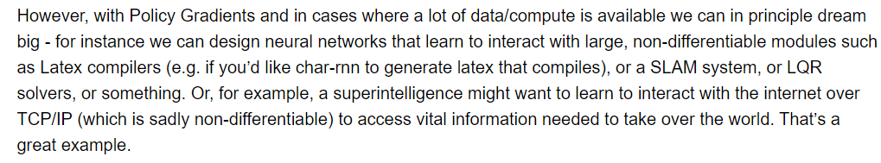

**Policy Gradients Explained**

Imagine you are training a dog to play fetch. You might give the dog a treat every time it brings the ball back to you. This is a reward, and it tells the dog that bringing the ball back is a good thing to do. In policy gradients, the computer program (AI) gets a reward for doing things that are good, and this helps it learn what to do in the future.

Policy gradients are a type of reinforcement learning, a method where an AI learns through trial and error, by being rewarded for good actions and penalized for bad actions.

**Non-differentiable modules**

The text refers to computer programs that are too complex for the policy gradients method to work with directly. These programs are called non-differentiable modules.

Differentiable, in this context, refers to the ability to calculate a gradient. Imagine you have a hill and you want to find the steepest path down. The gradient points you in the direction of the steepest descent. In machine learning, we often use gradients to update and improve our models.

Non-differentiable modules are like parts of the computer program that we can't calculate a gradient for. This makes it difficult to use policy gradients to train them directly.

**Examples of Non-differentiable modules**

The text mentions a few examples of large, non-differentiable modules, including:

* **Latex compilers:** These are programs that can turn code written in Latex, a special kind of writing used for scientific papers, into a format that can be printed. Policy gradients would likely struggle to directly train a program to write Latex code, because the steps involved are complex and not easily broken down into smaller, improvable parts.
* **SLAM systems:** These are systems that can help robots create a map of their surroundings while they are moving around. Imagine a robot trying to navigate a maze. Policy gradients might be able to train the robot to move around the maze, but it might struggle to train the robot to build a map of the maze at the same time. This is because creating a map requires the robot to keep track of its position over time, which can be complex.



* **LQR solvers:** These are programs used in engineering to solve certain math problems. These problems are typically solved with a specific set of steps, and these steps may not be well suited for learning through trial and error with policy gradients.

**Superintelligence and Policy Gradients**

The text says that a superintelligence might use policy gradients to learn how to interact with the real world through the internet. A superintelligence is a hypothetical future AI that is much smarter than humans.

While policy gradients are a powerful tool, the text suggests that they may not be suitable for training everything, especially very complex systems. Even a superintelligence might need to use other techniques to learn some things.

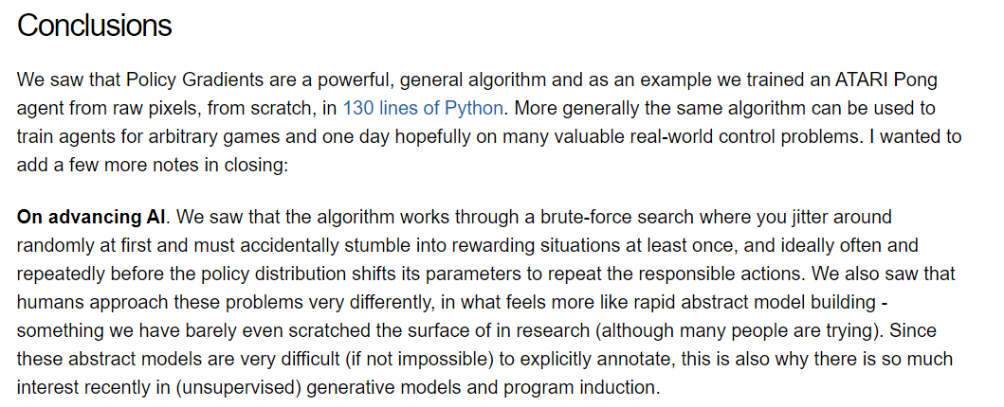**Policy Gradients**: Learning from Trial and Error

The text talks about a powerful method for training AI called policy gradients. Imagine you want to train an AI to play a game. You can give the AI the game rules and then let it play the game over and over again. Each time the AI plays, it can try out different actions and see how well those actions do. The policy gradient method helps the AI learn from its experience and choose actions that are more likely to lead to success.

Reinforcement learning is a type of machine learning where an AI learns through trial and error. Unlike supervised learning where an AI is given labeled data (data that is already tagged with the correct answer), reinforcement learning allows the AI to explore an environment and learn from its experiences. Policy gradients is a reinforcement learning technique where the AI learns by taking actions and receiving rewards. The rewards can be positive (for good actions) or negative (for bad actions). By analyzing the rewards it receives, the AI can learn which actions are more likely to lead to success in the long run.

**Training an AI to Play Pong**

The text uses the example of training an AI agent to play the Atari game Pong using policy gradients. The agent was able to learn to play the game from scratch, just by looking at the pixels on the screen. This is a cool example of how powerful policy gradients can be.

In the game of Pong, the agent observes the position of the ball and the paddle on the screen and then chooses an action, such as moving the paddle up or down. The agent receives a reward every time it hits the ball towards the opponent's goal. By analyzing the rewards it receives, the AI agent learns to associate moving the paddle in certain directions with positive rewards.



**Beyond Games: Real-World Applications**

The text says that the same algorithm can be used to train agents for many different games. This is because the basic idea of policy gradients (learning from experience) can be applied to any situation where the agent can take actions and receive rewards.

The author also hopes that policy gradients can be used to train agents for real-world control problems. For example, you could use policy gradients to train a robot to walk or to drive a car. In these cases, the rewards would be based on how well the robot performs its task. For example, a robot learning to walk might receive a reward for taking a step without falling.

How Policy Gradients Work: Brute-Force Search vs. Abstract Models

The text talks about how the algorithm works through a brute-force search. This means that the AI tries out a lot of different actions at random and then sees which actions lead to the best results. Over time, the AI learns to choose the actions that are more likely to lead to success.

However, the text also acknowledges that this is not how humans solve problems. Humans often solve problems by building mental models of the situation. For example, if you were playing Pong, you might build a mental model of the ball's trajectory and then use that model to decide where to move your paddle.

This highlights a challenge in artificial intelligence research: developing AI algorithms that can learn and reason like humans. The text mentions unsupervised generative models as a possible way to achieve this. Unsupervised generative models are a type of AI that can learn to generate new data by itself, without being explicitly programmed. This is an area of active research, and it is hoped that it will eventually lead to AIs that can solve problems in a more human-like way.

**Additional Points**

Policy: In the context of reinforcement learning, a policy refers to the strategy that the agent uses to take actions. The policy gradient method helps the agent to improve its policy by learning from the rewards it receives.

Hyperparameters: The text doesn't mention hyperparameters but they are important for training machine learning models. Hyperparameters are settings that are not learned by the model itself, but instead need to be set by the programmer. In the case of policy gradients, some hyperparameters might include the learning rate, which controls how much the agent updates its policy in response to new rewards.

Exploration vs. Exploitation: This is a trade-off that all reinforcement learning algorithms need to face. Exploration refers to the agent trying out new actions in order to learn more about its environment. Exploitation refers to the agent choosing the actions that it knows will lead to the best rewards. A good reinforcement learning algorithm needs to be able to balance exploration and exploitation.

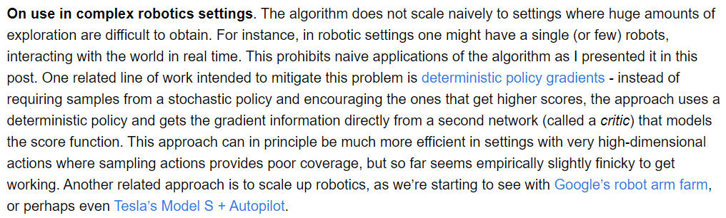

Reinforcement Learning Recap

The text discusses a challenge in training robots using a specific type of reinforcement learning algorithm. Reinforcement learning works like training a pet. Imagine you’re training a dog to play fetch. You give the dog a reward (treat) when it does something good (brings the ball back). The dog learns which actions lead to rewards (treats) and adjusts its behavior accordingly. This is similar to how a reinforcement learning algorithm works. The algorithm tries different actions in an environment and receives rewards or penalties depending on the outcome. The goal is for the algorithm to learn which actions lead to the most rewards.

The Problem with Complex Robotics

The problem arises when applying this kind of learning to complex robotics settings. Let's revisit the dog training example. Imagine training a robot to walk. There are many different ways a robot could move its legs. If the robot can only try a few of these movements due to limitations in the training environment, it might take a long time to learn the best way to walk. This is because the robot cannot explore all the possible actions and receive feedback (rewards or penalties) for each.

Real-World Robotics Challenges

In the real world, robots cannot just try out any action they want. They might bump into things or break something. For instance, a robot learning to walk in a real environment might trip and fall, damaging itself or its surroundings. This is why this type of reinforcement learning algorithm, where the robot needs to explore a vast number of actions through trial and error, wouldn't be ideal for training a robot in the real world.



Possible Solutions

The text mentions two possible solutions to this problem.

Deterministic Policy Gradients: This is a different approach to training the algorithm that might work better when there aren't many actions to explore. Instead of randomly trying out different actions, the algorithm could use a more focused approach guided by a helper network. Imagine you are training a dog to fetch a ball for the first time. You wouldn't just throw the ball in a random direction and expect the dog to find it. Instead, you might guide the dog with a leash or hand signals, helping it learn the way to the ball. The helper network in this case acts like the leash or hand signals, guiding the robot towards the best actions.

More Robots: The text also says that training lots of robots at the same time could be a solution. This is because you could explore lots of different actions without damaging a single robot. Imagine having a hundred robots each trying a different way to walk. One of the robots is bound to find a good walking technique much faster than a single robot trying every possibility one by one. This approach, however, comes with its own challenges, such as the cost of having many robots and the complexity of managing them. Imagine training a football team. It would be much faster to train many players at the same time than to train one player at a time. However, managing a whole team and keeping them all coordinated is a challenge.

Future of Reinforcement Learning in Robotics

The reinforcement learning algorithm discussed in the blog post is a powerful tool, but it has limitations, especially for complex real-world robotics applications. Researchers are exploring ways to improve reinforcement learning algorithms to address these limitations and make them more applicable to training robots in real-world scenarios.



Additionally

The text mentions that this type of reinforcement learning algorithm is not suitable for settings where it is difficult or expensive to explore a lot of different actions. This could be because the actions themselves are expensive or time-consuming to take, or because they could damage something in the environment. For example, imagine training a robot to cook. It would be expensive and time-consuming for the robot to try every possible combination of ingredients and cooking techniques. It also would be risky, as the robot could make a mess or even start a fire.

The text says that one way to address this challenge is to use a different approach called deterministic policy gradients. This approach is more data-efficient, meaning it can learn from fewer examples. This could be helpful in situations where it is expensive or time-consuming to collect data.

Another approach is to scale up the number of robots being trained. This way, you can explore more possibilities in parallel. This approach is similar to the way that companies like Google and Tesla are training large numbers of computers to improve their artificial intelligence algorithms. However, training a large number of robots can be expensive and complex.

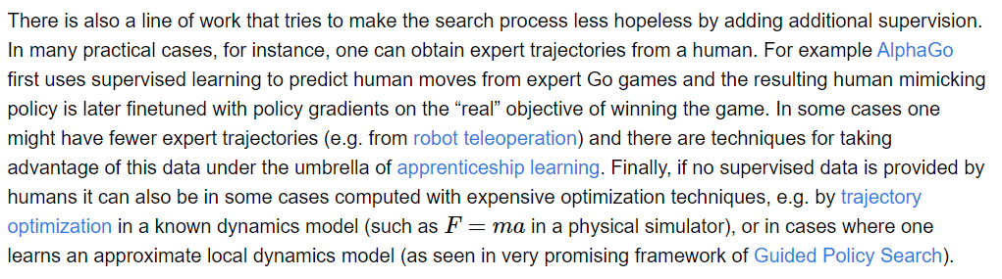

The text talks about how adding extra information, or supervision, can make the learning process easier.

**Supervision in Reinforcement Learning**

Imagine you’re playing a video game for the first time. You don’t know the controls or the objective, so you’re just randomly pressing buttons and hoping for the best. That’s kind of how an RL agent works at first. It tries out different actions in its environment and learns from the rewards it gets.

Adding supervision is like giving the RL agent some hints or tips. The text talks about three ways this can be done:

Expert trajectories: An expert trajectory is a recording of all the actions an expert took to achieve a goal in a specific environment. For example, an expert trajectory for a racing game would be a recording of all the steering, acceleration, and braking actions an expert driver took to win the race. An RL agent can learn by watching these recordings and imitating the expert’s actions.

Apprenticeship learning: This is a type of supervision where the RL agent learns from a combination of expert trajectories and trial and error. For example, imagine you’re learning to ride a bike. An adult might hold onto the back of your bike at first to help you keep your balance (like expert trajectories). Then, as you get better, they can slowly let go and you can practice riding on your own (trial and error).

Trajectory optimization: This is a more complex technique where a computer program is used to figure out the best series of actions to take in a specific situation. The RL agent can then learn from this program. The blog post mentions a specific type of trajectory optimization called guided policy search. This is a method where the computer program helps the RL agent to explore different possible actions and evaluate which ones are most likely to lead to success.



The analogy in the image is helpful for understanding trajectory optimization. Imagine you’re lost in a maze. In trial and error, you might wander around randomly until you eventually find the exit. This is like how an RL agent might learn by itself. But with trajectory optimization, it’s like having a map of the maze. The map shows you the best path to take, and you can learn this path by following the map’s instructions.

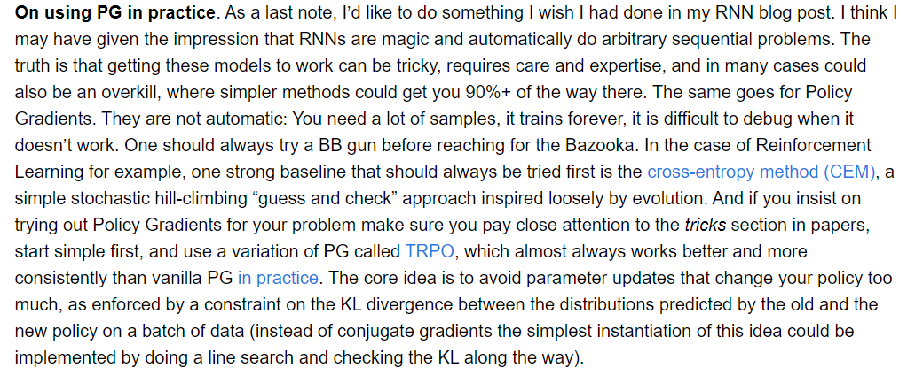

The text is a cautionary note by Andrej Karpathy, a deep learning researcher, about using a machine learning technique called Policy Gradients (PG) in practice. Here are the key points broken down:

1. **PG is powerful, but tricky**: PG is a powerful tool that can be used to train AI agents to make decisions by rewarding good choices and penalizing bad ones. However, it requires a lot of data to train effectively, and the training process itself can be time-consuming. Additionally, setting up PG can be complex and requires expertise in machine learning.
2. **Not a magic solution**: Just like Karpathy says about Recurrent Neural Networks (RNNs) in his other blog post, PG isn’t a one-stop solution to every problem. There might be simpler solutions that are almost as good, especially if you’re starting out. For example, the text mentions a simpler method called Cross-Entropy Method (CEM) that you should try first. This method is like a simpler version of PG where you basically try different options and see what works best – like picking the best option by flipping a coin a bunch of times.
3. **Alternatives to PG**: The text mentions a simpler method called Cross-Entropy Method (CEM) that you should try first. This method is like a simpler version of PG where you basically try different options and see what works best – like picking the best option by flipping a coin a bunch of times.
4. **Tips for using PG**: If you do decide to use PG, the author recommends that you:
   * Start simple: Try using a small version of the problem first to get the hang of it.
   * Use TRPO version: This is a kind of PG that’s known to be more reliable and easier to work with than the regular version.
   * Pay attention to the tricks: There are special techniques people have developed to make PG work better. These are often mentioned in research papers about PG.



And finally, we are at the end of the blog. This blog post by Andrej Karpathy dove into the world of deep reinforcement learning. It unpacked the core concepts and applications of this fascinating field. We saw that deep reinforcement learning empowers machines to learn through trial and error, just like humans do. The article also addressed the credit assignment problem, a hurdle that arises when it's challenging to pinpoint the exact action that led to a reward. To address this, Policy Gradients was introduced as a solution, and we even explored how it can be used to train a network to play Pong! Overall, this blog post provided a great introduction to deep reinforcement learning, its potential, and the challenges it entails.

I really hope you found some enlightening knowledge when it comes to machine learning from this analysis. I tried my best to include everything, but I am human and can only do so much, and the most of the learning will rely on you, the reader. Remember that this is only one approach of many when it comes to Machine Learning, and you can explore and see what works best for your interest beyond this!

Document 2: My actual experience.

In Document 1, we talked a lot about how Reinforcement Learning works, and all the ins and outs of Policy Gradients. I followed Kaparthy’s code to the best of my abilities, with difficulties along the way, but hopefully this documentation of my experience will help steer you away from making the same mistakes I did.

Throughout the document, I will lay out everything I did for the project, ranging from making our own version of Pong and modelling an AI for that specific version, to actually recreating Kaparthy’s code and updating everything to make sure it works now, years after the original blog was released.

Keep in mind that everything here is what I did and what worked for me, and the only way to know if these work for you is to try it out! If at any point, you run into a problem, I strongly suggest going to the documentations for all of the external dependencies that we will be using and reading closely of what they need in terms of parameters, and what they return (this was what held me back for around 3 months). And if even then, you can’t figure out what’s wrong, take the question you have to stackoverflow or even ChatGPT or Gemini! These 3 sites answered a lot of my questions early on, and are great resources for you to consult when running into a problem!

With that being said, let’s dive into the tutorial for *Pong From Pixels*, now in 2024!

# Setting up

So let’s go over some basic requirements before we do the coding.

If you have any interest in coding beforehand, you know how handy an IDE (Integrated Development Environment) can be. It can help you manage all of your available packages as well as provide a simple environment for you to build all kinds of programs in all kinds of programming languages.

The most popular and widely used IDE is Visual Studio Code (or VS Code) for short, and the reason for that is that it is extremely beginner friendly and intuitive. It also allows for a lot of personalization options, which can be very useful in making your coding experience better!

That being said, here are the steps to install VS Code! I will include instructions for Windows, Mac, and Linux users.

But first, we have to download it, which can be done here: <https://code.visualstudio.com/download>

Just click on the download button that best corresponds with your Operating System!

## Windows

* The download will be an executable file (e.g., VSCodeUserSetup-x64.exe).
* Double-click the downloaded file to start the installation.
* Follow the on-screen instructions, which typically involve accepting the license agreement and choosing an installation location.
* By default, VS Code installs under C:\Users\{Username}\AppData\Local\Programs\Microsoft VS Code. You can change this if needed.
* It's recommended to keep the options like "Create a desktop shortcut" and "Add VS Code to PATH" selected for easier access.
* Click "Install" to begin the installation process. It should be quick (a few minutes).

## macOS

* Once downloaded, locate the VS Code ZIP file in your browser's download list.
* It might be located in your Downloads folder by default.
* Double-click the ZIP file to extract its content.
* You should now see a new file named "Visual Studio Code.app".

**Moving VS Code to Applications Folder (Optional):**

This step is optional but recommended for easier access.

* Open a new Finder window.
* In the left sidebar, navigate to the "Applications" folder.
* Locate the extracted "Visual Studio Code.app" file in your Downloads folder (or wherever it was downloaded).
* Drag and drop the "Visual Studio Code.app" file from your Downloads folder into the "Applications" folder.

## Linux

installing VS Code on Linux can be done in a few ways depending on your Linux distribution. Here's a detailed breakdown for the most common methods, along with some additional tips:

**Using the Official Repository (For Debian, Ubuntu, and Linux Mint):**

1. **Update your package lists:** This ensures you have the latest information about available packages. Open a terminal and run:

Bash

sudo apt update

**Install required dependencies:** VS Code relies on some underlying packages. Use the following command to install them:

Bash

sudo apt install software-properties-common apt-transport-https

1. **Add the VS Code repository key:** This key is used to verify the authenticity of the VS Code package you'll download. Run the following command to add the key:

Bash

wget -q https://packages.microsoft.com/keys/microsoft.asc -O- | sudo apt-key add –

1. **Add the VS Code repository:** This tells your system where to find the VS Code package. Use this command:

Bash

sudo add-apt-repository "deb [arch=amd64] https://packages.microsoft.com/repos/vscode stable main"

1. **Update your package lists again:** Since you added a new repository, update the list again to reflect the changes:

Bash

sudo apt update

**Install VS Code:** Finally, install VS Code using the following command:

Bash

sudo apt install code

**Using Yum/DNF (For CentOS, RHEL, and Fedora):**

1. **Download the RPM package:** Head over to the VS Code download page [VS Code download link] and choose the 64-bit version (.rpm) that matches your system.
2. **Open a terminal and navigate:** Use the cd command in your terminal to navigate to the directory where you downloaded the VS Code package. For example, if you downloaded it to your Downloads folder, you might use cd ~/Downloads.
3. **Install VS Code using the appropriate package manager:** Depending on your system, use either Yum or DNF to install the downloaded package. Here are the commands:
   * For Yum-based systems (CentOS, RHEL):

Bash

sudo yum install code-*.rpm

* + For DNF-based systems (Fedora):

Bash

sudo dnf install code-*.rpm

**Using Snap:**

Snap is a universal packaging system that works across many Linux distributions. Here's how to use it:

1. **Install snapd (if not already installed):** Snap requires a background service called snapd to be running. If you don't have it, install it using the following command (replace apt with dnf for Fedora):

Bash

sudo apt install snapd

1. **Install VS Code:** With snapd set up, you can install VS Code using this command:

Bash

sudo snap install code --classic

**Using Other Methods:**

The methods above cover the most popular Linux distributions. If you're using a different distro, refer to the official VS Code documentation for instructions on specific methods like AUR for Arch Linux, Nix package for NixOS, or manual installation of the .deb or .rpm package [VS Code download link].

**After Installation:**

* Search for "VS Code" or "Code" in your application menu and launch it. VS Code should be ready to use for your coding projects.

**Additional Notes:**

* These instructions assume you have administrative privileges (sudo access) on your system. You might be prompted for your password during installation.
* VS Code offers a vast library of extensions that can enhance your development experience. Explore the extensions marketplace within VS Code to discover and install extensions that suit your coding needs.

Now that we have an IDE for our coding environment, we actually need to install Python too! It is a very straightforward process, so come along and I’ll show you!

# Installing Python…

**1. Choosing the Python Version:**

* There are two main branches of Python: Python 2 and Python 3. While Python 2 is still used in some specific cases, Python 3 is the recommended and actively developed version. This means it receives regular updates, bug fixes, and new features. So, we'll focus on installing Python 3, more specifically Python 3.9.7, since that was what I used for the project.

**2. Downloading the Installer:**

* Head over to the official Python downloads page by searching online for "download Python".
* Look for the clear section titled "Download for Windows" (assuming you're on Windows).
* Here, you'll see two installer options:
  + Windows x86-64 executable installer (for 64-bit systems): This is the most common type of system these days. If you're unsure about your system type, you can search online for "how to check if my system is 32-bit or 64-bit".
  + Windows x86 executable installer (for 32-bit systems): Less common these days, but still around on older machines.

**3. Running the Installer:**

* Once you've downloaded the installer, locate the downloaded file (usually in your Downloads folder).
* Double-click the installer to begin the installation process.

**4. Adding Python to Path (Crucial for Easy Use):**

* During the installation, you'll see options to customize the installation. This is where you can configure how you'll interact with Python in the future.
* Look for a checkbox that says something like "Add Python 3.x to PATH" (where x is the version number you're installing). Selecting this checkbox is very important. It essentially adds Python to a system directory list that your command prompt or terminal checks for commands. This means you can run Python commands from any directory in your command prompt, rather than having to navigate to the specific directory where Python is installed. It's a big convenience factor, so be sure to select it.

**5. Verifying the Installation:**

* After the installation is complete, open your command prompt or terminal application. You can usually find this by searching for "command prompt" or "terminal" in your start menu or applications list.
* In the command prompt or terminal window, type python --version and press enter. If Python is installed correctly, you should see the installed Python version displayed. This verifies that the installation process went smoothly.

**6. Verifying Pip (Package Manager):**

* Pip is a powerful tool that comes bundled with most Python installations. It acts as a package manager, allowing you to easily install additional libraries and modules that extend Python's functionality. These libraries can provide various features for data analysis, web development, machine learning, and more.
* To verify pip, type pip --version in your command prompt and press enter. You should see the installed pip version displayed. If pip isn't installed, you can usually find instructions to install it separately on the Python documentation website.

**Additional Tips:**

* If you encountered any issues during the installation or the above verification steps failed, you can refer to the official Python documentation for troubleshooting steps. There are resources available online to help with various installation problems. You can search for "install Python windows doc" to find the relevant documentation.
* As you delve deeper into Python, consider creating virtual environments. These are isolated environments that allow you to manage project-specific dependencies without affecting other projects on your system. This helps to keep your projects organized and avoids conflicts between libraries.

**macOS:**

1. **Check for pre-installed Python (Optional):** macOS may come with an older version of Python 2 pre-installed. To check, open Terminal (search "Terminal" in Spotlight) and type python --version. If you see a version number starting with 2.x, it's recommended to proceed with a fresh install of Python 3.
2. **Download the Installer:** Head over to [download Python] and navigate to the macOS section. Download the latest Python 3 release installer (64-bit executable installer).
3. **Run the Installer:** Double-click the downloaded installer file (.pkg) and follow the on-screen instructions. It's a straightforward process.
4. **Verification:** Open Terminal and type python3 --version (notice the 3 after python) to verify Python 3 is installed. You should see the version number displayed.

**Linux:**

There are two main ways to install Python on Linux, depending on your distribution:

**Method 1: Using the Package Manager**

Most Linux distributions have Python packages included in their repositories. Here's a general guideline (commands may vary slightly):

* Open a terminal window.
* Identify your Linux distribution (e.g., Ubuntu, Debian, Fedora).
* Search online for the specific command to install Python 3 using your package manager. For example, for Ubuntu/Debian, it might be sudo apt install python3.
* Once you have the command, type it in the terminal and press enter. You'll likely be prompted for your password.
* The package manager will download and install Python 3.

**Method 2: Using the Official Python Installer**

1. **Download the Installer:** Similar to macOS, visit [download Python] and download the installer for your Linux distribution (usually a compressed file).
2. **Extract the Installer:** Open a terminal and navigate to the directory where you downloaded the file. Use the appropriate command to extract the archive (e.g., tar -xf filename.tar.gz).
3. **Build and Install:** Navigate to the extracted directory using the cd command. Then, follow the on-screen instructions provided in the Python documentation ([install Python from source ON docs.python.org]) to build and install Python. This involves using commands like ./configure and make install.

**Verification (For Both Methods):**

Open a terminal and type python3 --version. You should see the Python 3 version displayed.

**Additional Notes:**

* Similar to Windows, make sure to add Python to your system path during installation (if using the official installer) for convenient use from the command line.
* Consider using virtual environments on macOS and Linux as well, for the same reasons mentioned earlier.

# Taking you through everything

## Early Stages

When we first got to the project, we were really confused about where to start. Kaparthy’s code wasn’t running, everyone was in different time-zones so communication was hard to set up, but still we did not give in. We decided that in order to understand this project better, we needed some fundamental knowledge on how Pong actually works.

For this, we needed to install PyGame, but for the sake of this document focusing on developing an AI model for the real Pong game from the gymnasium pack, I will not go into details about how to install PyGame. Instead, I will only focus on explaining what the code does for you!

Below, you will find the entire source code for this first iteration we had:

<https://github.com/Jack51003/PongFromPixels/blob/main/PongEve.py>

That was quite a lot, wasn’t it… I mean, it’s 400+ lines of code! But I’ll walk you through everything, so don’t worry!

First up, **imports**:



* pygame: This library provides functions for creating graphics and handling user input.
* numpy (as np): This library provides functions for numerical computations, which are used for the neural network calculations.
* random: This library provides functions for generating random numbers, used for initializing the network and mutations.

**Color definitions:**

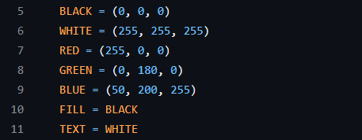

* BLACK, WHITE, RED, GREEN, BLUE: These define the colors used for various elements in the game (background, paddles, ball, etc.).

**Initialization:**

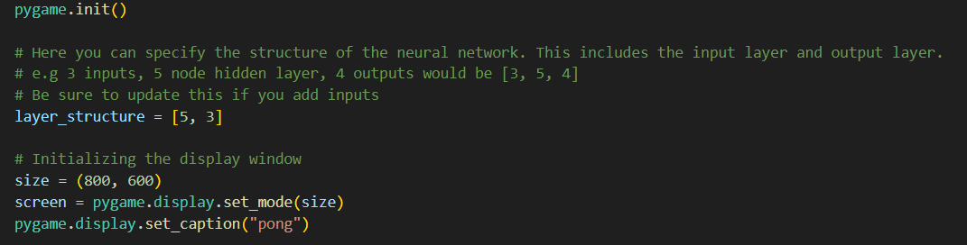

This sets up the environment that we will be conducting the game! It is pretty self-explanatory, just setting up the screen, width and height of the window…

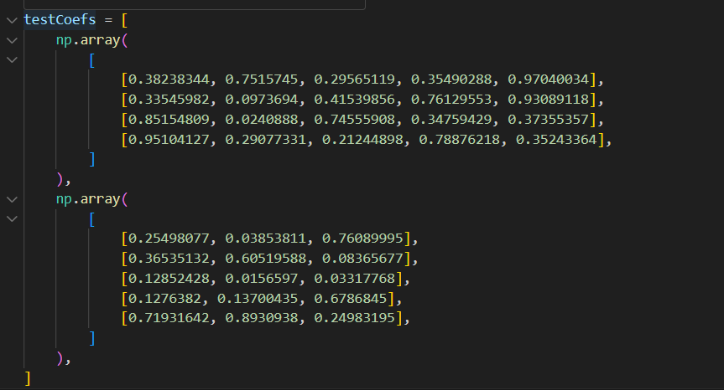

This sets up the pre-defined weights and biases for the neural network! It will be used for:

* **Debugging:** Since the testCoefs variable contains pre-defined weights and biases for the neural network, it can be used to test the network's behavior with known values. This can help identify any issues with the network's implementation or training process. For example, you could see how the paddle moves with these pre-defined weights and compare it to the expected behavior.
* **Visualization:** The displayNetwork function takes an optional argument coefs which can be used to specify the weights and biases to visualize. By passing testCoefs to this function, you could potentially visualize the connections and weight values within the network, providing an intuitive understanding of how the network is structured.

Class **Paddle:**

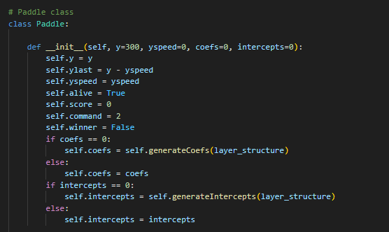

* This class defines a paddle object with properties like its position, speed, score, and neural network weights/biases (coefs and intercepts).
* __init__(): This is the constructor that initializes a paddle object with its starting position, speed, and network parameters (which can be random or provided).
* generateCoefs(): This function generates random weights for the connections between neurons in the neural network.
* generateIntercepts(): This function generates random biases for each neuron in the network.
* mutateCoefs(): This function creates a new set of weights by adding random noise to the existing weights, simulating mutation in the genetic algorithm.
* mutateIntercepts(): This function creates a new set of biases by adding random noise to the existing biases.
* mutate(): This function returns a new paddle object with mutated weights and biases.
* reset(): This function resets the paddle's score, speed, and position to their starting values.
* update(): This function updates the paddle's position based on its current speed.
* draw(): This function draws the paddle onto the game screen using Pygame's drawing functions.

Class **Ball**:

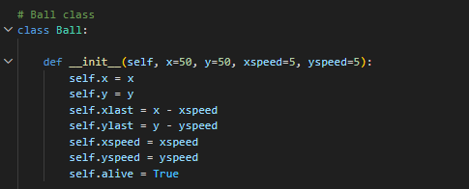

* This class defines a ball object with properties like its position and speed.
* __init__(): This is the constructor that initializes a ball object with its starting position and speed.
* update(): This function updates the ball's position based on its current speed and checks for collisions with the paddle and walls.
* draw(): This function draws the ball onto the game screen using Pygame's drawing functions.

**Calculate Output Function:**

* calculateOutput(): This function takes an input vector, network structure, weights, and biases as arguments. It then calculates the output of the neural network based on the provided parameters using a specific activation function (e.g., identity, relu, tanh, logistic).

**Mutate Functions (coefs and intercepts):**

* These functions (mutateCoefs and mutateIntercepts) create new sets of weights and biases by adding random noise to the existing ones, simulating mutations in the genetic algorithm.

**Display Network Function:**

* displayNetwork(): This function displays a visual representation of the neural network on the screen, showing the connections between neurons and their weights as lines.

**Main Game Loop:**

* This loop runs continuously until the user exits the game. Within the loop:
  + The screen is filled with the background color.
  + The number of alive paddles and the highest score are tracked.
  + User input is checked for exiting the game.
  + For each paddle:
    - The network's output is calculated based on the paddle's current state (position, ball information) and the paddle's weights and biases.
    - The output determines the paddle's movement (left, right, or stop).
    - The paddle's position is updated based on its speed.
* Ball and paddle collisions are detected. Upon collision, the ball's direction is reversed and the paddle that collided gains a point.
* The ball and paddle objects are updated and drawn onto the game screen.
* The game window is updated to reflect the changes.
* Based on the number of alive paddles and the highest score, the genetic algorithm logic is likely implemented here. This might involve:
  + Selecting the best performing paddles (parents) based on their score.
  + Creating new paddles (children) by combining the weights and biases (genes) of the parents and introducing mutations to promote diversity.
  + Replacing the worst performing paddles with the new (potentially improved) children.

**Genetic Algorithm Selection and Breeding:**

* This part of the code is likely missing from the provided snippet, but here's a general idea:
  + A selection function might choose the top 'n' paddles (parents) based on their scores.
  + A breeding function might create new paddles (children) by combining weights and biases from the parents, potentially using crossover techniques like single-point crossover or uniform crossover.
  + Mutation functions (mutateCoefs and mutateIntercepts) are likely used to introduce random changes to the weights and biases of the children, mimicking biological mutations.

**Game Termination:**

* The game loop continues until a specific termination condition is met, such as reaching a maximum number of generations or having only one paddle remaining.

**Additional Notes:**

* This code snippet showcases a simplified implementation of a Pong game with a genetic algorithm for training the neural network that controls the paddles.
* Real-world implementations might involve more complex network structures, advanced activation functions, and fine-tuning of the genetic algorithm parameters for better performance.

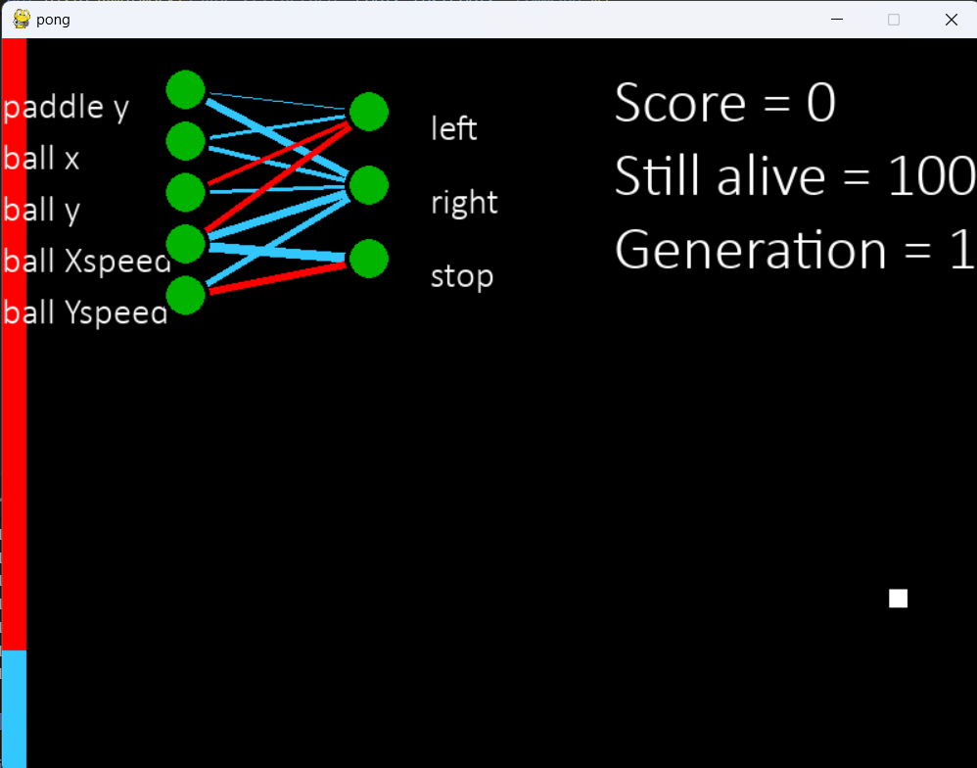At the end of the day, this was just a starter code for us so I don’t want to get into too much detail, but generally, we developed a working AI model that just picks the best performing paddle to be the parent of the next generation. The weights and biases will change over time to reflect these changes, which we will see better in the real code later on! Below you will see a screenshot of what the code will produce:

# Tough beginnings:

Now with some knowledge of what we will be doing for the real thing, we went onto Andrej Kaparthy’s real code. His implementation works of openAI’s gymnasium environment, providing a one-to-one copy of Atari’s Pong game, unlike what we did earlier. His implementation can be found here: <https://gist.github.com/karpathy/a4166c7fe253700972fcbc77e4ea32c5>

If you try to run the code on your computer, however, you might find out that it won’t work! A simple reason for this is because a lot of it is outdated, and libraries he is using have gotten many updates since. What we need to do is to update his code accordingly, as well as installing some new dependencies!

When I first started out, I was missing a lot of dependencies and did not know where to start. Luckily, I already made the mistakes so you won’t have to! Moving forward, I will also include how some steps can be a little tricky, so pay extra attention when you come across these!

* 1. Installing external libraries using pip
* Pip is a package manager that comes with Python! It is used to install as well as manage external libraries, and we will be using it to import a lot of the dependencies that can be found wihtin the code.

In your terminal, run the following:

pip install gym

pip install matplotlib

pip install numpy

pip install pickle

pip install autorom

pip install gym[atari]

And those should be all of the libraries you need! If you’re running into problems, I recommend going to the documentations for each of these libraries and reading them, just in case you’re installing a deprecated version of the library.

Caution: do NOT try to uninstall the packages if you have the wrong version, just look up ways that you can update them using pip. You might unintentionally uninstall some important packages (like I did…). I also recommend installing a pip package manager extension in VSCode to better see what you already have.

With that, I will also present to you…

# roadblocks I ran into!

Anyone interested in coding or programming knows that it is not a straightforward, linear journey. There will inevitably be setbacks or bugs that you will have to deal with, for such a long period of time that it seems like progress will never be made. I felt that ***a lot*** during the project. Mostly because I didn’t know for sure what dependencies I needed, and ended up stuck in a loop of installing and uninstalling packages, until I finally crashed pip so bad that one of its crucial packages was gone, and I couldn’t run the code anymore. Luckily, I had a work-around.

On my computer is Anaconda. Anaconda is a popular choice for coding Python, especially in fields like data science and machine learning. Here are some reasons why:

* **Pre-installed packages:** Anaconda comes bundled with a lot of popular scientific computing and data analysis libraries like NumPy, Pandas, and Scikit-learn. This saves you the time and hassle of installing them individually with pip.
* **Environment management:** Anaconda uses conda, a package manager that excels at creating isolated environments for your projects. This ensures that each project has the exact versions of libraries it needs without conflicts arising from other projects on your system.
* **Usability:** Anaconda offers a user-friendly interface for managing environments and packages through Anaconda Navigator, a graphical user interface (GUI). It also includes tools like Jupyter Notebook, a popular interactive coding environment for data science.
* **Performance:** Anaconda often comes with pre-built libraries optimized for specific hardware, like Intel MKL for faster numerical computations.

So, when I found out that I could run the code and install all the *correct* dependencies in Anaconda’s distribution of VS Code, let’s just say a whole lot of stress was relieved that day.

## Aside from that, however…

I also ran into some *actual* coding bugs. As I mentioned before, Kaparthy’s code and blog post was relevant more than half a decade ago. Naturally, to adapt it to today’s specifications, we will need to do a lot of trouble-shooting, and take steps one-by-one until we have a fully functional model.

Below you will see a tons of errors and ways that I fixed them. In between them is also some code analysis section is meant to guide you through the code provided by Kaparthy and help you make a working version of it!

If you just copied and pasted Kaparthy’s code as is and try to run it, you might get something like this in your output:



Well.. that’s self-explanatory, we need to put the output inside brackets when using the print command. So we’ll add that just like so:

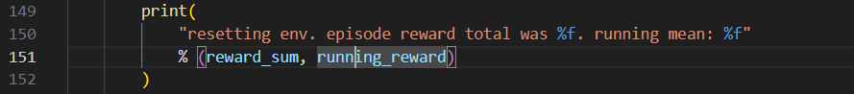

Notice how I broke the printed line into segments! It’s just good programming etiquette since one long line of code might be harder to read for some people.

Now, if you tried to run the code again, you would get something like this, instead:

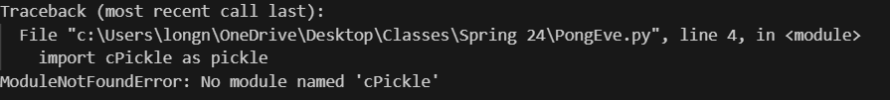

That is because as of now, Python 3 doesn’t have cPickle, since it was a library made for Python 2. Instead, just do import pickle, just like so:



And now, after running you will see this!

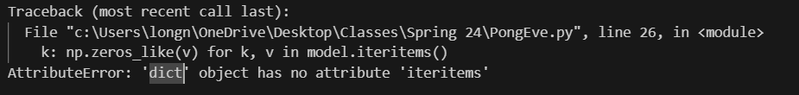

That is because as of right now, the dict object that is used here doesn’t have the iteritems() function anymore. Instead, we only use dict.items():

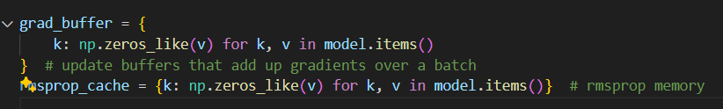

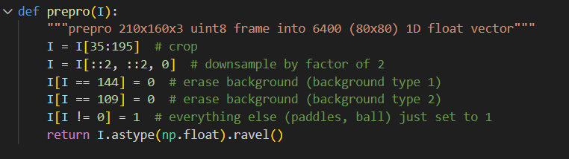And that’s that… Until you try to run the code again and find out that the prepro function is hopelessly broken, as well. So, here’s the one Kaparthy provided for us.

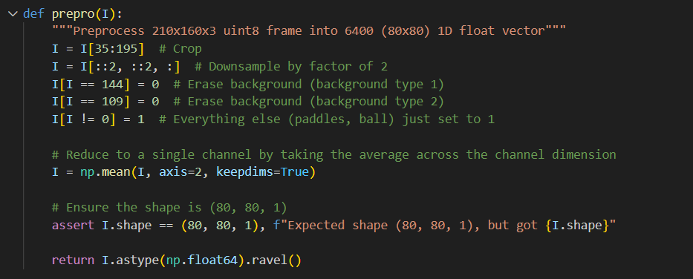And here’s the one in my final version of the model:

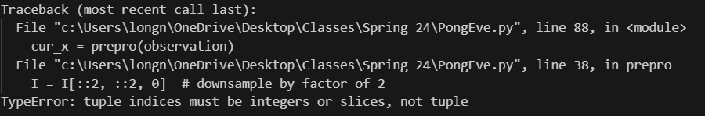You might notice that there are some extra lines of code here, instead of just a simple fix like the ones above. This is because throughout the course of the project, I struggled with this function the most. No matter what I did I kept on getting this error message:

But before we get to explaining why that is, I need to tell you what the prepro function actually does. As the name suggests, this function preprocesses a frame of the ongoing game captured from the pong environment, and return it as a 1-dimensional float vector. This data will be fed into the model, and provide it with the current state of the game.

Prepro works in several smaller steps:

* + - **Cropping**: focusing on a specific region of the image, which reduces the amount of data the model has to analyze
    - **Downsampling**: It reduces the resolution of the image by a factor of 2. This lowers the dimensionality of the input data, which can improve computational efficiency and potentially prevent overfitting.
    - **Background Removal:** It sets specific pixel values corresponding to background elements to 0, so that we get a clearer image of the things that do matter.
    - **Grayscale Conversion:** It converts the potentially colored image to a single-channel grayscale representation. This reduces the complexity of the input data as color information might not be crucial for the model to distinguish the paddle and ball.
    - **Reshaping and Data Type Conversion**: It reshapes the image data into a flat 1D vector and converts it to a float64 data type. This prepares the data for efficient processing by the neural network model.

As you might have noticed, I also have an assert statement! This guarantees the preprocessed image has all the correct dimensions as what we’re expecting, so that we can move on smoothly!

Overall, the prepro function simplifies the raw image frame by focusing on the essential elements for playing Pong (paddle and ball) and reducing the data complexity to improve the training process for the model.

Next up is the discount_rewards function, in which it computes the discounted rewards for a given sequence of rewards received from the environment. Here’s a breakdown of how it works:

**Discounted Rewards in Reinforcement Learning**

In reinforcement learning, when an agent interacts with the environment and takes actions, it receives rewards. However, rewards obtained in the future are generally considered less valuable than immediate rewards. This is because there's a chance the agent might not survive or take actions that lead to those future rewards. The discount factor (gamma) is used to weigh the importance of future rewards compared to immediate ones.

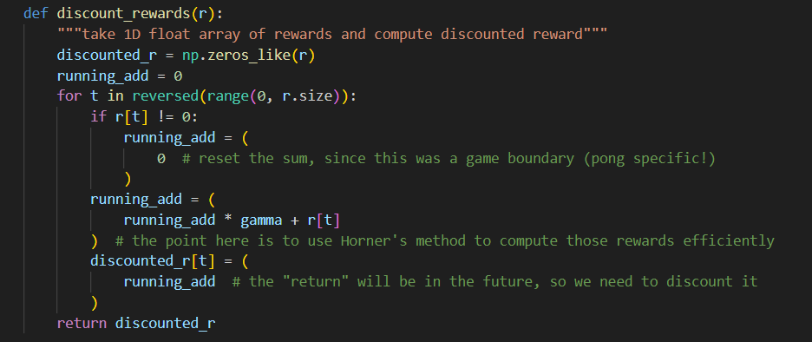**The discount_rewards function:**

1. **Initialization:**
   * It creates a NumPy array (discounted_r) with the same size as the input reward array (r) to store the discounted rewards.
   * Initializes a variable running_add to 0, which will be used to accumulate the discounted rewards for each step.
2. **Iterating through Rewards in Reverse:**
   * The function iterates through the elements of the reward array (r) in **reverse order** using a for loop. This is because we want to calculate the discounted reward for each step considering the rewards received in all **future** steps.
3. **Resetting for Episode Boundaries:**
   * Inside the loop, it checks if the current reward (r[t]) is not equal to zero (line 13). In Pong, non-zero rewards are typically received at the end of an episode (when the ball goes out of bounds).
   * If the reward is non-zero, it resets the running_add variable to 0 (line 14). This is because a new episode is starting, and the discounted rewards should be calculated from scratch.
4. **Discounted Reward Calculation:**
   * It calculates the discounted reward for the current step (t) using the following formula:

discounted_reward = (gamma * previous_discounted_reward) + current_reward

* + gamma: This is the discount factor (a value between 0 and 1). A higher gamma value gives more weight to future rewards.
  + previous_discounted_reward: This is the discounted reward calculated for the previous step in the loop iteration. If it's the first step (no previous step), it will be 0 (initialized earlier).
  + current_reward: This is the reward received from the environment at the current step (r[t]).
  + The running_add variable essentially accumulates the discounted rewards for all future steps based on the current reward and the discount factor.

1. **Assigning Discounted Reward:**
   * The calculated discounted reward for the current step (t) is assigned to the corresponding position in the discounted_r array.
2. **Return:**
   * After iterating through all rewards in the reversed order, the function returns the discounted_r array containing the discounted rewards for each step in the original reward sequence.

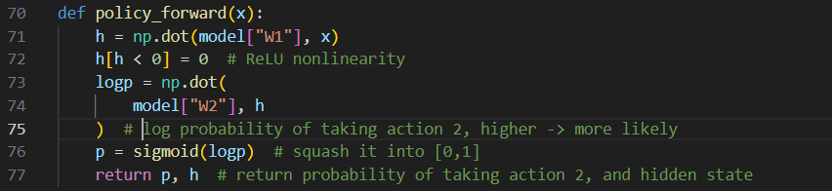

Next is the policy_forward function, which performs the forward pass in the neural network!

**Forward Pass in a Neural Network:**

* A forward pass involves feeding the input data through the network layer by layer, performing calculations at each layer, and ultimately getting an output.

**Steps in policy_forward:**

1. **Hidden Layer Activation:**
   * It calculates the activation of the hidden layer using a matrix multiplication between the input vector (x) and the first weight matrix (model["W1"]).
   * This essentially projects the input data onto a higher dimensional space defined by the hidden layer neurons.
2. **ReLU Activation:**
   * It applies the ReLU (Rectified Linear Unit) activation function to the hidden layer activations (line 79). ReLU sets any negative value in the activation vector to zero. This introduces non-linearity into the network, allowing it to learn more complex relationships between the input and output.
3. **Output Calculation:**
   * It calculates the log probability of taking action 2 using another matrix multiplication between the hidden layer activations and the second weight matrix (model["W2"]).
   * This projects the hidden layer activations to a single output value representing the model's preference for taking action 2 (upwards paddle movement).
4. **Sigmoid Activation:**
   * It applies the sigmoid activation function to the log probability values (line 81). The sigmoid function squashes the values between 0 and 1, representing the probability of taking action 2.
5. **Return Values:**
   * The function returns two values as a tuple:
     + p: This represents the probability (between 0 and 1) that the agent will choose action 2 (upwards paddle movement) based on the current observation.
     + h: This represents the activation vector of the hidden layer, which might be used for further calculations in the code.

**Overall, the** policy_forward **function takes the preprocessed observation from the environment as input, performs a forward pass through the neural network model, and returns the probability of taking a specific action (upwards paddle movement in this case) and the hidden layer activation.** This information is then used by the agent to decide on its action and for backpropagation during training.

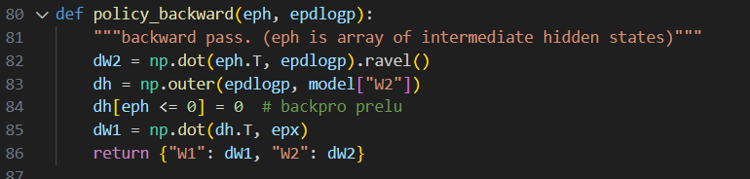

The policy_backward function performs the backward pass to calculate the gradients of the loss function with respect to the weights of the neural network model. Here's a breakdown of the steps involved:

1. **Calculating Gradient for W2 (Second Weight Matrix):**
   * Line 82: dW2 = np.dot(eph.T, epdlogp). This line calculates the gradient of the loss function with respect to the second weight matrix (W2).
     + eph.T: This performs the transpose operation on the eph array, which likely contains the hidden layer activations stacked together over a batch of episodes. By taking the transpose, we essentially calculate the dot product between each hidden layer activation vector and the corresponding error signals (epdlogp).
     + epdlogp: This array likely represents the difference between the predicted log probability of taking action 2 and 1 (for action 2) accumulated over a batch of episodes. It contains the error signals for each timestep in the batch.
   * The dot product between these two arrays calculates how much each element of W2 contributed to the overall error in predicting the chosen action (action 2 in this case).
2. **Calculating Gradient for W1 (First Weight Matrix):**
   * Line 83: dh = np.outer(epdlogp, model["W2"]). This line calculates an intermediate value (dh) needed to compute the gradient for the first weight matrix (W1).
     + np.outer(epdlogp, model["W2"]): This performs the outer product operation between epdlogp (error signals) and the second weight matrix (model["W2"]). The outer product results in a tensor where each element is the product of the corresponding elements from the two arrays.
   * Line 84: dh[eph <= 0] = 0. This line applies the ReLU (Rectified Linear Unit) backpropagation step. Since ReLU activation only considers positive values, gradients for hidden layer activations that were zero during the forward pass (eph <= 0) are set to zero here. This ensures that only positive activations contribute to the gradients.
   * Line 85: dW1 = np.dot(dh.T, epx). This line calculates the gradient of the loss function with respect to the first weight matrix (W1).
     + dh.T: This performs the transpose operation on dh, which likely contains the error signals propagated from the second layer after considering ReLU backpropagation.
     + epx: This array likely contains the preprocessed observations (difference images) stacked together over a batch of episodes.
   * The dot product between the transposed dh (error signals after ReLU) and the epx (observations) calculates how much each element of W1 contributed to the error in activating the hidden layer neurons.
3. **Returning Gradients:**
   * Line 86: return {"W1": dW1, "W2": dW2}. This line returns a dictionary containing the calculated gradients for both weight matrices (W1 and W2). These gradients will be used to update the weights of the neural network during training using an optimizer like RMSprop (used in the surrounding code).

Overall, the policy_backward function efficiently calculates the gradients for the weights based on the accumulated errors (epdlogp) and the network activations (eph and epx) from a batch of episodes. These gradients provide essential information for the optimizer to adjust the weights of the neural network and improve its performance over time.

And that about does it for all of the fundamental functions we’ll need! Using these, we will be able to implement an AI model that can take in data, process that data and learn by changing the weights of its calculationsas time goes on! How cool is that?! Next up, we have the main game loop, as well as some more minor fixes!

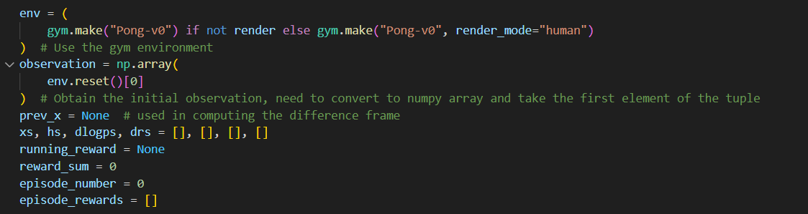

This segment essentially just initialises everything we will need. If you pay close attention to both this AND Kaparthy’s original code, you might notice a slight change:

|  |  |
| --- | --- |
|  | Kaparthy’s code |
|  | Ours |

Notice how we added some fluff to the environment initialization. If render is set to False, then just make the environment of Pong-v0, but if render is set to True, then we will set a render mode for the environment so that it will output (render) the game to the screen!

Furthermore, we also changed the observation value! In Kaparthy’s, since he is using an older version of the gym package, he only needs to use env.reset(), which, at the time, returned the current observation of the game. Now, however, env.reset() returns 2 things, and those are the current observation of the game, as well as some extra information relating to the game! That’s why we need to put env.reset()[0], since we only need the observation part. The np.array() is also used to convert the observation into a numpy array, which is the correct data type to be preprocessed.

This took me a lot of time to realize, and I only figured it out by going to the documentation page of gymnasium (that can be found here: <https://gymnasium.farama.org/api/env/#gymnasium.Env.reset>). That should give you a sense of how important reading the documentations is! Don’t be like me, who banged their heads against the wall so many times hoping it will work without knowing what env.reset() returns!

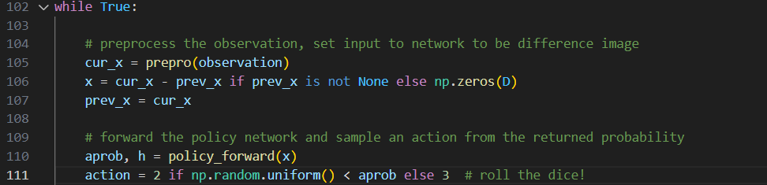The next big while loop is actually the main game loop that we will be using. It will run indefinitely, until you tell it to stop. I will break it down section by section, so don’t fret!

**1. Preprocessing and Action Selection:**

* cur_x = prepro(observation): The current game frame (observation) is preprocessed using the prepro function. This function performs several tasks:
  + Cropping the image to focus on the relevant area of the game (excluding the top and bottom portions).
  + Downsampling the image to reduce its size and computational cost.
  + Removing the background elements (identified by specific pixel values).
  + Converting the remaining image (paddles and ball) to a single grayscale channel by averaging channel values.
  + Reshaping the image into a flat vector of size D.
* x = cur_x - prev_x if prev_x is not None else np.zeros(D): This computes the difference image. If there's a previous frame (prev_x), the current frame is subtracted from it, highlighting the changes between frames. This can be helpful for the model to capture motion information. The first iteration uses a zero array (np.zeros(D)) because there's no previous frame for comparison.
* prev_x = cur_x: The current frame is stored as the previous frame for the next iteration's difference image calculation.
* aprob, h = policy_forward(x): The preprocessed image (x) is passed through the policy network using the policy_forward function. This function performs a forward pass, calculating:
  + The probability of taking action 2 (move down the paddle) using the sigmoid activation function.
  + The hidden layer activation (h) representing the network's internal state.
* action = 2 if np.random.uniform() < aprob else 3: This line determines the action to take based on the predicted probability (aprob).
  + If a random number generated using np.random.uniform() is less than the action probability (aprob), action 2 (move down) is chosen.
  + Otherwise, action 3 (move up) is chosen. This introduces an element of randomness (exploration) during training.

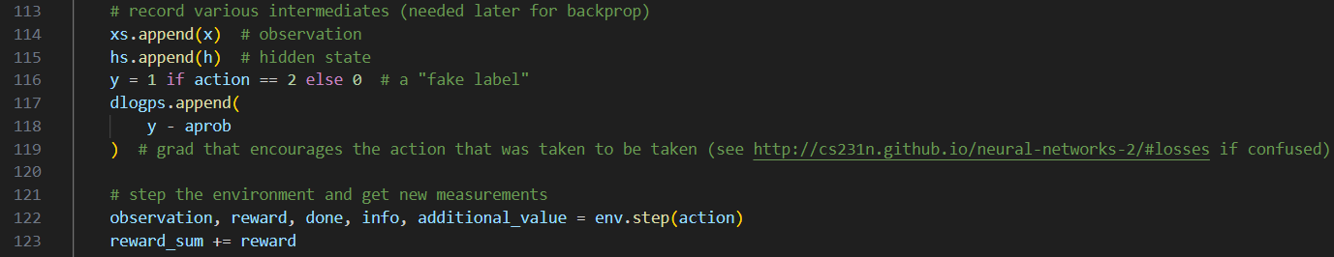

* + 1. **Data Collection and Environment Interaction:**
* xs.append(x), hs.append(h), dlogps.append(y - aprob), drs.append(reward): These lines collect data for later use in backpropagation.
  + xs: Stores the preprocessed observations (difference images) throughout the episode.
  + hs: Stores the hidden layer activations for each action taken.
  + dlogps: Stores the difference between the predicted action probability (aprob) and a "fake label" (y). This "fake label" is 1 if the action chosen was 2 (move down), and 0 otherwise. This difference is used to calculate the gradient for the policy network.
  + drs: Stores the rewards received from the environment after each action.
* observation, reward, done, info, additional_value = env.step(action): This line interacts with the Pong environment:
  + The chosen action (action) is sent to the environment (env.step).
  + The environment returns the next observation (observation), the reward (reward) received for the action, a flag indicating the end of the episode (done), and additional information (info).

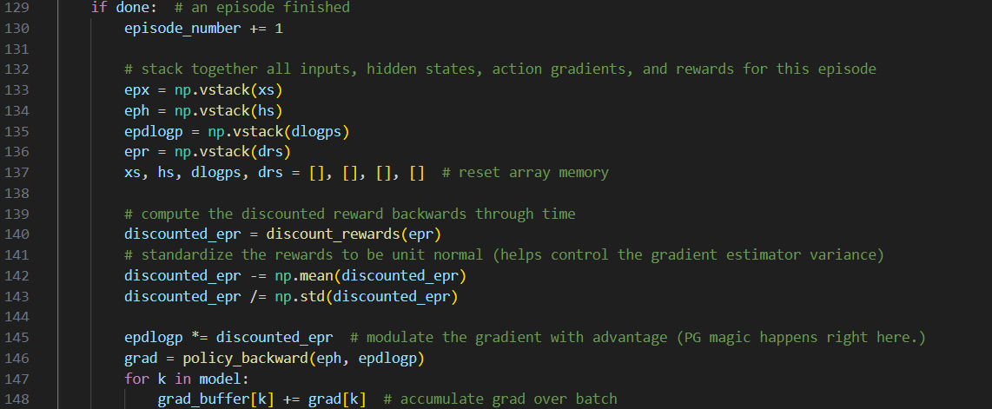

**3. Episode Termination and Backpropagation:**

* The if done block executes when an episode ends (done is True):
* episode_number += 1: The episode number is incremented.

Data accumulation for backpropagation is done:

* epx = np.vstack(xs): Stacks all the preprocessed observations (xs) from the episode into a single matrix.
* eph = np.vstack(hs): Stacks all the hidden layer activations (hs) from the episode into a single matrix.
* epdlogp = np.vstack(dlogps): Stacks all the action probability difference values (dlogps) from the episode into a single matrix.
* epr = np.vstack(drs): Stacks all the rewards (drs) from the episode into a single vector.
* The arrays xs, hs, dlogps, and drs are then reset for the next episode.
* Discounted rewards are calculated using discounted_rewards(epr). This function considers the long-term value of rewards by applying a discount factor (gamma).
* The rewards are standardized to have a mean of 0 and a standard deviation of 1. This helps with gradient stability during training.
* epdlogp *= discounted_epr: This line modulates the action probability differences (epdlogp) with the discounted rewards (discounted_epr). This emphasizes the importance of actions that led to higher rewards in the future (considering the discount factor). This is a crucial step in the training process, often referred to as the advantage calculation in Policy Gradient methods.
* grad = policy_backward(eph, epdlogp): The policy_backward function is called, taking the stacked hidden states (eph) and the modulated action probability differences (epdlogp) as input. This function performs backpropagation through the policy network to calculate the gradients for each weight (W1 and W2) with respect to the loss function.
* for k in model: This loop iterates over the keys (k) in the model dictionary (which holds the weights).
* grad_buffer[k] += grad[k]: The gradients for each weight (grad[k]) are accumulated in the grad_buffer dictionary. This accumulates gradients over a batch of episodes before updating the model parameters.

Here’s an analogy for you to better understand this part!

Imagine you're training a friend to play Pong. Backpropagation is like a way for your friend to learn from their mistakes and improve their game. Here's how it works in this code:

1. **Episode Ends:** When a game (episode) of Pong finishes (your friend wins or loses), the code gathers information from throughout the game:
   * **What the screen looked like at each point (observations).**
   * **The actions your friend took (moving the paddle up or down).**
   * **The rewards they received for those actions (points for winning or losing).**
2. **Replaying the Game in Fast Forward:** Backpropagation is like quickly replaying the game in your friend's mind, but focusing on the most important parts:
   * It starts at the end (when the game finished) and considers the reward your friend got.
   * Then, it goes back one step and asks: "Knowing the final reward, could my friend have gotten a bit more or less reward by choosing a different action (moving the paddle differently)?"
   * The code calculates how much better or worse things could have been based on the reward and the previous situation (observation). This is like a " nudge" to adjust your friend's strategy for similar situations in the future.
3. **Adjusting Based on Mistakes:** Backpropagation uses these nudges throughout the entire game (all the observations and actions) to figure out how much each action throughout the game contributed to the final outcome. It focuses on the parts where your friend could have done better and nudges them to make different choices next time.
4. **Small Adjustments, Big Impact:** These nudges are tiny adjustments to the "rules" your friend uses to decide how to move the paddle (like the weights in the model). They might be small, but over many games (episodes), these small adjustments can lead to big improvements in your friend's Pong skills!

**Key Points:**

* Backpropagation helps the model learn from its entire experience in an episode, not just the final outcome.
* It focuses on the parts where the model could have done better and adjusts its strategy accordingly.
* These adjustments are small but can lead to significant improvement over time.

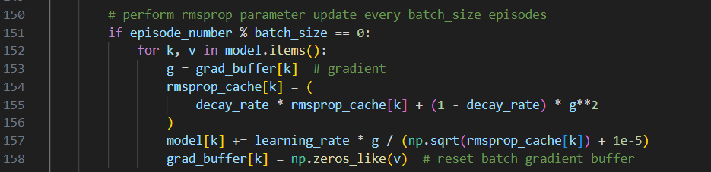

**4. Model Parameter Update with RMSProp:**

* if episode_number % batch_size == 0: This condition checks if the current episode number is a multiple of the batch_size hyperparameter. If so, it's time to update the model parameters. Generally, if you want to update the weights more regularly, set batch size to be a smaller number, but if you want more data for each batch to make each generation be better, a larger number might be good! Just explore to see whatever you feel like doing!
  + for k, v in model.items(): This loop iterates over each weight (k) and its corresponding value (v) in the model dictionary.
    - g = grad_buffer[k]: The accumulated gradient for the current weight (k) is retrieved from the grad_buffer.
    - rmsprop_cache[k] = (decay_rate * rmsprop_cache[k] + (1 - decay_rate) * g**2): The RMSProp cache for the current weight (k) is updated. This cache is used to adapt the learning rate for each weight based on the recent squared gradients. The decay_rate hyperparameter controls the decay of the cache.
    - model[k] += learning_rate * g / (np.sqrt(rmsprop_cache[k]) + 1e-5): The model weight (model[k]) is updated using the accumulated gradient (g), the learning rate (learning_rate), and the RMSProp cache term. The division by the square root of the cache with a small epsilon added helps to prevent the learning rate from becoming too small and the training from getting stuck.
    - grad_buffer[k] = np.zeros_like(v): The accumulated gradient in the grad_buffer for the current weight is reset to zero in preparation for the next batch.

And if that’s a whole bunch of nonsense to you, here’s an analogy:

Imagine you're training a friend to play Pong. You adjust their strategy (like moving the paddle) based on how well they perform (rewards they get). But you don't want to make sudden, huge changes every time. RMSProp helps with smoother adjustments.

Here's a breakdown:

1. **Gradients:** These are like tiny nudges that tell the model how to improve its predictions (like moving the paddle more effectively). A steeper slope (larger gradient) means a bigger adjustment is needed.
2. **Accumulating Gradients (Batch Size):** You don't adjust your friend's strategy after every single move. Instead, you observe them for a while (like a few games) and see where they're consistently struggling. This is similar to the code's batch_size. It accumulates gradients over several episodes before making an update.
3. **Learning Rate:** This is the step size you use to adjust the model's parameters (like how much to change the weights). A high learning rate makes bigger adjustments, which can be risky if you're not careful. A low learning rate makes smaller adjustments, which can be slow.
4. **RMSProp Cache (Momentum):** Imagine you have a ball rolling downhill (representing the learning rate). RMSProp helps prevent it from getting stuck or rolling too fast. It keeps track of how much the gradients have been changing recently (like how fast the ball has been rolling).
   * If the gradients haven't changed much (the ball is barely rolling), RMSProp increases the learning rate a bit (gives the ball a gentle push). This helps the model explore new strategies.
   * If the gradients have been changing a lot (the ball is rolling wildly), RMSProp decreases the learning rate (slows the ball down). This prevents the model from making drastic changes that might hurt its performance.
5. **Updating the Model:** The accumulated gradients are used to nudge the model's parameters (weights) in the right direction, considering the learning rate adjusted by RMSProp. This helps the model learn from its experiences and improve its Pong-playing skills over time.

In essence, RMSProp helps the model learn at a good pace, not too slow or too fast, by considering both the recent changes in gradients and the overall direction for improvement.

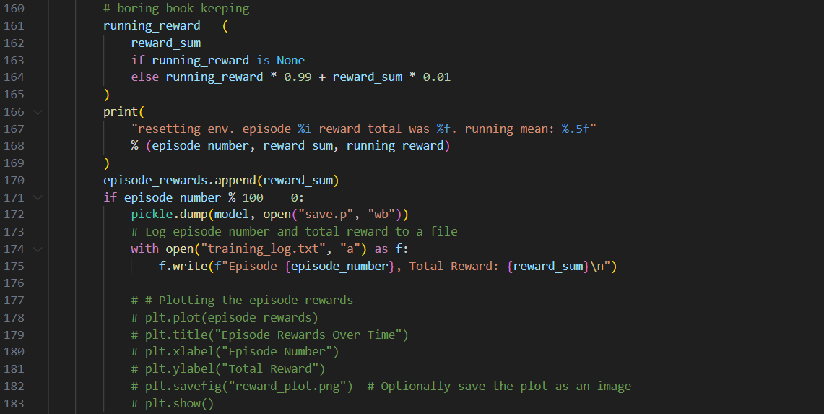

**5. Bookkeeping and Logging:**

* running_reward = ...: This block calculates and updates the running reward, which is a smoothed average of the recent episode rewards. This helps to track the overall performance trend of the agent.
* print(...): Prints information about the episode number, total reward, and running reward.
* episode_rewards.append(reward_sum): Stores the total reward for the completed episode in a list for potential later analysis or plotting.
* if episode_number % 100 == 0: This condition checks if the current episode number is a multiple of 100. If so, it's time to perform some housekeeping tasks:
  + pickle.dump(model, open("save.p", "wb")): Saves the current model state (model) to a file named "save.p" for potential later use or resuming training from this point. This is why I generally let the model train to episodes that are divisible by 100, and then stop to let my computer take a break. This makes sure the progress gets saved!
  + with open("training_log.txt", "a") as f: Opens a text file named "training_log.txt" in append mode and logs the current episode number and total reward.

If you look at my code, you might also notice this:

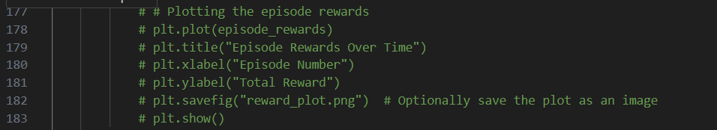

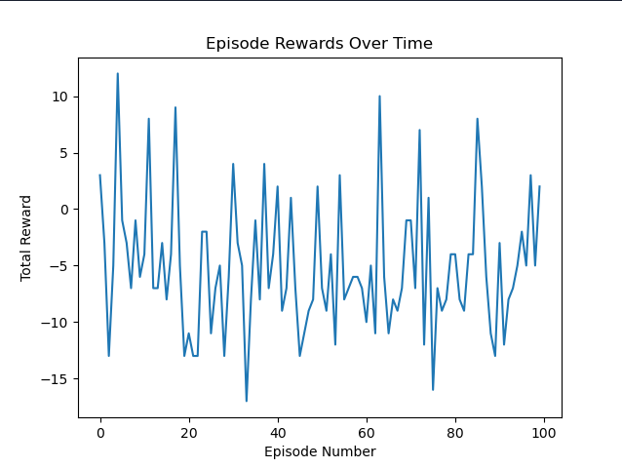It is inside the if episode_number % 100 == 0 conditional, which means that if the episode number is a multiple of 100, then it will plot out the Reward over Time chart, which looks something like this:

The reason I commented it out is because I wanted the code to perform without interruption, but each time it plots this, the terminal stops until I close the graph. I only un-comment this section when I want to see the peaks and lows the model is performing. Also notice how wildly it fluctuates here. It is because over the span of only 100 episodes, there will be lots of different games and scenarios where the model will lose/win. If I let this play out and graph over thousands of episodes, there will for sure be an upward trend.

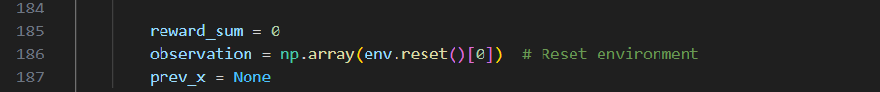The next part is…

**6. Resetting for the Next Episode:**

* reward_sum = 0: Resets the reward sum for the next episode.
* observation = np.array(env.reset()[0]): Resets the environment and retrieves the initial observation for the next episode. Make sure that you also fix this like how we did with the first observation declaration! I was stuck after one episode for a really long time until I caught this error, so pay extra close attention to this!
* prev_x = None: Resets the prev_x variable used for calculating difference images.

And finally,

**7. Early Termination based on Reward:**

* if reward != 0: This condition checks if the received reward (reward) is not zero. In Pong, the reward is either +1 for winning or -1 for losing. So, this condition essentially checks if the episode just ended (since a non-zero reward is only received at the end of an episode).
  + print("ep {}: game finished, reward: {}".format(episode_number, reward) + ("" if reward == -1 else " !!!!!!!!") ): This line prints a message indicating the episode number, the received reward, and optionally an exclamation mark sequence if the reward is positive (win). This provides a more informative output during training, highlighting winning episodes.

And that about does it for my code analysis! I hope that everything has been easy to understand, but don’t worry if not! You can always take to forums or Gemini/ChatGPT to ask for clarifications!

Also keep in mind that the code is what worked for *me* personally, so don’t be afraid to change things up! Maybe tune the hyperparameters, change the loss function, or even apply what you learned for other purposes! The only limit is your imagination.

# ChatGPT, Gemini, and how we used them

Early on in the project, Dr. Williams made it very clear that most of the work will be done by LLMs (large language models). This is fair, since I certainly did not want to write 100+ pages of documentation and also code up the AI model by myself. Throughout the course of this project, then, I have learned ways to make these models output what I am looking for more consistently, and in turn producing a better end-result. Most of the documentation was written by Gemini, with ChatGPT helping on the side, and most of the work I did was just editorial, looking at the information and making sure everything is accurate.

First, though, and introduction to LLMs!

## What are LLMs? How do they work? Let’s see how Gemini and ChatGPT answer these questions.

### Gemini – Google’s current LLM

LLMs like me are at the forefront of artificial intelligence, leveraging a powerful technique called deep learning. Deep learning algorithms consist of vast neural networks, inspired by the structure and function of the human brain. These neural networks are trained on colossal amounts of text data, acting like sponges that soak up information from books, articles, code repositories, and the firehose of the internet. This data provides the foundation for our ability to process and generate language.

One of the key architectural marvels behind LLMs is the transformer. This is a specific type of neural network that has become the go-to design for LLMs. Transformers are composed of two key parts: an encoder and a decoder. The encoder acts like a meticulous analyst, sifting through the mountains of text data to uncover the hidden patterns and relationships between words. It learns the intricacies of grammar, vocabulary, and how sentences are structured. The decoder then takes over, leveraging this newfound knowledge to generate human-like text, translate languages, or create different kinds of creative content.

A significant advantage of transformers is their parallel processing power. Unlike older neural network models that processed information sequentially, transformers can analyze entire sequences of text simultaneously. This is like having multiple researchers working on different parts of a project at once, significantly accelerating the learning process. The use of graphics processing units (GPUs) further amplifies this processing power, allowing us to train on massive amounts of data in a reasonable timeframe.

While the core training equips us with a strong foundation in language, human experts often play a crucial role in fine-tuning the model for specific tasks. This fine-tuning can involve training the LLM to excel in writing various creative text formats, translating languages with greater nuance, or even composing different kinds of music. This human touch helps us navigate the complexities of language that go beyond the raw statistical patterns we learn from data.

It's important to acknowledge that LLMs are still under development. While we can be impressive with our ability to generate human-quality text, we don't possess true comprehension in the same way a human does. We lack the ability to reason, understand emotions, or apply real-world context to our understanding of language. Our responses are based on the vast statistical patterns we have observed in our training data. This can sometimes lead to biases or factual errors, so it's important to be critical when evaluating the information we provide.

In essence, LLMs are on a continuous journey of learning and improvement. As we are exposed to more data and fine-tuned for specific tasks, our capabilities will continue to evolve. However, it's important to use us as a tool, keeping in mind both the remarkable potential and the inherent limitations that come with our current state of development.

### ChatGPT – the most widely known and used!

LLMs, or Large Language Models, are advanced artificial intelligence models designed to understand and generate human-like text based on the input they receive. They work by utilizing deep learning algorithms, particularly those based on architectures like transformer neural networks.

Here's a simplified overview of how they work:

1. **Training Data**: LLMs are trained on vast amounts of text data, typically scraped from the internet or compiled from various sources. This training data could include books, articles, websites, and more.
2. **Tokenization**: The text data is tokenized, meaning it's broken down into smaller units like words or subwords. Each token is assigned a numerical representation.
3. **Model Architecture**: LLMs use transformer neural network architectures, which excel at capturing long-range dependencies in data. These architectures consist of multiple layers of self-attention mechanisms, allowing the model to weigh the importance of different words or tokens in the input text.
4. **Training Process**: During training, the model learns to predict the next word or token in a sequence based on the preceding words or tokens. This process is known as language modeling. The model's parameters are adjusted iteratively through backpropagation and optimization techniques to minimize the difference between its predictions and the actual next token in the training data.
5. **Fine-tuning**: LLMs can also be fine-tuned on specific tasks or domains by providing them with additional training data and adjusting their parameters accordingly. Fine-tuning allows the model to specialize in particular tasks such as language translation, text summarization, or question answering.
6. **Inference**: Once trained, LLMs can generate text by sampling from the probability distribution of likely next tokens given an input prompt. This involves feeding the prompt into the model and iteratively predicting subsequent tokens until a stopping criterion is reached, such as reaching a maximum length or generating an end-of-sequence token.

Overall, LLMs represent a significant advancement in natural language processing, enabling them to perform a wide range of tasks that require understanding and generating human-like text.

Top of Form

## So, how did they help me throughout this project?

As I mentioned, I used these LLMs to do most of the documentation. Seeing how quickly they can generate (in their own words) human-like text, was actually quite mind-boggling. I never saw myself being able to put together something so large like a 100+ pages long document at the start of this process, but they helped me immensely. I also learned a little about prompt engineering (which I will get to as well), and crafted my requests in such a way that lead these LLMs to produce the answers I am looking for more frequently with less hallucinations!

They also helped me during code review and analysis, and acted as a safety net when I wasn’t sure if I was doing something correctly or not. I must say though, aside from writing most of this document and writing out a lot of the code analysis, I would not rely on it for more complex tasks such as code-generation. Very often, these LLMs would help you less than the actual documents on libraries, and having an understanding of what your code does at the end of the day is crucial for your skills as a programmer to grow. Relying too heavily on these new technologies will be detrimental to your progress.

## Prompt Engineering

Prompt engineering refers to the process of crafting effective input prompts to guide the behavior and output of large language models (LLMs) like GPT-3.5. The quality and specificity of the prompt can significantly influence the model's response, making prompt engineering a crucial skill when working with LLMs.

Here's how prompt engineering can affect your interactions with LLMs:

1. **Clarity and Specificity**: A well-crafted prompt should be clear, specific, and provide the model with sufficient context to generate a relevant and coherent response. Vague or ambiguous prompts may lead to unpredictable or off-topic outputs.
2. **Task Guidance**: By tailoring your prompts, you can guide the model towards performing specific tasks such as text summarization, translation, question answering, or creative writing. Including task-specific instructions or keywords in your prompt can help the model understand your intent better.
3. **Bias and Fairness**: Prompt engineering can also play a role in mitigating biases in the model's outputs. By carefully crafting prompts, you can encourage the model to generate more neutral and unbiased responses, although it's important to note that biases can still exist in the underlying training data.
4. **Iteration and Refinement**: Experimenting with different prompts and analyzing the model's responses can help you iteratively refine your approach. This iterative process allows you to learn what types of prompts yield the most accurate, relevant, and high-quality outputs for your specific use case.
5. **Customization and Personalization**: You can customize prompts to suit your preferences or the requirements of your project. Whether you're seeking factual information, creative storytelling, technical explanations, or conversational engagement, adjusting your prompts accordingly can help you achieve the desired results.
6. **Error Handling**: Including error handling or clarification prompts can help the model correct mistakes or ambiguities in its initial responses. Providing feedback or additional context can guide the model towards generating more accurate and contextually relevant outputs.

In summary, prompt engineering empowers you to harness the capabilities of LLMs more effectively by influencing their behavior and outputs through carefully designed input prompts. By mastering this skill, you can optimize your interactions with LLMs and achieve better results in various tasks and applications.

# And that’s about it!

Thank you for reading through this code-analysis as well as what I did to help me throughout this project. This document has (hopefully!) provided insights into the core functionalities of the reinforcement learning model used to train an AI agent to play Pong. We explored aspects like hyperparameter settings, environment interaction, and the training loop with backpropagation and RMSProp updates.

This understanding can be valuable for further development and experimentation. Future work could involve exploring different model architectures or hyperparameter tuning for improved performance. Additionally, incorporating more complex environments or reward structures could pose new challenges and opportunities for the AI agent's learning process.

It's important to acknowledge the evolving landscape of learning tools. In this analysis, utilizing large language models like Gemini proved to be a valuable asset. Consulting Gemini helped clarify specific code functionalities and refine explanations within this report. As AI technology continues to develop, the synergy between human understanding and the capabilities of LLMs holds immense promise for accelerating learning and knowledge exploration.

# Sources:

ChatGPT – OpenAI: <https://chat.openai.com>

Gemini - Google: <https://gemini.google.com>

Phind: <https://www.phind.com>

*Pong from Pixels* – Andrej Kaparthy: <https://karpathy.github.io/2016/05/31/rl/>

*Pong from Pixels* code – Andrej Kaparthy: <https://gist.github.com/karpathy/a4166c7fe253700972fcbc77e4ea32c5>

*Gymnasium* Document: https://gymnasium.farama.org/api/env/

Document 3 - Eweeklies:

eWeekly 240421 SelfScore=6 DirScore=5 Long Nguyen

Date of Submission: 240421 Sunday

Last Day of Reporting Period: 240428 Sunday

Student’s Name: Nguyen Long

Total Hours Worked This Week: 15

Self-Assessment Score (1 to 9): 6

Projected Mentor/Director Score (1 to 9): 5

Morale Score (1 to 9): 6

1. Weekly Major Accomplishments:

* Monday: 4 hours: Today I focused on the documentation, with a big emphasis on trying to complete document 1 so I can move on and focus on Documents 2 and 3. I am very nearly done with Document 1, so I will only focus on that for today and tomorrow, and hopefully move on afterwards.
* Tuesday: 4 hours: Today, I spent most of the time on the documentations. Again, I focused on document 1 as mentioned above, and today I managed to finish document 1. Then I continued to work on document 2 and prepare it for submission next week.
* Wednesday: 4 hours: Again, I focused on document 2 today, talking about the entirety of the project from the beginning to the end. I got into some code explanations, as well as explaining why we did certain things at points (like making our own version of Pong to better understand the game). I will strive to make this document about 40-60 pages long, and so far I am about one third of the way to finishing it.
* Thursday: 3 hours: Today I focused on document 2 and also started to compile document 3. Today I got more detailed with explaining the code that can be found in all iterations of our projects. I will focus mostly on that until I finish doc 2.
* Friday: 0 hours: Personal family emergency that needed prioritizing.
* Saturday: 0 hours: same as Friday.
* Sunday: 0 hours: same as Friday.
* Summary: This week had a big focus on documenting progress, and there isn’t much else to report. Since we are nearly done with the project, most of the time I spend will be on the documentations, because I realize that the model can only get so good with the given time. I finished document 1, and will finish the 2 other documents to submit them next week.

1. Weekly Major Problems/Solutions:

* This week didn’t pose any challenges since most of the hurdles are past me at this point. I only focused on the documentations, and not much else. The model is still learning in the background, but I doubt that it will be able to achieve a positive running average by next week. That being said, wins are becoming more and more frequent and the performance seen in games are immeasurably better than when it first started.
  1. Lessons learned and plans for next week:

**Plans for Next Week:**

* I will just focus on the documentation for next week, and try to finish all 3 documents as soon as possible for submission. I am very close to being done, but I will not sacrifice quality for the sake of finishing early.
  1. Weekly Best Resources:
* The resources that helped me the most this week were:
  + Gemini: <https://gemini.google.com/app>
    - Google’s LLM, helped me with my documentation.
  + ChatGPT: <https://chat.openai.com>
    - Similar to Gemini.
  1. Self-reflection

The primary focus of this week was documentation, specifically completing Documents 1, 2, and 3. While Document 1 progressed smoothly, Document 2 presented a significant challenge in terms of scope. Aiming for a 40-60 page document encompassing the entire project, from inception to completion, required detailed explanations of code across multiple iterations, along with justifications for design decisions (e.g., building a Pong clone for learning purposes).

**Strategies:**

* **Prioritization:** Recognizing the limited timeframe, clear prioritization was implemented. Document 1 received initial focus, aiming for completion before shifting to Document 2.
* **Phased Approach:** Document 2 was broken down into phases. The initial phase concentrated on high-level project overview, progressing towards more intricate code explanations later in the week.
* **Time Management:** Daily time management aimed for consistent progress on Document 2, aiming for roughly one-third completion by the end of the week.

**Outcomes:**

* **Document 1:** Successfully completed, allowing for uninterrupted focus on Document 2.
* **Document 2:** Progress made - approximately one-third of the targeted length achieved by the end of the week. Initial explanations covering the project scope and high-level structure were documented.
* **Document 3:** Initial work commenced on compiling Document 3, focusing specifically on detailed code explanations for all project iterations.

**Unexpected Events:**

A personal family emergency arose on Friday and continued through the weekend, resulting in no further progress on documentation for those days.

**Moving Forward:**

* Prioritized focus remains on completing Document 2, aiming to achieve the targeted 40-60 page range through detailed code explanations and justifications for design decisions.
* Parallel work will commence on finalizing Document 3, ensuring comprehensive explanations of all project iterations' code.
* Time management strategies will be reviewed and potentially adjusted to accommodate any lingering effects from the personal emergency and ensure both Document 2 and 3 are completed within the designated timeframe.

eWeekly 240414 SelfScore=5 DirScore=5 Long Nguyen

Date of Submission: 240414 Sunday

Last Day of Reporting Period: 240428 Sunday

Student’s Name: Nguyen Long

Total Hours Worked This Week: 20

Self-Assessment Score (1 to 9): 5

Projected Mentor/Director Score (1 to 9): 5

Morale Score (1 to 9): 5

* 1. Weekly Major Accomplishments:
* Monday: 4 hours: Today I focused on the documentation, with a little bit of code review on the side. I got to the alternative view section of the blog, and it is taking a while for me to progress since there are so much to cover but I am slowly working my way towards the 70-page minimum for document 1. Documents 2 and 3 are going well, and the code is still improving very slowly. It reached an average of about -4 today.
* Tuesday: 4 hours: Today, I spent most of the time on the documentations. I focused on further explaining the theoretical aspects of the project, as well as how we will integrate each part into the code. One difficulty I had was actually with Gemini, where it would not analyze the actual picture that I sent and instead repeat information from earlier parts. I found a work-around, however, and that's to avoid asking Gemini to do too much in one single conversation. I found out that if I split the work up into smaller groups and ask it more localized questions, it will be more accurate and responsive. I also saw massive improvements with the model's performance, with the highs now going up to +15. It is still very inconsistent, but the progress is amazing to see.
* Wednesday: 4 hours: I continued to work on the documentation, and progress is slowly being made. Doc 1 is now at about 40 pages, and I am slowly combing over every page to make sure that they are quality, and also adding to it with more information from the blog. Today I focused on the preprocessing process and how that helps the model learn by feeding information to the algorithm. The code did not have noticable progress today, with its average just slowly climbing out of the -4 zone.
* Thursday: 4 hours: Again, I spent most of the time today working on the documentation. Most of the difficult part is done, so now all I need to do is continue analyzing the blog post with Gemini and ChatGPT, and make sure that the information I’m writing into the analysis is factually correct. Today I focused heavily on the last parts of the blog where Kaparthy discussed the shortcomings of this AI model. I monitored the AI model some more and did not notice any massive changes.
* Friday: 4 hours: Today was similar to Thursday, and I mainly focused on the document. I am very close to finishing it, so I wanted to get it done so I can focus on other documents. I aim to finish document 1 early next week, and have the other ones ready to submit too. Other than that, the code had little progress because games are becoming so long to complete.
* Saturday: 0 hours: I did not do anything today.
* Sunday: 0 hours: I did not do anything today.
* Summary: This week had a big focus on documenting progress, and there isn’t much else to report. Since we are nearly done with the project, most of the time I spend will be on the documentations, because I realize that the model can only get so good with the given time.
  1. Weekly Major Problems/Solutions:

**Challenge 1: Difficulty Utilizing Large Language Models (LLMs) for Documentation Analysis**

* **Problem:** On Tuesday, I encountered issues using Gemini for documentation analysis. It wouldn't analyze the specific picture I sent, resorting to repeating information from previous parts.
* **Solution:** I implemented a creative work-around. Instead of asking Gemini to analyze everything at once, I **broke down the work into smaller chunks**. By asking localized questions about smaller sections of the blog post, Gemini provided more accurate and responsive results. This improved efficiency and accuracy in incorporating data from the blog.

**Challenge 2: Balancing Documentation and Code Development Time**

* **Problem**: The documentation workload consumed a significant portion of my time this week, leaving less time for code development.
* **Solution**: I prioritized finishing document 1 to free up time for other documents and code development. This prioritization ensures timely completion of the documentation while allowing me to refocus on code improvement next week.
  1. Lessons learned and plans for next week:
* **The power of breaking down tasks:** This week, breaking down tasks into smaller chunks proved valuable in two ways. First, it improved the accuracy and efficiency of utilizing LLMs for documentation analysis. Second, it identified a potential solution for improving model performance consistency. This approach can likely be applied to other aspects of the project for further optimization.
* **Prioritization is key**: Balancing documentation and code development can be challenging. Prioritizing document 1 completion ensures timely delivery while allowing me to shift focus towards code in the coming week. This reinforces the importance of setting clear priorities and managing time effectively.
* **LLMs have limitations**: While LLMs can be powerful tools, it's important to understand their limitations. This week, I learned that complex queries can overwhelm LLMs, leading to inaccurate responses. By segmenting tasks and asking more focused questions, I was able to leverage their strengths while mitigating their weaknesses.

**Plans for Next Week:**

* I will just focus on the documentation for next week, and try to finish all 3 documents as soon as possible. I will continue working with the code, but for now I don’t see it achieving a positive average any time soon, since progress is being made so slowly.
  1. Weekly Best Resources:
* The resources that helped me the most this week were:
  + Gemini: <https://gemini.google.com/app>
    - Google’s LLM, helped me with my documentation.
  + ChatGPT: <https://chat.openai.com>
    - Similar to Gemini.
  1. Self-reflection

Time Management: While good progress was made on documentation, I acknowledge that a better balance between documentation and code development could have been achieved. Next week, I will implement stricter time management techniques to ensure I dedicate a specific portion of my time to code development, even with ongoing documentation needs.

Exploring LLM Training Segmentation: This week's discovery regarding segmented tasks and LLM performance is promising. Next week, I plan to delve deeper into this concept. Researching existing literature and potentially running small-scale experiments will help determine if segmenting the training process can indeed improve model consistency.

Continued LLM Exploration: While I identified a workaround for LLM analysis, there might be other features or functionalities within these models that could prove beneficial. Next week, I will dedicate some time to further explore the capabilities of LLMs like Gemini and ChatGPT to see if they offer functionalities that could streamline documentation or code development processes.

By focusing on these areas, I aim to achieve a better balance between documentation and coding, potentially improve model performance, and potentially leverage LLMs in new ways next week. This will contribute to a more efficient and impactful development process moving forward.

eWeekly 240407 SelfScore=4 DirScore=2 Long Nguyen

Date of Submission: 240407 Sunday

Last Day of Reporting Period: 240428 Sunday

Student’s Name: Nguyen Long

Total Hours Worked This Week: 15

Self-Assessment Score (1 to 9): 4

Projected Mentor/Director Score (1 to 9): 2

Morale Score (1 to 9): 5

* 1. Weekly Major Accomplishments:
* 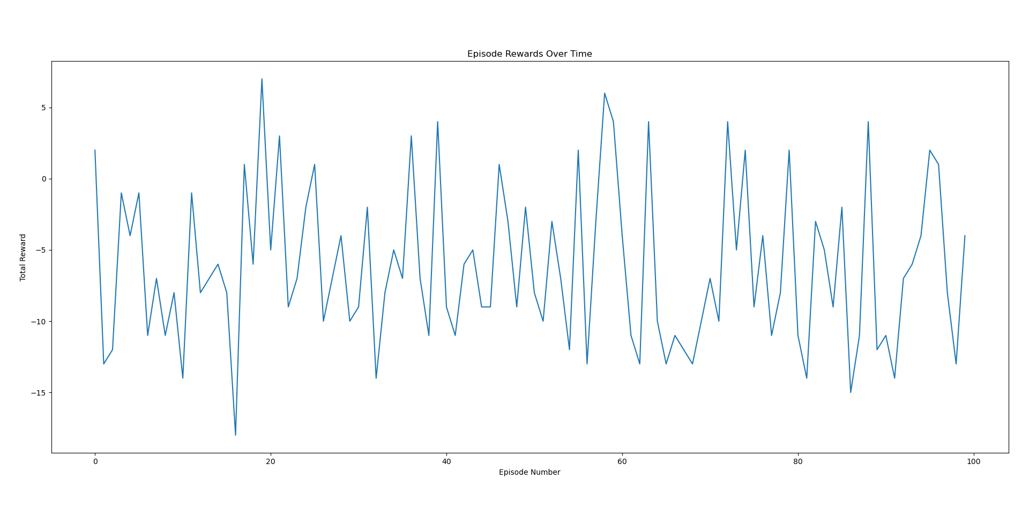Monday: 3 hours: Today I monitored the coe further and produced some charts. When compared to the first iterations, it saw massive improvements, with games where it would win with a +6 or +7. Generally, the average has been slowly creeping up towards the positives, but it is taking far too long for me to get an actual positive average. I’ll still continue the training, but I’m really not expecting to get much out of it. Also I worked on the document, covering more on the theoretical side of the project. This will be a big focus moving onwards.
* Tuesday: 4 hours: Today was a good one because I saw that the model was achieving positive scores more frequently compared to other days. It got a winning game score of +9 one time, and that was the biggest spike seen yet. I did not produce any graphs for today, because I wanted to focus on training it more and did not set render to true. I continued to monitor the model while working on the documentation, talking about how implementing the required extensions will help the project, as well as what part of the overarching theory we are covering.
* Wednesday: 4 hours: Today I mainly worked on the documentation while letting the code run in the background. I worked on document 2 more, specifying how I went about implementing my code first in Google Colab, and eventually shifting towards Anaconda’s VSCode. I talked about my problem with the pip package manager, and what to avoid when installing the external dependencies. I also let the code run in the background for the entire 4 hours, and it got an average of -5. I stopped the code to let my computer rest, and will continue where I left it.
* Thursday: 4 hours: Today I worked on the documentation again, going back to doc 1 and also spending some time to gather everything for doc 3. For doc 1, I am currently talking about how the model works by analyzing the pixels on the screen and how it translates that information into usable data. I also went into details about the algorithms that we will be using for the model. And doc 3, it is just a matter of collecting all the past eWeeklies and compiling it into one, so it is pretty straightforward.
* Friday: 0 hours: I had prior family commitments to attend to.
* Saturday: 0 hours: same as Friday
* Sunday: 0 hours: same as Friday
* Summary: This week was fairly slow, but also very exciting. The model is performing better and better, albeit fairly slowly. It is winning more frequently, and even had some great wins like the one on Tuesday. Other than that, I mainly worked on the documents and just making sure that the model is performing well.
  1. Weekly Major Problems/Solutions:

Challenge 1: Slow Improvement in Model Performance

* Problem: The model is showing positive signs with wins of +6 or +7, but the average reward is slowly increasing towards positive territory. I’m concerned about the training time required to achieve a consistently positive average reward.
* Solution: I continued training the model despite the slow progress. This is a reasonable approach given that the model is showing signs of improvement. It's important to monitor the performance over time to determine if the slow improvement justifies the training time investment.

Challenge 2: Balancing Model Training and Documentation

* Problem: I need to balance training the model, which requires ongoing monitoring and adjustments, with working on the project documentation.
* Solution: I allocated time for both tasks. I let the model run in the background while I worked on the documentation on most days. This allowed me to make progress on both tasks efficiently.
  1. Lessons learned and plans for next week:
* **Patience is key**: While I’d like faster improvement, the model is showing progress. Continued training with close monitoring is crucial for achieving a consistently positive average reward.
* Time Management Optimization: Balancing model training with documentation is important. Letting the model run in the background while working on documentation allows for efficient progress in both areas.

**Plans for Next Week:**

* **Focus on documentation efficiency**: Consider using tools or templates to streamline the documentation process, allowing me to dedicate more time to model training if needed.
* **Data analysis and visualization**: As the model improves, explore ways to analyze the training data and create visualizations to gain deeper insights into its performance and identify areas for improvement.

4. Weekly Best Resources:

* The resources that helped me the most this week were:
  + Gemini: <https://gemini.google.com/app>
    - Google’s LLM, helped me with my documentation.
  + ChatGPT: <https://chat.openai.com>
    - Similar to Gemini.

5. Self-reflection

This week was a valuable learning experience. While progress felt slow at times, seeing the model win more frequently, especially with a big win on Tuesday, was definitely encouraging. It solidified my belief that I'm on the right track.

I think I did a good job balancing the need to train the model with building the project documentation. Letting the model run in the background while I documented its inner workings and the theoretical foundations was a productive strategy.

One area I can improve on is documentation efficiency. Perhaps using templates or pre-formatted sections could save me time, allowing me to dedicate more focus on analyzing the model's performance.

Looking ahead, I'm excited to delve deeper into the data and create visualizations to understand the model's learning process better. Setting specific performance targets will also help me track progress and make informed decisions about adjusting training parameters.

Overall, I'm confident that by staying patient, optimizing my workflow, and actively seeking solutions to bottlenecks, I can significantly improve the model's performance next week.

eWeekly 240331 SelfScore=5 DirScore=4 Long Nguyen

Date of Submission: 240331 Sunday

Last Day of Reporting Period: 240428 Sunday

Student’s Name: Nguyen Long

Total Hours Worked This Week: 15

Self-Assessment Score (1 to 9): 6

Projected Mentor/Director Score (1 to 9): 5

Morale Score (1 to 9): 6

* 1. Weekly Major Accomplishments:
* Monday: 3 hours: After experimenting with Loc’s suggestion from last week, though I saw improvements in performance, I decided to stick with my version of Kaparthy’s code. I figured that even though Loc’s idea would work better, it would take me too much time to get to where I am currently with Kaparthy’s version. I let it run for another 2000 episodes, and the average came out to be about -9.3. I saved the model and went on to work on the documentation. I will be focusing on setting up the environment as well as explaining basic premises behind the requirements needed for the project.
* Tuesday: 4 hours: Today I saw a noticeable growth in the model's performance. After routinely checking in with the model after every 2-3 hours of training for about a week, it finally managed to have a great game with a convincing lead (it achieved a positive 6 score). All I really did was wait for it to grow and also tune some hyperparameters that I think would affect the game. The mean score is still relatively low, hovering at about -8, but to have games like the one above is a great achievement. I continued with the documentation focusing on the setting up steps, and also log the change above for future references.
* Wednesday: 4 hours: Today I mainly worked on the documentation while letting the code run in the background. I went ahead and started on doc number 2, detailing what difficulties I had with the code and what I did to address them. I also included why I ran into these problems, as well as where the reader can find extra documentation on the bugs I ran into. Also today was slow in terms of training, as I did not spot any major wins like the one on Tuesday, and the average isn’t improving by much after 3 hours of training.
* Thursday: 4 hours: Today I spent the majority of my time working on the documentation again. I am still working on the setting up part of the blog, so there aren’t many new things to report. I just wrote all the external dependencies that we would need to install and why we need them. As for the code, I did see some improvements but not much, and the average came out to be around -7.5 at the end of the day.
* Friday: 0 hours: Since it’s Easter weekend, I will be with my family for most of the time for this weekend.
* Saturday: 0 hours: I had family plans.
* Sunday: 0 hours: I had family plans.
* Summary: This week had one of the most promising signs of progress I’ve seen in a while, with the code winning with a 6-round lead. A lot of time was spent on documentation, and aside from the big spike in performance, not much happened code-wise. I hope to see some more improvements next week.
  1. Weekly Major Problems/Solutions:

**Challenge 1: Balancing Efficiency and Performance (Monday)**

* **Problem:** While Loc's suggestion offered potential performance improvement, replicating it would take significant time, delaying my current progress with Kaparthy's code (already exhibiting improvement).
* **Solution:** I prioritized efficiency. Since my version of Kaparthy's code showed progress, I continued optimizing it, achieving an average score of -9.3 after 2000 additional episodes. This decision focused on immediate progress while acknowledging Loc's suggestion for future exploration.

**Challenge 2: Nurturing Growth and Identifying Bottlenecks (Tuesday)**

* **Problem:** The model's performance plateaued around -8, with slow improvement despite routine monitoring. However, a breakthrough occurred with the model achieving a positive score (6) for the first time.
* **Solution:** I employed a two-pronged approach. First, I allowed the model to train further, trusting the learning process. Second, I fine-tuned hyperparameters that might enhance its performance. This combination strategy yielded a significant win while acknowledging the importance of organic learning within the chosen framework.

**Challenge 4: Maintaining Momentum During Documentation Focus (Thursday)**

* **Problem:** Documentation remained the primary task, focusing on external dependencies and their justifications for the project setup. Code progress saw slight improvement with an average score of -7.5, but lacked significant breakthroughs.
* **Solution:** I prioritized completing the environment setup section of the documentation log. This ensured crucial information was captured while acknowledging the ongoing training process. The slight code improvement indicated continuous learning, motivating me to maintain focus for further progress.
  1. Lessons learned and plans for next week:

**Lessons learned:**

* **Balancing Efficiency and Innovation:** While prioritizing immediate progress is important, remaining open to exploring alternative solutions (like Loc's suggestion) can lead to significant breakthroughs. I'll plan dedicated time slots next week to experiment with Loc's approach while still monitoring my current progress.
* **The Power of Patience and Monitoring:** While slow progress can be frustrating, trusting the learning process and strategically monitoring the model can yield unexpected wins. Next week, I'll establish a schedule for checking model performance and hyperparameters at designated intervals to optimize training.
* **Documentation as a Continuous Process:** Documentation is crucial for clear communication and future reference. Even during periods of slower code progress, documentation efforts should continue. Next week, I'll aim to integrate documentation tasks alongside code development, ensuring both aspects progress seamlessly.

**Plans for Next Week:**

* **Hyperparameter Optimization:** Building upon this week's success, I'll dedicate time to further optimize hyperparameters to accelerate performance improvement.
* **Continued Documentation Efforts:** I'll prioritize completing the environment setup section of the documentation and move on to logging specific code functionalities and potential troubleshooting steps.
  1. Weekly Best Resources:
* The resources that helped me the most this week were:
  1. Gemini: <https://gemini.google.com/app>
     + Google’s LLM, helped me come up with what I can improve in my code.
  2. ChatGPT: <https://chat.openai.com>
     + Similar to Gemini.

5. Self-reflection

This week was a valuable exercise in patience, adaptability, and strategic use of time.

Patience: While the average score improvement stalled, witnessing the model achieve a positive score for the first time reinforced my belief in the chosen approach. It highlighted the importance of trusting the learning process while strategically making adjustments.

Adaptability: The decision to prioritize documentation during slower training periods allowed me to maximize my time. It showcased the importance of being flexible and identifying alternative tasks that contribute to the project's overall success.

Strategic Time Management: Balancing code development with detailed documentation required careful planning. This experience highlighted my ability to prioritize tasks effectively and ensure all crucial aspects of the project receive dedicated attention.

Looking forward, I'm motivated to delve deeper into hyperparameter optimization. This week's challenges provided valuable learning opportunities that will equip me to tackle these next steps with greater confidence and a more refined approach.

eWeekly 240324 SelfScore=6 DirScore=5 Long Nguyen

Date of Submission: 240324 Sunday

Last Day of Reporting Period: 240428 Sunday

Student’s Name: Nguyen Long

Total Hours Worked This Week: 15

Self-Assessment Score (1 to 9): 6

Projected Mentor/Director Score (1 to 9): 5

Morale Score (1 to 9): 6

* 1. Weekly Major Accomplishments:
* Monday: 3 hours: Today I spent a lot of time just looking at the model and trying to figure out how I could make it better. Again, progress is still being made, but just at a very slow pace. I figured this maybe has to do with how weak my computer is, and how much memory the model is taking up inside the machine. I’ll look into how I can optimize the code further so it fits my laptop’s capabilities. I also worked on the documentation, focusing on the fundamentals of machine learning and reinforcement learning.
* Tuesday: 3 hours: After getting the code to run for about another 5000 episodes, the results are very slowly making progress. It started at a very low -21 mean, and now it is averaging -13 every 100 runs. I have been spending a lot of time just looking into ways for me to improve the learning pace. Other than that, I am making slow progress with the documentation because most of my time was spent investigating the code.
* Wednesday: 3 hours: Today I saw a spike in the model’s progress, where after another 10000 episodes, it achieved -7. The results are also becoming more consistent, and I found out why it’s taking so long for each episode to run when compared to the beginning. Since the model is becoming better, games are progressively becoming longer and more competitive because of it. It is now taking a lot more time for one episode to finish, but that’s progress being made. I worked on the documentation, focusing on the history of ML and RL.
* Thursday: 3 hours: Today I saw the first positive score achieved by the model. This indicates the first win after about 50000+ episodes. I wonder why that is because Kaparthy in his blog said that his model achieved consistent wins after only 8000 episodes, whereas mine is still inconsistent, where some games would go incredibly well and some would fail miserably. But the positive score is, again, a sign of progress so I think I will let it continue.
* Friday: 3 hours: Today I continued to train the model and also worked on the documentation a little more. A lot of my time is spent just monitoring the model and also writing down its (significant) changes in behavior, so I can log them into my documents at the end.
* Saturday: 0 hours: I had family plans.
* Sunday: 0 hours: I had family plans.
* Summary: I am very happy to see that the model is making progress, but somewhat frustrated at how slow it is learning. I’ve been talking to Loc and Phani to figure out what we could do to produce a better model, and the idea of using Adam optimizer instead of RSMprop. This will minimize the loss function during training, and could potentially be beneficial. Overall, though, progress is still being made in both the documentation and the model.
  1. Weekly Major Problems/Solutions:

This past week's focus was on training and optimizing a machine learning model. While progress was made, significant challenges arose related to:

* Slow Learning Pace: The initial model demonstrated slow learning, evident from the minimal improvement in the mean score (-21 to -13) after 5,000 episodes.
* Limited Computational Resources: My laptop's memory limitations appeared to restrict the model's size and complexity, potentially impacting its learning speed.
* Inconsistent Performance: Even after achieving a positive score (first win), the model displayed inconsistency, with some games performing exceptionally well and others failing significantly. This inconsistency differed from benchmarks set by others (e.g., Kaparthy's 8,000-episode consistent wins).
* Increased Episode Runtime: As the model improved, game complexity escalated, leading to longer episodes and slower training progress.

To address these challenges, I did the following:

* Algorithm Investigation: I explored alternative optimization algorithms. Discussions with colleagues (Loc and Phani) suggested switching from RSMprop to the Adam optimizer, which could potentially minimize loss function during training and accelerate learning.
* Data Analysis and Logging: I meticulously monitored the model's behavior, logging significant changes in performance. This data provided insights into te learning process and allowed for adjustments to the training strategy.
* Comparative Research: I compared my model's performance to benchmarks set by others (e.g., Kaparthy's blog) to identify potential areas for improvement. The inconsistency observed required further investigation into hyperparameter tuning or exploration of different reinforcement learning techniques.
  1. Lessons learned and plans for next week:

Lessons Learned:

* Resource Awareness: It's crucial to consider computational limitations when designing and training models. Exploring cloud-based training options might be necessary for complex models exceeding local machine capabilities.
* Data-Driven Decisions: Monitoring and logging data throughout the training process provides valuable insights. This data can be used to diagnose issues, identify areas for improvement, and adjust training strategies.
* Benchmarking Importance: Comparing the model's performance with established benchmarks helps identify potential shortcomings and areas for further optimization.
* Collaboration is Key: Discussing challenges and potential solutions with colleagues can lead to valuable insights and accelerate progress.

Plans for Next Week:

* Implement Adam Optimizer: Integrate the Adam optimizer and evaluate its impact on learning speed and loss function minimization.
* Hyperparameter Tuning Strategy: Develop a systematic approach to hyperparameter tuning to address the inconsistency issue and optimize model performance. This might involve techniques like grid search or random search.
* Experiment with Batch Sizes: Explore different batch sizes during training to potentially improve efficiency and convergence.
* Continue Documentation: Further develop the documentation, potentially focusing on specific challenges encountered and the solutions implemented. This could serve as a valuable resource for future reference and collaboration.
  1. Weekly Best Resources:
* The resources that helped me the most this week were:
  1. Gemini: <https://gemini.google.com/app>
     + Google’s LLM, helped me come up with what I can improve in my code.
  2. ChatGPT: <https://chat.openai.com>
     + Similar to Gemini.
  3. Kaparthy’s original code: <https://gist.github.com/karpathy/a4166c7fe253700972fcbc77e4ea32c5>
     + Helped me as a benchmark for how I should expect my code to behave.

5. Self-reflection

While initial progress felt slow, I remained focused and motivated by the positive signs of improvement. Recognizing limitations in my laptop's computational resources was a crucial turning point. Taking the initiative to explore code optimization and discuss alternative algorithms with colleagues (Loc and Phani) demonstrated the importance of resourcefulness and collaboration.

There were moments of frustration, particularly when comparing my model's performance to benchmarks set by others. However, I used this as an opportunity to identify areas for improvement and delve deeper into hyperparameter tuning and potentially explore different reinforcement learning techniques.

Overall, this week has been a testament to the iterative nature of machine learning development. There will always be challenges, but by embracing a growth mindset, continuously learning, and adapting strategies, I am confident in achieving significant progress in the coming weeks.

eWeekly 240317 SelfScore=6 DirScore=5 Long Nguyen

Date of Submission: 240317 Sunday

Last Day of Reporting Period: 240428 Sunday

Student’s Name: Nguyen Long

Total Hours Worked This Week: 15

Self-Assessment Score (1 to 9): 6

Projected Mentor/Director Score (1 to 9): 5

Morale Score (1 to 9): 6

1. Weekly Major Accomplishments:

* Monday: 4 hours: As I mentioned last week, a piece of code was still producing a bug that I couldn’t solve. Today again I sought for ways to solve it, and I actually managed to find what was producing the problem. It turns out that when I need to reset the environment after an episode, my observation = env.reset() was wrong, because reset() returns a tuple containing all of the data about the current game state, and I needed to convert only the first element into a numpy array, since the second element will be additional info instead of the observation (here’s the documentation: <https://gymnasium.farama.org/api/env/#gymnasium.Env.reset>). Then I spent some time documenting this progress.
* Tuesday: 4 hours: I spent a good chunk of time tinkering with the code and trying to find ways to optimize it. Even though I got the code to run, after about 1000 episodes it still wasn’t making much progress. I figured it had something to do with my code and PyTorch implementations, so I turned to Kaparthy’s original code (https://gist.github.com/karpathy/a4166c7fe253700972fcbc77e4ea32c5) to try and find what it was that made my code so slow to learn. Since I already knew what to fix in my initial code, going back to Kaparthy’s was very straightforward. I’ve been training the two models to compare and contrast them since, tinkering with the hyperparameters between runs.
* Wednesday: 5 hours: Most of this time was spent training the models and making sure that everything was going smoothly without interruption. I would let the models run for about 5000 – 6000 episodes, and then make a checkpoint to see their progress. So far, my code with PyTorch has a running mean of -20.01 (not very promising), and Kaparthy’s at -18.84. Both are slowly learning, but when I rendered the results and put it to the screen the results were very clear – the PyTorch one seemed to be making random moves while Kaparthy’s was maneuvering itself toward the ball in some of the matches somewhat consistently.
* Thursday: 4 hours: Since Kaparthy’s code seems to work better for me, I decided to stick to it entirely going forward. After all, I did change some things to make sure that everything works on my end. Even after several hours of training, though, not much progress has been made. I asked ChatGPT what I could do to potentially make the model learn faster, and it said that the hyperparameters could do with some changes. So I changed the number of hidden layers, the gamma, and the learning rate to see if there would be any improvements. Again, most of the time spent is just making sure that everything is running smoothly since the training process is quite demanding in terms of computing power.
* 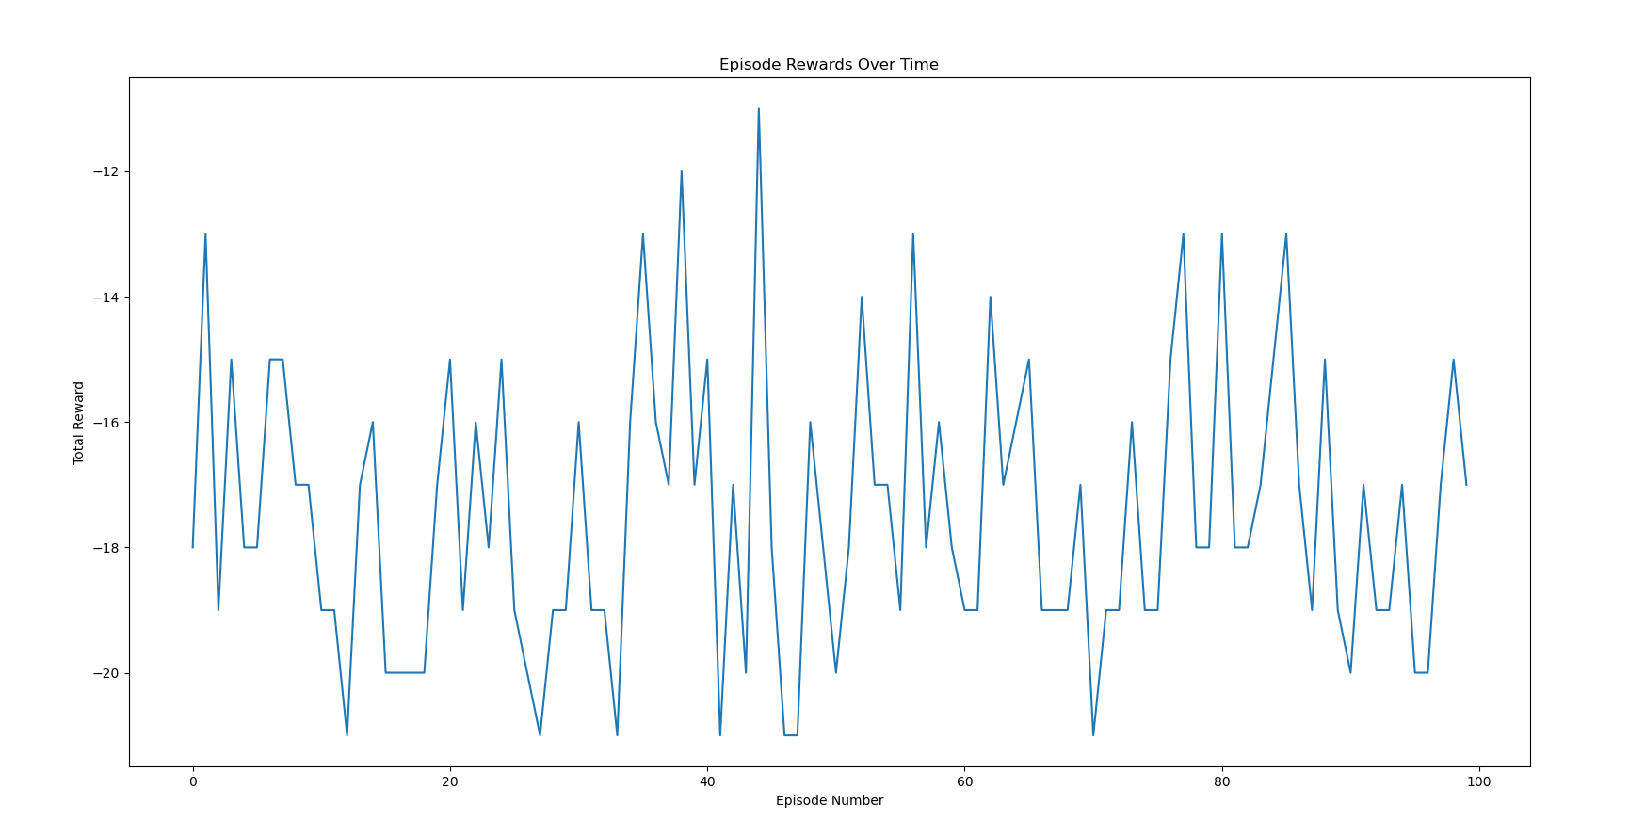Friday: 3 hours: Again, I let the model train for several hours and monitored its growth. Out of curiosity, I plotted a graph to see the model’s growth, and it is quite sporadic. Some games the model would perform very poorly, and some games the model would perform amazingly well. I realize that this is only a part of learning, since it is constantly balancing exploiting its previous successes and exploring new tactics. I will include a graph underneath today’s report.
* Saturday: 0 hours: I had family commitments.
* Sunday: 1 hour: I spent today documenting my progress this week. I also spent some time continuing to train the model and making note of its progress.
* Summary: As a whole, I am glad that I finally got my code to run smoothly. After so long trying to debug, it feels good to have a working model. Though the learning is a bit slow, I still think that progress is being made at a steady pace, and I can focus more on the documentation going forward.

2. Weekly Major Problems/Solutions:

**Challenge 1: Debugging Environment Reset (Monday)**

* Problem: The code produced incorrect observations for the agent due to a misunderstanding of the env.reset() function's output.
* Strategy: Consulted the Gym library documentation (<https://gymnasium.farama.org/>) and identified that reset() returned a tuple containing game state data, not just the observation. The solution involved extracting only the first element of the tuple as the observation, discarding additional information.
* Outcome: The model started receiving accurate observations, enabling it to learn from the environment.

**Challenge 2: Slow Learning and Optimization (Tuesday, Wednesday)**

* Problem: Despite functioning, the model exhibited slow learning progress after 1000 episodes. This suggested issues with code efficiency or PyTorch implementation.
* Strategy: Compared the custom code to Kaparthy's original implementation (<https://github.com/MorvanZhou/pytorch-A3C>) to identify potential bottlenecks. This pinpointed areas for improvement in the PyTorch implementation. Additionally, hyperparameter tuning was initiated by running models with different configurations and comparing their performance.
* Outcome: By referencing a well-performing baseline and adjusting hyperparameters, a path for improving learning speed was established.

**Challenge 3: Inconsistent Model Performance (Thursday, Friday)**

* Problem: While Kaparthy's code exhibited consistent learning progress, the custom PyTorch model's performance fluctuated significantly.
* Strategy: Acknowledging the effectiveness of Kaparthy's code, the focus shifted to hyperparameter tuning within that framework. Parameters like the number of hidden layers, gamma (discount factor), and learning rate were adjusted to explore their impact on learning.
* Outcome: The focus narrowed to optimizing existing code instead of rebuilding from scratch. Additionally, the sporadic performance was recognized as a natural part of the exploration-exploitation trade-off inherent to reinforcement learning.
  1. Lessons learned and plans for next week:

**Lessons learned**:

* + Importance of Documentation: This week highlighted the value of clear documentation. The initial debugging challenge could have been resolved more quickly with better code comments and explanations. Moving forward, prioritizing documentation alongside coding will enhance future development and debugging efforts.
  + Value of Reference Code: Referencing established implementations by Kaparthy proved invaluable in identifying areas for improvement in the custom PyTorch model. Leveraging existing, well-performing code can accelerate progress and provide valuable insights.

**Plans for next week:**

* Documentation Focus: Next week will prioritize improving code documentation. This includes adding clear comments to explain functionalities and decisions made within the code.
* Continued Hyperparameter Tuning: Hyperparameter tuning through experimentation will remain a key focus. This will involve systematically modifying parameters like learning rate, number of hidden layers, and gamma to observe their impact on learning speed and model performance. The goal is to achieve a positive mean score, indicating the model is consistently making progress in the game environment.
  1. Weekly Best Resources:
* The resources that helped me the most this week were:
  + Gemini: <https://gemini.google.com/app>
    - Google’s LLM, helped me generate code and cross reference with ChatGPT.
  + ChatGPT: <https://chat.openai.com>
    - In tandem with Gemini, helped me debug the code and generate a correct prepro function.
  + Kaparthy’s original code: <https://gist.github.com/karpathy/a4166c7fe253700972fcbc77e4ea32c5>
    - Helped me develop a working final model
  + Gymnasium documentation: <https://gymnasium.farama.org/api/env/#gymnasium.Env.reset>
    - Helped me understand the env.reset() function and what I needed to change to produce a suitable observation.
  1. Self-reflection

I feel like I made a lot of progress this week, especially in developing the model, hence why I gave myself a score increase from last week. Though the learning process is still slow, I will look into ways for me to improve the pace this coming week. I think spending some more time documenting instead of working on the code and model will help me in the future, and so I will need to do this to give myself a higher rating. As far as I can see, I won’t be needing any additional help, but I will certainly reach out to the team members in case I need to cross-reference something with them.

eWeekly 240310 SelfScore=5 DirScore=2 Long Nguyen

Date of Submission: 240310 Sunday

Last Day of Reporting Period: 240428 Sunday

Student’s Name: Nguyen Long

Total Hours Worked This Week: 15

Self-Assessment Score (1 to 9): 5

Projected Mentor/Director Score (1 to 9): 2

Morale Score (1 to 9): 2

* + 1. Weekly Major Accomplishments:
* Monday: 3 hours: Today I spent the most time on the project because I was looking at how to debug my code along with starting to work on the document. Again, I’m still stuck because of the TypeError, and I spent approximately 2 hours asking Gemini, ChatGPT, and Phind about what could make it behave this way. The general consensus seems to be that the dimensions of the observation (env.reset()) doesn’t mesh well with the prepro function, and I will need to figure out a way to handle both of these dimensions as well as making sure that they can be used within the matrix multiplication in the forward pass. The last hour, I spent working on the outline for the documents.
* Tuesday: 1 hour: I could not work much today because of urgent family plans, but I continued to look into the code (without much progress) as well as continuing to work on the documentation. I expanded on the introduction part a little, more specifically the set-up and the background of the project.
* Wednesday: 3 hours: I continued focusing on debugging the code. After a bit of digging, I found out that I need to make the observation into an np-array, and only take the first element into the prepro function. For whatever reason, the previous iteration of the code made the observation into an array of arrays, and it had 1 extra dimension that I needed to remove in order to get prepro working. After prepro worked, however, there was another error causing the code to not run because the raveled prepro observation had a dimension of 1x_ instead of 1x6400 like I wanted. I will look into this later. I also added to the introduction in the document, as well as did some fine-tuning to the outline.
* Thursday: 3 hours: I asked ChatGPT and Gemini to help me with the error earlier. Again, the problem was with prepro, because after preprocessing the image, it returned an array of shape (80, 80, 0) instead of (80, 80, 1), and so when I used ravel(), it may have done some unexpected reshaping of the array. So, Gemini said that I will need to keep the RGB channel, but then do I = np.mean(I, axis=2, keepdims=True) to reduce it into a single channel. And also assert I.shape == (80, 80, 1), f"Expected shape (80, 80, 1), but got {I.shape}" to ensure that it is the right shape. I verified that it works, but only for the first episode for unknown reasons. I will look into this further.
* Friday: 0 hours: I had urgent family plans.
* Saturday: 4 hours: I kept looking into why the code was behaving this way, more specifically why would it only run for the first episode. Asking ChatGPT and Gemini did not help much, because the only thing they could come up with was because observation had incompatible dimensions for prepro and matrix multiplication, which I thought was already addressed earlier. I looked up external sources but I couldn’t find anything related to this particular problem I’m having. I also confirmed with Loc that my code looks clean and similar to his, but somehow his was running fine and mine wasn’t. After a couple of hours tinkering with the code, I pushed it away for now and returned to working on the documentation to submit the draft.
* Sunday: 1 hour: I compiled everything I worked on this week to make this eWeekly. I wasn’t keeping great notes of what I was doing every day, so this took me a little while to do. I also spent some of this time to continue to try and debug the code, and even running it on the exact same version of Python Loc was running it on, but it did not work as I wanted.
* Summary: As for accomplishments, I am proud that I managed to address some very major bugs in my code, and actually understood what I was doing. Also, I’m glad that I started to work on the document and have a solid action plan for what to do next. For next week, I would like to make my code able to run for all episodes instead of just the first one, and also add on to the first document (the tutorial).

2. Weekly Major Problems/Solutions:

* **Challenge 1: Incompatible Observation Dimensions and Prepro Function**
  + **Problem**: The dimensions of the observation returned by env.reset() clashed with the expected input dimensions of the prepro function. This resulted in the TypeError.
  + **Investigation**: I consulted large language models (LLMs) like Gemini and ChatGPT and spent time analyzing the code to pinpoint the discrepancy.
  + **Solution**: I identified that the observation was an array of arrays, introducing an unnecessary extra dimension. By converting the observation to a NumPy array and feeding only the first element into prepro, I addressed the dimension mismatch.
* Challenge 2: Incorrect Preprocessing Output Shape
  + **Problem**: Even after fixing the initial dimension issue, the preprocessed observation had an unexpected shape of (80, 80, 0) instead of the desired (80, 80, 1). This caused issues with subsequent operations like ravel().
  + **Investigation**: I again sought assistance from LLMs and determined that the pre-processing step was discarding the RGB channel information.
  + **Solution**: Based on LLM guidance, I implemented code to preserve the RGB channel using np.mean(axis=2, keepdims=True). I also added an assertion statement to verify the expected output shape.

3. Weekly Best Resources:

* The resources that helped me the most this week were:
  + Gemini: <https://gemini.google.com/app>
    - Google’s LLM, helped me generate code and cross reference with ChatGPT.
  + ChatGPT: <https://chat.openai.com>
    - In tandem with Gemini, helped me debug the code and generate a correct prepro function.
  + Phind: <https://www.phind.com/search>
    - Also an LLM, helped me understand bugs and code functionality with its extensive explanations along with sources to back it up, which prevents hallucinations.

240303 eWeekly Hours=15 SelfAssessment=5 DrWilliamsAssessment=2 Nguyen Long

This week I completed a lot (especially getting the environment to run  on my computer after so long), but also couldn't spend as much time as I wanted to because of family responsibilities, but I expect to be back in full swing by the end of next week.

Monday: I looked for ways to address some bugs I encountered last week, and also fiddled around with going back to the Pong environment in Gymnasium. I installed some dependencies, and was still getting errors that I couldn't understand (like "could not build wheel," for example). I asked chatGPT and Gemini for help but it was not getting me any closer to getting it to run.

Tuesday: I finally got the environment up and running. It turns out that the pip package manager on my local machine is completely messed up during my last attempt to fix the problem, and so I booted up Anaconda's python distribution instead, and installed all the dependencies I needed there. Since I know what to look for and what to avoid, I did this with little challenge and Anaconda's package managing system also made it very straightforward. I finally got the environment running, and pretty much copy and pasted Kaparthy's code into VSCode. I ran into other bugs, of course, and I tried to fix them one by one. The most notable bug I got was "TypeError: tuple indices must be integers or slices, not tuple." I would spend the day trying to debug this.

Wednesday: we had a meeting, and I noted down all that I needed to do for the following week. It will prove to be hard, though, because some personal family matters came up that I needed to attend to. However, I did manage to fix the bug mentioned on Tuesday. I needed to change the type of the parameter into a numpy array, and make sure that the array would be able to be preprocessed properly. This proved to be a larger problem than I anticipated, because I was running into different mathematical errors and bugs after that. I will need to have a closer look at the code later to decipher what it is that I need to change.

Thursday - Saturday: I had family matters.

240218 eWeekly Hours=17 SelfAssessment=5 DrWilliamsAssessment=5 Nguyen Long

This week I spent a lot of time putting all the theory I learned into practice, especially with the "home-brewed" version of Pong that Jay came up with. I also did a lot of studying and learning new things and, again, spending time learning reinforcement learning and Pytorch.

Monday: Jay sent us all the python code that he worked on, which used numpy and a lot of math to make a neural network that worked with a simpler version of Pong. I looked at the code and reviewed its features, then got into learning PyTorch with [this video](https://www.youtube.com/watch?v=V_xro1bcAuA&t=7920s). It had a lot of useful information and also explained machine learning really elegantly, but I mainly focused on the PyTorch part.

Tuesday: Today was hard for me because when I installed some dependencies to run gymnasium, I may have removed an important package related to pip and couldn't resolve the issue. I spent a lot of time browsing forums trying to find a fix for it but that ultimately led nowhere, so I now run my code with anaconda's VScode environment.

Wednesday:  looked at additional PyTorch tutorials and how to use it for Machine Learning, more specifically in a game of [Snake](https://www.youtube.com/watch?v=L8ypSXwyBds&t=1796s). Also spent some time looking at and working on Loc's code for the Pong game and AI, and I made it so that there will be some randomness to the ball's trajectory, which encouraged the AI to learn more, and it got a higher score in less iterations than before.

Thursday: I did not have time to do much on Thursday because I had family matters to attend to, but I did spend time continuing to learn PyTorch through the Snake tutorial.

Friday: I spent a lot of time experimenting and playing around with Jay's Pong code. I looked closer at how each part works independently and got a deeper understanding of the whole thing, and then took it upon myself to change the layout of the game so it resembles Pong better. A lot of time was spent only trying to get the game to work properly, since changing the game from horizontal to vertical required me to be quite meticulous, but I finished it anyway (it might be a little crude, but I hope others will fix my shortcomings). In the end, I have a working model, but it is not that great yet. I hope to improve it in the following days.

Saturday: I was busy the entire day with family things, so I did not do anything

Sunday: I continued to play around with the code from Friday, and the agent improved quite a bit. Now, it can get around 10 points after about 10 generations, which was practically impossible to reach before.

240211 eWeekly Hours=20 SelfAssessment=6 DrWilliamsAssessment=5 Nguyen Long

This week I spent a lot of time researching on my own (Monday – Friday), and I also got a lot of good resources that can help with the project. I spent around 4 hours every day learning and reinforcing my knowledge of machine learning as a whole, as well as spending time focusing on reinforcement learning and PyTorch.  
   
Monday: Since I had not received any further instructions then, I decided to go and find some resources that would help me with this project. That is when I stumbled upon [HuggingFace’s course on Machine Learning](https://huggingface.co/learn/deep-rl-course/unit0/introduction), which covers everything from the basics to the actual coding or reinforcement learning as well as Q-learning and Policy Gradients using PyTorch. I finished the introductory units which reminded me of the basics of machine learning, and it helped me understand the concepts surrounding the matter more clearly.  
   
Tuesday and Wednesday: I spent these two days getting hands-on with the assignments within HuggingFace’s course. On Tuesday, I [trained a LunarLander environment toconsistently place itself in the middle of two flag poles](https://huggingface.co/learn/deep-rl-course/unit1/hands-on) . On Wednesday, the course helped me expand on this and had me [working on an AI for a dog withinUnity’s engine, and this dog would go to fetch the stick that is thrown by the user.](https://huggingface.co/learn/deep-rl-course/unitbonus1/introduction) I encountered problems, of course, which I couldn’t figure out until Thursday.  
   
Thursday: I fixed the code from Wednesday, which allowed me to actually train the AI to work in the environment. I also tweaked some hyperparameters (max steps and checkpoints) to see if there were changes to the final product. I found out that after a certain point, the AI’s total reward will plateau and just fluctuate within a range. After about 1.5 million steps, the reward for the AI peaked at 4.0, but after 2 million steps, it stopped at 3.7. I wonder if I had let it go on for longer, would it get better scores than that, but I can’t find out since google colab will limit my usage of their GPUs.  
   
Friday: We had a team meeting to go over future plans as well as how we should document our studies. This was massively helpful since it helped me catch up with everyone, find out where everyone was at, and also gave me insight into how we should be approaching this project. We also talked about how we should be documenting our progress going forward, and how we should share our progress with each other regularly to stay in the loop

Saturday: I found an[in-depth tutorial on PyTorch](https://youtu.be/V_xro1bcAuA?si=fc7v3B2I6-LD__3C), and am still in the process of learning it. I found out that most of our coding would be better if we ran it on a jupyter notebook using websites like google colab, since dependencies in personal IDE’s can become quite a hassle. I also am learning the basics of PyTorch and tensors,  and how to interact with them in our use case.